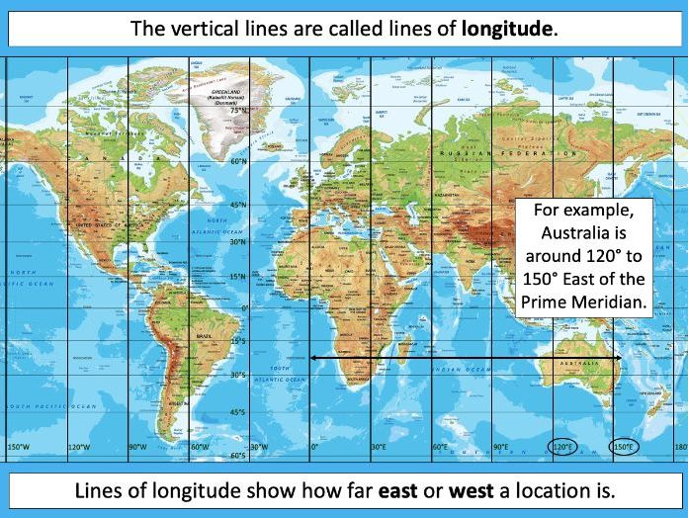**Geography Knowledge Organiser – The Voyage of the Beagle**

**The Voyage of the Beagle**

*During this unit, we are going to be looking at Charles Darwin’s voyage aboard the HMS Beagle. We will look into longitude and latitude, as well the different time zones around the world.*

*We will look at Darwin’s stops during his incredible journey, considering the amount of time it took to complete this once in a lifetime adventure.*

*This unit has curriculum links to our Science and History learning this term.*

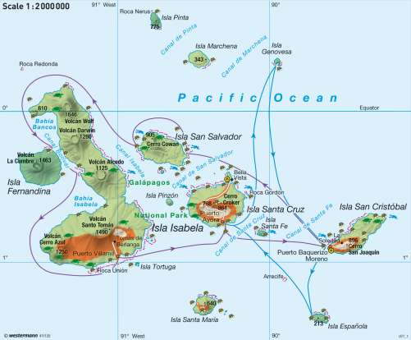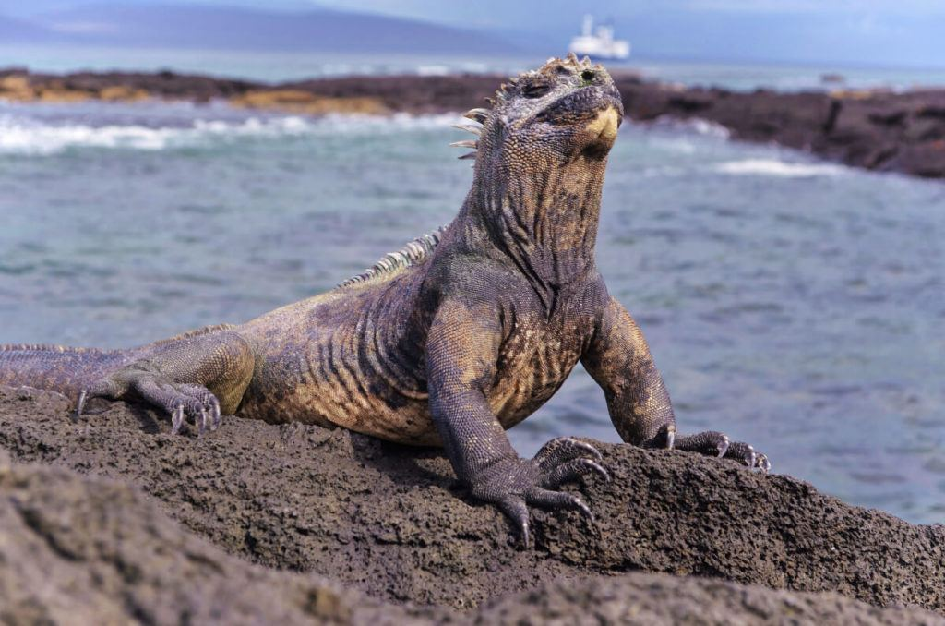

**The Galapagos Islands**

*We will also consider and compare the different Galapagos Islands. We will use maps to look at topography, compare the human geographical features for each island as well as drawing geographical similarities and differences.*

**Key Vocabulary   
Longitude** – the angular distance of a place east or west of the Greenwich meridian  
**Latitude** – the angular distance of a place north or south of the Earth’s equator  
**Prime Meridian** – a planet’s meridian adopted as the zero of longitude  
**Equator** – the halfway point between the two poles, separating the Northern and Southern Hemispheres  
**Time Zone** – a geographical region within which the same standard of time is used  
**Tropic of Cancer** – the line 23 degrees north of the equator  
**Tropic of Capricorn** – the line 23 degrees south of the equator  
**Topography** – the arrangement of natural and artificial physical features of an area  
**Human geography** – how human activity affects or influences an area  
**Biome** – a geographic area that is defined by the species living there  
**Vegetation Belt** – area with distinct plant types, determined by climate, soil and elevation