VOCABULARY: Christianity, water, baptism, significance, gospel, Matthew, Mark, Luke, John, Trinity, Son of God, Holy Spirit, God the Father, baptism prayer, cleansing, refreshing, life- giving
R.E: What is the Trinity and why is it important for Christians?
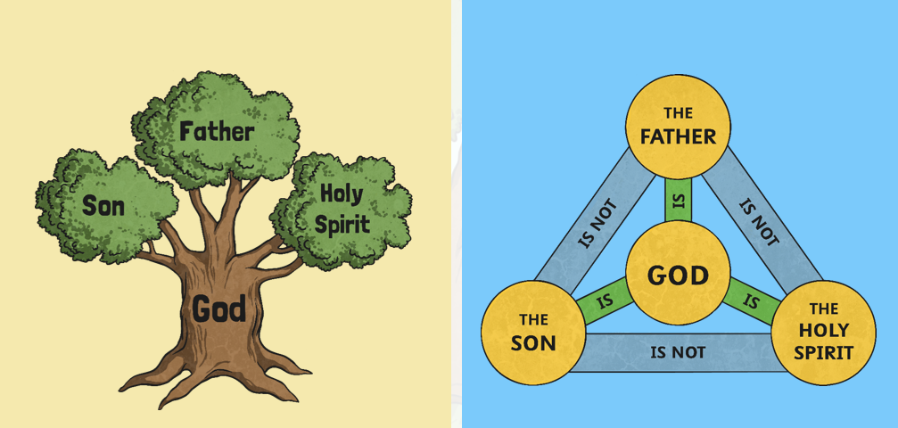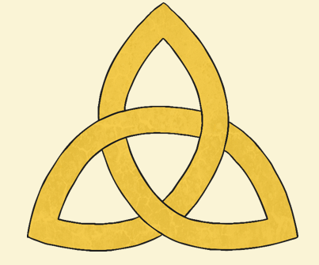
Similarities between these 2 representations.
How do they show God?
Role of the different aspects of The Holy Trinity.
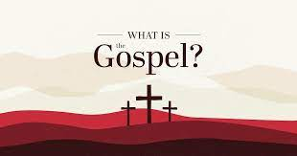

hih

Why is water used as a symbol in Christianity?

