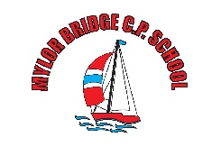

Mylor Bridge School: Zoom Policy
- No 1:1 lessons should take place, groups only.
- All Zoom chats need to be agreed by the head teacher prior to taking place.
- All Zoom meetings to be recorded and saved onto the server for safeguarding reference.
- Staff and children must wear suitable clothing, as should anyone else in the household.
- Any computers used should be in appropriate areas, for example, not in bedrooms; and where possible be against a neutral background.
- Language must be professional and appropriate, including any family members in the background. Any inappropriate language or behaviour will mean that the user is removed from the chat.
- Videos may be muted for both pupils and staff if other children in the household become unsettled or cause a disruption.
- Waiting room to be used.
- Users are not to be admitted before the host.

Agreed by staff 2.6.2020

