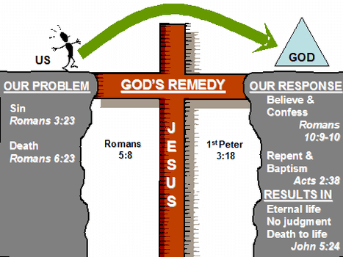**RE Knowledge Organiser – How did Jesus save people?**

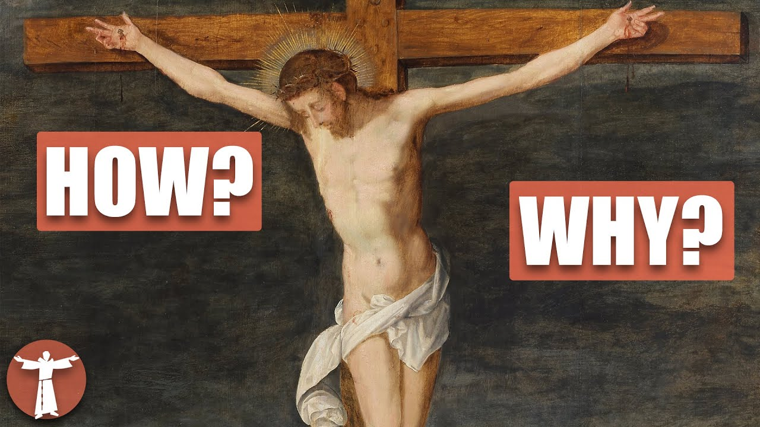

**Key Vocabulary**

**Salvation** – the deliverance from sin and its consequences, believed by Christians to be brought about by faith in Jesus Christ

**Sacrifice** – Christ’s offering of himself in the Crucifixion

**Bible** – the religious text of the Christian religion

**Crucifixion** – a form of execution where the person was bound to a cross