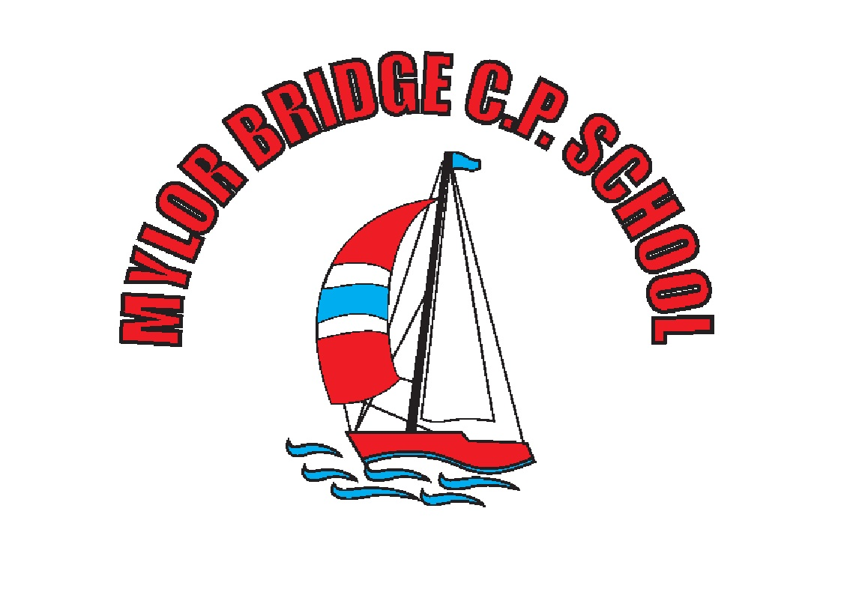

Mylor Bridge Primary School
Religious Education Policy

Adopted and Ratified by the Governing Body Summer 2020
To be reviewed Summer 2022

Page 1 of 6

BACKGROUND TO RELIGIOUS EDUCATION AT MYLOR BRIDGE SCHOOL

Religious Education (RE) is not a National Curriculum subject, but must be provided for all registered pupils in state-funded schools in England including those in the sixth form, unless withdrawn by their parents. It is a necessary part of a broad and balanced curriculum .

As RE is not nationally determined a locally agreed syllabus of RE is prepared by a local Standing Advisory Council on Religious Education (SACRE) and adopted by a local authority. It is this Cornwall Agreed Syllabus of Religious Education 2020-2024, which we have used as the basis of our planning and delivery of RE.

Families who send their children to this school are in the main ‘nominally’ Christian. Some children are from practising Christian families, in addition, there are children who are from religions other than Christianity and some from non-religious backgrounds. Our school is committed to valuing the opinions, beliefs and practices of all and to showing sensitivity to minority groups.

PURPOSE OF STUDY AND AIMS

We believe at this school that RE both supports and strengthens what we aim to do in every aspect of school life. Our caring ethos and the value which we place on the development of the whole child; spiritually, morally, socially, culturally and intellectually, is reflected in the RE curriculum.

RE provokes challenging questions about the ultimate meaning and purpose of life, beliefs about God, the self and the nature of reality, issues of right and wrong and what it means to be human. It challenges pupils to reflect on, consider, analyse, interpret and evaluate issues of truth, belief, faith and ethics and to communicate their responses.

Purpose of Study: At this school we aim to achieve high quality RE for all pupils. RE teaching provides pupils with a systematic knowledge and understanding about Christianity, principal religions and worldviews which give life value. RE aims to enable pupils to become religiously and theologically literate so they can engage in life in an increasingly diverse society. It is not about telling pupils what religious views they should have but rather assists them in gaining shared human understanding, developing personal identity and searching for meaning in the context of evaluating different viewpoints.

Aims: The principal aim of religious education is to explore what people believe and what difference this makes to how they live, so that pupils can gain the knowledge, understanding and skills needed to handle questions raised by religion and belief, reflecting on their own ideas and ways of living.

- make sense of a range of religious and non-religious beliefs, so that they can:
  - • identify, describe, explain and analyse beliefs and concepts in the context of living religions, using appropriate vocabulary
  - • explain how and why these beliefs are understood in different ways, by individuals and within communities
  - • recognise how and why sources of authority (e.g. texts, teachings, traditions, leaders) are used, expressed and interpreted in different ways, developing skills of interpretation

- understand the impact and significance of religious and non-religious beliefs, so that they can:
  - • examine and explain how and why people express their beliefs in diverse ways
  - • recognise and account for ways in which people put their beliefs into action in diverse ways, in their everyday lives, within their communities and in the wider world
  - • appreciate and appraise the significance of different ways of life and ways of expressing meaning

- make connections between religious and non-religious beliefs, concepts, practices and ideas studied, so that they can:
  - • evaluate, reflect on and enquire into key concepts and questions studied, responding thoughtfully and creatively, giving good reasons for their responses
  - • challenge the ideas studied, and allow the ideas studied to challenge their own thinking, articulating beliefs, values and commitments clearly in response
  - • discern possible connections between the ideas studied and their own ways of understanding the world, expressing their critical responses and personal reflections with increasing clarity and understanding

Throughout schooling, teachers should consider how their teaching contributes towards the principal aim of RE in Cornwall, and how they help pupils to achieve the threefold aims above.

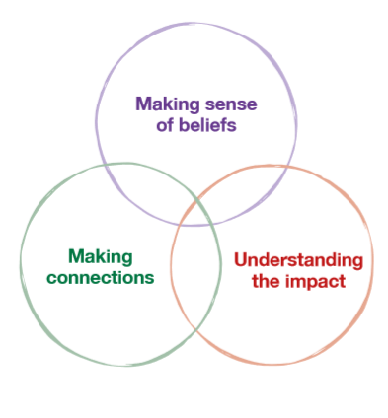

RE is for all pupils:
• Every pupil has an entitlement to religious education (RE)
• RE is a necessary part of a ‘broad and balanced curriculum’ and must be provided for all registered pupils in state-funded schools in England, including those in the sixth form, unless withdrawn by their parents (or withdrawing themselves if they are aged 18 or over)
• This requirement does not apply for children below compulsory school age (although there are many examples of good practice of RE in nursery classes).
• Special schools should ensure that every pupil receives RE ‘as far as is practicable’.
• The ‘basic’ school curriculum includes the national curriculum, RE and relationships and sex education.

Right of withdrawal
This was first granted when RE was actually religious instruction and carried with it connotations of induction into the Christian faith. RE is very different now – open, broad, exploring a range of religious and non-religious worldviews. However, parents have the right to withdraw their children from RE lessons or any part of the RE curriculum9 and the school has a duty to supervise them, though not to provide additional teaching or to incur extra cost. Where the pupil has been withdrawn, the law provides for alternative arrangements to be made for RE of the kind the parents want the pupil to receive. These arrangements will be made by the parents; the school is not expected to make these arrangements. This RE could be provided at the school in question, or by another school in the locality. If neither approach is practicable, the pupil may receive external RE teaching as long as the withdrawal does not have a significant impact on the pupil’s attendance. Schools should have a policy setting out their approach to provision and withdrawal. However, it is good practice to talk to parents to ensure that they understand the aims and value of RE before honouring this right. Students aged 18 or over have the right to withdraw themselves from RE. More guidance on withdrawal can be found in Religious education in English schools: non-statutory guidance 2010, available online at www.gov.uk/government/publications/religiouseducation-guidance-in-english-schools-non-statutory-guidance-2010

Time for religious education
Schools have a statutory responsibility to deliver religious education to all pupils, except those withdrawn by parents (see p.9).
Schools must ensure that sufficient time is given in order to enable pupils to meet the expectations set out in this agreed syllabus, ensuring that the curriculum is coherent and shows progression, particularly across transitions between key stages.

What religions are to be taught?
10 Section 96 of the Learning and Skills Act 2000. This requires maintained schools to provide only qualifications approved by the Secretary of State. See www.dfes.gov.uk/section96/uploads/download_records_full.xls
This agreed syllabus requires that all pupils develop understanding of Christianity in each key stage. In addition, across the age range, pupils will develop understanding of the principal religions represented in the UK, in line with the law. These are Islam, Hinduism, Sikhism, Buddhism and Judaism. Furthermore, children from families where non-religious worldviews are held are represented in almost all of our classrooms. These worldviews, including for example Humanism, will also be the focus for study in thematic units. Pupils are to study in depth the religious traditions of the following groups: 4–5s Reception Children will encounter Christianity and other faiths, as part of their growing sense of self, their own community and their place within it.
Consideration of other religions and nonreligious worldviews can occur at any key stage, as appropriate to the school context.

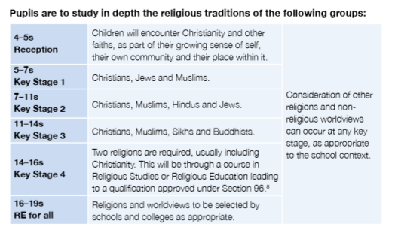.

Page 3 of 6

ASSESSMENT, RECORDING AND REPORTING (see school Assessment policy)

The Cornwall Agreed Syllabus for Religious Education sets out a structure for recognising pupil achievements and each pupil can work progressively towards achieving the expected end of key stage learning outcomes as a requirement outlined in the syllabus.

Through activities for example, discussion with pupils, group activities, marking and guiding their work, observing, displaying work, asking and answering questions, teachers are continually finding out about their pupils’ achievements. This information is then recorded against expected learning outcomes – detailed in the syllabus.

School reports are sent home in the summer term of each year and the RE report is written with reference to the records made or pieces of work retained.

PLANNING

In order to ensure that our aims are met and the Programme of Study is covered at each key stage, our schemes of work ensure that pupils have encountered and explored the religions through the EYFS and Key Stage/s 1 and 2. We have used a combination of teaching RE through the creative curriculum, RE days and as a separate subject, depending on the material which has to be covered.

Our medium-term plans give details of each unit of work for each term. The Subject Leader reviews these plans on a regular basis. As we have some mixed-age classes, we carry out the medium-term planning on a two-year rotation cycle. By so doing, we ensure that children have complete coverage of the Agreed Syllabus at an appropriate level and that any repetition of topics is mindful of progression and of the children’s developmental stage, ability and interest.

Short term planning of individual lessons is a matter for the class teacher. The Subject Leader is available to help with this and keeps a range of teachers’ resources as a guide. When planning each unit of work the teacher will identify which parts of the programme of study are to be the focus, the learning objectives for the unit, the learning tasks planned to

SACRE, November 2017 Page 4 of 6
achieve them, time allocated and any resources, visits or visitors needed. The work planned must be relevant to the needs of all pupils.

CROSS CURRICULAR APPROACHES
14. British Values within Computing
Children at Mylor Bridge Primary School demonstrate the following values whilst learning about Computing by:
Democracy
- Listening to everyone’s ideas in order to form a majority.
- Working as part of a team and collaborating to use computing devices effectively.
Rule of Law
- Developing knowledge of lawful computing behaviours.
- Demonstrating respect for computing laws.
Individual Liberty
- Taking responsibility for our own computing behaviours.
- Challenging stereotypes and bias.
- Exercising rights and personal freedoms safely through knowledge of E-safety.
Respect and Tolerance
- Showing respect for other cultures when undertaking research using computing devices.
- Providing opportunities for pupils of all backgrounds to achieve in computing.

15. School Learning Powers
At Mylor Bridge School, we have adopted a learning approach called ‘Building Learning Powers. It allows children to understand how they learn, what inhibits their learning and how to overcome these difficulties. It helps children to become more effective and independent learners
There are four elements:
Resourcefulness
- Questioning – Getting below the surface; being curious.
- Making Links – seeking coherence, relevance and meaning.
- Imagining – Using the mind’s eye as a learning theatre.
- Reasoning – thinking rigorously and methodically.
- Capitalising – making good use of resources.
Resilience
- Absorption – The pleasure of being rapt in learning….awe and wonder!
- Managing Distractions – recognising and reducing interruptions.
- Noticing – really sensing what’s out there.
- Perseverance – stickability; tolerating the feelings of learning.
Reflectiveness
- Planning – working learning out in advance
- Revising – monitoring and adapting along the way.
- Distilling – drawing out the lessons from experience
- Meta - learning – understanding learning and yourself as a learner.
Reciprocity (which we call Relationships).
- Interdependence – balancing self-reliance and sociability.
- Collaboration – the skills of learning with each other.
- Empathy and listening – getting inside others’ minds.
- Imitation – picking up others’ habits and values
These learning powers are reinforced across all parts of our school life such as curriculum led lessons and extra-curricular activities and visits to places of learning.

RE teaching and learning will be the means to many wider cross-curricular themes and dimensions. Children’s skills in oracy and literacy will be enhanced. Problem-solving, decision-making and interpersonal skills will be developed.

RE presents many opportunities to explore multicultural and equal opportunities issues and for consideration of the environment. Moral questions will be raised and pupils will develop a sense of citizenship through many aspects of the explicit RE curriculum. Links will be made with people and communities within the locality. It is recognised that for some families visits to places of religious significance may conflict with their own religious beliefs. In the case of such a visit parent / carer permissions will be sought in advance.

The RE curriculum makes a significant contribution to pupils’ spiritual, moral, social and cultural (SMSC) development knowledge and awareness of Prevent, British values, keeping children safe and the diversity, equality and cohesion agendas, these are all essential contributing factors in providing outstanding RE teaching and learning for all children.

LEADERSHIP AND MANAGEMENT

The Subject Leader manages this area of the curriculum for their department

There is a yearly staff meeting on RE, led by the subject leader; where areas for development are discussed. This policy is reviewed to ensure it still represents the values and practice of the school.

SACRE, November 2017 Page 6 of 6

