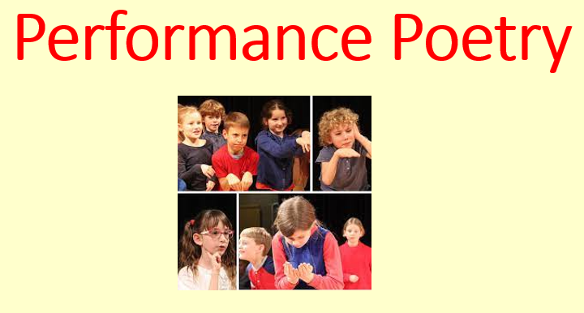

Knowledge Organiser

Writer’s Toolkit

Key Vocabulary

volume, pace, intonation, expression, delivery, performance, rhythm, line, verbs, mood, language patterns, sentence length, rhyme, stanza, verse, epithet, voice, expression, presentation, imagery, similes, personification, metaphors, figurative language