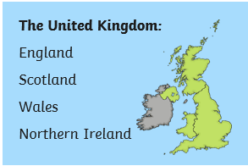

**Year 3 Geography Mapping Skills**

**United Kingdom of Great Britain and Northern Ireland**

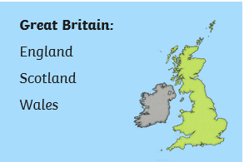

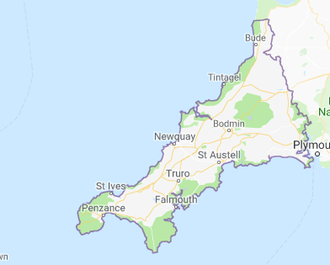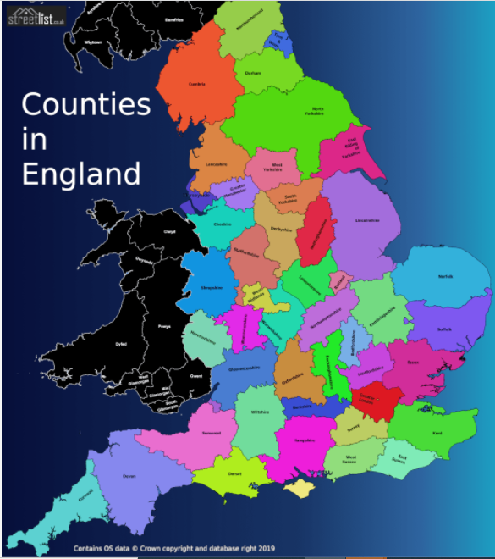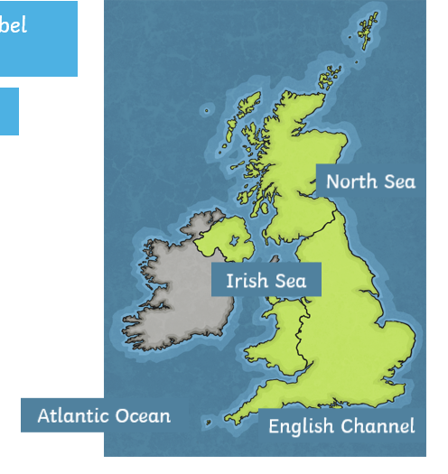

Seas and oceans surrounding the UK

Our county: Cornwall

**Key Questions**

* Which countries make up the United Kingdom? What are their capital cities?
* What are the sea surrounding the UK called?
* What are some of the main rivers in the UK called?
* What are some of the counties in England called? Where is Cornwall?
* What are some of the highest peaks in the UK called?

**Key Vocabulary**

* United Kingdom, England, Scotland, Wales, Northern Ireland, Great Britain, London, Edinburgh, Cardiff, Belfast, capital,

|  |  |  |  |
| --- | --- | --- | --- |
| * River, sea, North Sea, English Channel, * Irish Sea, Atlantic Ocean, River Thames,  |  |  |  | | --- | --- | --- | | |  |  | | --- | --- | | * River Severn, River Tay, River Bann. * County, country town.  |  | | --- | | * Mountain, hill, range, peak, height, | | | |

|  |
| --- |
| . |