Year 6 Science Knowledge Organiser – Animals including Humans
The Circulatory System
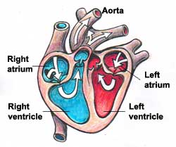
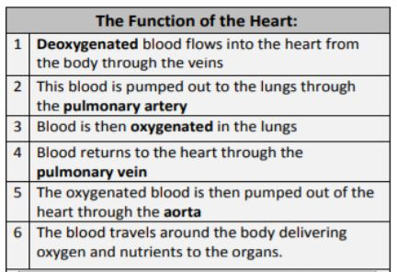

Key Questions
How does blood move around the body?
What are the key parts of the circulatory system?
What happens to the circulatory system during exercise?
What effects do lifestyle choices have on my health?
What are the roles of some of the organs in my body?
How are nutrients transported around the body?
