Early Reading in EYFS and KS1
Book Management and Tracking
All books from book band 1 – 6 are closely matched to the corresponding stage of learning in the Twinkl Phonics programme. When children have completed the phonics programme and have learnt all GPCs, assuming their fluency allows, they will move through book band 7 onwards. These children’s progress will be monitored through regular reading with teachers and support staff, communication with parents, regular assessments through the 2eskimos Reading Assessment app and, from Spring term in Year 2, Star tests and AR quizzing.
Through the scheme, children will be introduced to key text types they should know. This includes fiction, non-fiction, poetry, quiz books and play scripts. When issuing children books, we ensure the children are given opportunities to access all of these text types.
Reading books are organised into book bands with smaller sub-sets within this. The image below, outlines the progression through the book bands and sub-sets that correspond to each phonics level.
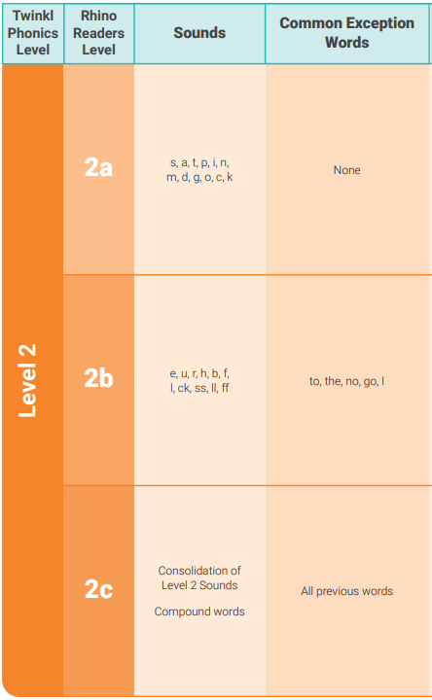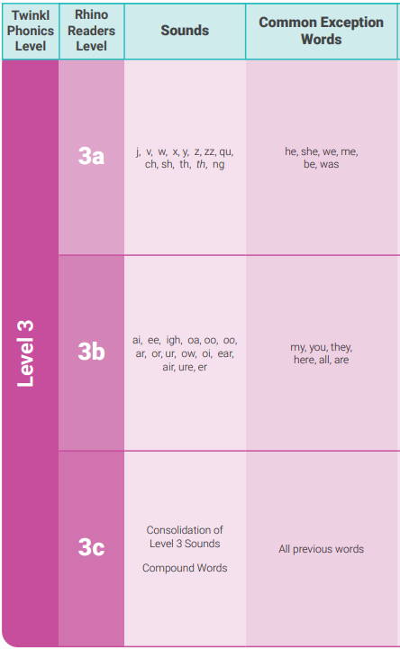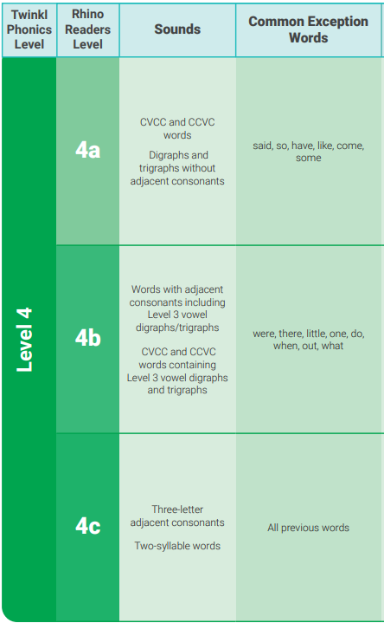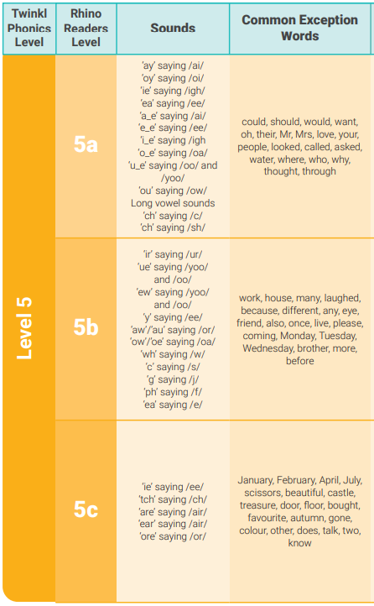
Children should be reading the books from the sub-set that precedes their current learning point in phonics (i.e. the level that they have just completed in phonics lessons). For example, children who have recently started learning in the 2nd portion of GPCs in Level 3, should be reading books from Book Band 3, Sub-set 1 (3a). When they have learnt all GPCs from this 2nd portion of Level 3, they will be ready to move onto reading books from Book Band 3, Sub-set 2 (3b). They will be reading books from 3b while learning the third and final set of GPCs from Level 3 in Phonics lessons).
Each child should have a copy of the appropriate book band tracker kept in class. When a book is issued, the title should be dated on the record. This allows for a record of progression and to track which books have been read. It will also ensure steady progression through the book bands.

Books are changed once a week (Mondays) and children will keep the same book for the week. Children will be encouraged to read the book several times (ideally 2-3 times). This enables the first read to be focused around decoding, the second to develop fluency and confidence, and the third is to encourage understanding and comprehension of the text. Although books are changed once a week, teachers and support staff check book bags every day to keep a running record of frequency of reading at home. This allows for continued communication between home and school, as well as build a picture of children struggling with reading at home or not reading at home frequently enough. Teachers then quickly identify children to be prioritised for frequent reading in school.
When children have completed a phonics Level or sub-set (e.g. Moving from Phase 2 to Phase 3), teachers make a judgement regarding moving them onto the next sub-set. In most cases, this is the appropriate action as it will give the child the opportunity to practise and consolidate the sounds they have just learnt. In some cases, children may have the phonic knowledge to progress onto the next phonics level but may not be confident or fluent enough to be moved up to the corresponding book band or sub-set. In this instance, teachers use their judgement to decide if the child should remain on their current set and when they are ready to move onto the next set.
Should children remain on a sub-set longer than expected but have read all titles from this, teachers can select books from a list of supplementary sets. These are from a range of other publishers and schemes but do correspond to the progression of phonics levels being taught. These are also organised into the same sub-sets so teachers can select the appropriate level from these to access more books of the same level.
Reading the Books
Step 1: Before Reading
- Rehearse the GPCs and tricky words they will meet in the book.
- Allows opportunities to blend and read key words and sounds, developing confidence when reading the text.
- The imagery and mnemonics on this page are the same as those used within the Twinkl phonics programme, offering a high level of consistency.

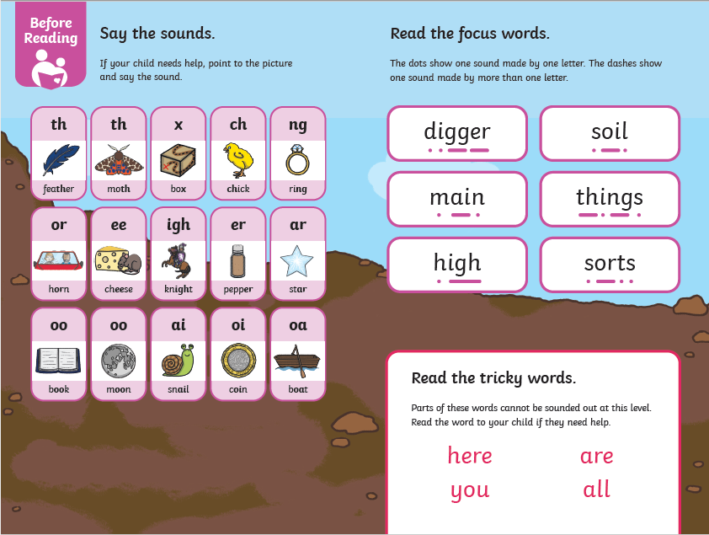

Step 2: Tackle the Text
- Read the story to a grown-up, using knowledge of the GPCs learnt so far.
- Through levels 2-5, new or current tricky or common exception words are highlighted in red to support recognition.

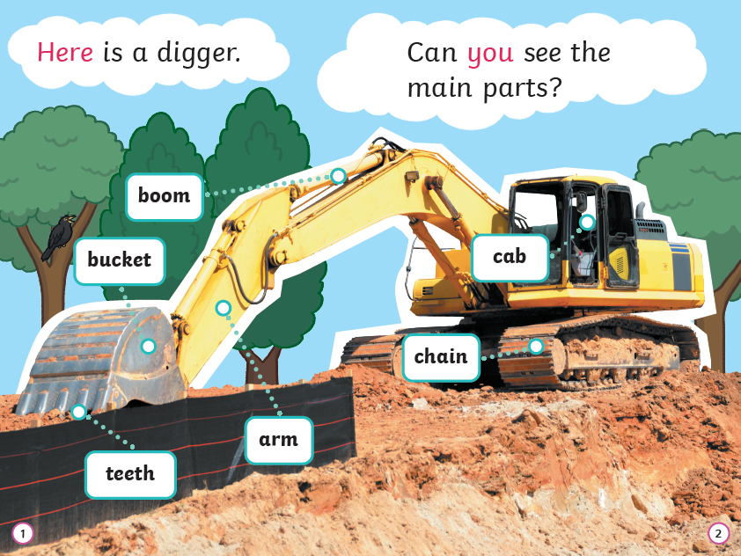
Step 3: After Reading
- Use this page to consolidate learning through discussion, comprehension practise and language building opportunities.
- There are further activities or ‘Rhino challenges’. These are a range of linked activities to allow children to learn ‘beyond the book’.
- This third and final stage is best accessed after the second or third read of the book.
