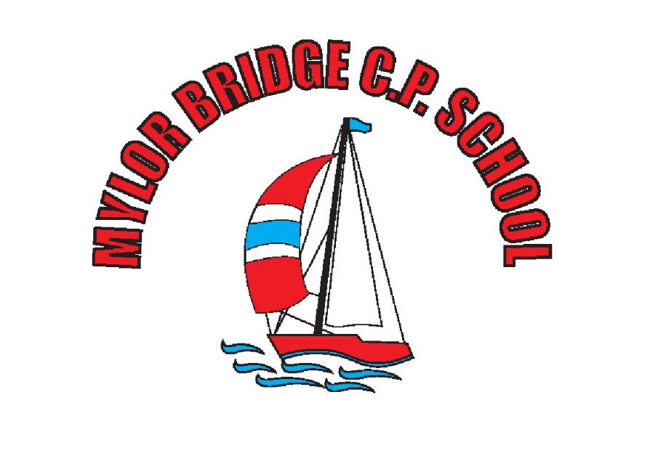

Mylor Bridge CP School
Computing Policy

Written by: Sam Shainberg
Date written: September 2019

Reviewed and approved by:
Headteacher: _________________________
Chair of Governors: _________________________

Review date: July 2020
At Mylor Bridge, we believe that Computing is an integral part of preparing children to live in a world where technology is continuously and rapidly evolving, so much so that children are being prepared to work with technology that does not even exist yet. For this reason, we feel that it is important that children are able to participate in the creation of these new tools to fully grasp the relevance and the possibilities of emerging technologies, thus preparing them for a world of work, communication and creativity.
Computing has deep links with mathematics, science, and design and technology, and provides insights into both natural and artificial systems. Computing also ensures that pupils become digitally literate – able to use, express themselves and develop their ideas through information and communication technology – at a level suitable for the future workplace and as active participants in a digital world.

- Purpose
The National Curriculum splits the teaching and learning of Computing into three strands (Computer Science, Digital Literacy and Information Technology). It is therefore important that children recognise the difference between what makes each one relevant to their future, as well as their everyday lives. High quality teaching of Computing, from Reception through to Year 6, utilises a combination of practical and theory lessons designed to promote discussion and nurture understanding, which are also relevant to other areas of the curriculum such as PSHE and Citizenship.
This policy reflects the values and philosophy in relation to the teaching and learning of and with ICT. It should be read in conjunction with the scheme of learning for Computing that sets out what children in different year groups will be taught and how ICT can facilitate or enhance learning in other curriculum areas.
This document is intended for:
- All members of staff
- School governors
- Parents
- Inspection Teams

Copies of this policy are available to view on the school website and kept on the server in the Subject Leadership file.

- Aims:
Computer Science
- To enable children to become confident coders on a range of devices.
- To create opportunities for collaborative and independent learning.
- To develop children’s understanding of technology and how it is constantly evolving.
Digital Literacy
- To develop children’s appreciation of safe and appropriate use of ICT, including using the internet.
- To give children the opportunity to explore and experience a range of digital devices.
Information Technology
- To develop ICT skills, which allow children to use computers and other devices effectively and efficiently.
- To develop ICT as a cross curricular tool for learning and progression.
- To enable children to understand and appreciate their place in the modern world.

- Objectives
In order to develop computing and ICT capabilities and understanding of each child, we provide:
- Computing through all three strands taught within the classroom.
- Continuity and clear progression throughout the school to ensure that experience and skills are developed in a cohesive and consistent way.
- Access to computers, netbooks and iPads within the classroom environment or in designated communal areas.
- Experiences of a variety of well-planned, structured and progressive activities.
- Opportunities for cross-curricular links to widen children’s knowledge of the capability of computing including safe use of the internet and other digital equipment.
- Opportunities for children to recognise the value of computing and ICT in their everyday lives and their future working life as active participants in a digital world.

- Curriculum development and Organisation
Our scheme of learning is based on the National Curriculum guidelines and adapted from the ‘2 Simple-Purple Mash’ scheme.
Class sets of laptops and iPads are stored centrally and all staff and pupils have access to these. The range of devices available in school support the development of Computing and ICT capability by enabling independent learning, encouraging research and allowing for the creative use of ICT in all subjects. Digital projectors, SMART screens, interactive whiteboards and visualisers are in all classrooms and are used as a teaching and learning resource across the curriculum.
Our school website showcases some of the wealth of experiences that the children are involved in as well as providing help and supportive information for the school community.

- Teaching and Learning
Across Key Stage 1 and Key Stage 2, our children will use technology to:
• Learn Programming by using programmable toys, program on screen, through animation, develop games (simple and interactive) and to develop simple mobile apps.
• Develop their computational thinking through filming, exploring how computer games work, finding and correcting bugs in programs, creating interactive toys, cracking codes and developing project management skills.
• Develop computing creativity by illustrating eBooks, taking and editing digital images, shooting and editing videos, producing digital music and creating art.
• Investigate computer networks through finding images using the Web, researching a topic, finding out how the school network operates, editing and writing code and planning the creation of mobile apps.
• Communicate and collaborate by producing projects in groups, using email, create and write blog pages and design interfaces for apps.
• Understand the need for productivity as a life skill through creating a card electronically, record bug hunt data, create surveys and analyse results, record and analyse weather data, create virtual spaces and research the app market.
Teachers differentiate their planning to meet the range of needs in each class. They employ a wide range of teaching and learning styles to ensure all children are sufficiently challenged. Children may be required to work individually, in pairs or in small groups according to the nature of the task. Different outcomes may be expected depending on the ability and needs of the individual child.

- Internet Safety
Children have access to the internet to enrich and extend learning activities across the curriculum. However, we have acknowledged the need to ensure that all pupils are responsible and safe users of the Internet and other communication technologies both in school and outside. An e-safety policy has thus been written to protect all parties and to ensure staff and pupils are using computers and the internet safely and responsibly. Rules for responsible Internet use are displayed next to all stationary computers and in each classroom within our school. To further ensure the safety of the children we will teach each class the rights and responsibilities of using the Internet.

- Roles and Responsibilities
- Head Teacher – Vicky Sanderson
In consultation with the computing coordinator will
  - Determine the ways on which computing and ICT supports, enriches and extends the curriculum.
  - Decide on the provision and allocation of resources.
  - Ensure that computing and ICT is used in a way that achieves the aims and objectives of the school.
- Computing coordinator – Sam Shainberg
With the support of the head teacher will:
  - Monitor the delivery of the Computing curriculum within the school through strategies outlined in section 9.
  - Report to the head teacher and governors about the delivery and development of the subject.
  - Plan and oversee the subject development plan, regularly evaluating the progress and impact of this.
  - Facilitate the use of ICT across the curriculum.
  - Provide or organise training to keep staff skills and knowledge up to date.
  - Advise colleagues about effective teaching strategies and managing equipment.
- Teaching staff
With support and guidance from the computing coordinator will:
  - Plan, prepare and deliver high quality computing activities in line with the school’s knowledge and skills progression.
  - Report to the computing coordinator regarding pupil progress and assessments in the subject.

- Assessment
We assess the children’s work in computing whilst observing them working in lessons. Formative assessment occurs on a lesson-by-lesson basis, outcomes for which are determined by the learning objective (WALT). Teachers will begin to record progress made by children against milestones, or targets, on a tracker document at the end of each unit or block. These assessment tools will be based on the Purple Mash scheme objectives. As this scheme is being introduced, this assessment strategy will be developed and embedded over the course of the year.
- Monitoring
Monitoring termly enables the computing coordinator to gain an overview of computing and ICT teaching and learning throughout the school. This will assist the school in identify areas of strength as well as those for development. In order to carry this out effectively, the coordinator will:
- Observe teaching and learning in the classroom.
- Pupil and staff conferencing to understand their views regarding the subject.
- Review children’s work.
- Review long term and medium term planning to ensure milestone coverage and appropriate progression both within year groups and year on year.

10. Deployment of computing/ICT resources
To enable regular and whole class teaching of Computing and ICT, each class has access to a bank of laptops, netbooks and shared bank of iPads. Each member of teaching staff has a laptop computer, which they are able to use at home. Every class has an interactive touch-screen board linked to a main computer on the school network. The hall has a large TV connected to a laptop, which is also linked to the school network.

11. Security, Legislation, Copyright and Data Protection
We ensure that the school community is kept safe by ensuring that:
- The school’s IT support and maintenance provider, NCI Technologies, is responsible for regularly updating anti-virus software. They also maintain the filtering system.
- The use of ICT and computing will be in line with the school’s Acceptable Use Policy (AUP).
- All staff, volunteers and children must read and sign a copy of the school’s AUP.
- Parents are made aware of the AUP at school entry and are informed if there are any amendments to this.
- All children are aware of the school rules for responsible use and understand the consequences of any misuse.

12. Health and Safety
The school is aware of health and safety issues surrounding children’s use of ICT and this is taken very seriously. As with all aspects of the school life, we ensure that pupils and staff have a safe environment in which to learn and work. As such, we will ensure that:
- All fixed and portable appliances and devices are tested regularly, in line with LA guidelines.
- Damaged equipment is reported to the school secretary or head teacher, who will arrange for repair or disposal.
- Children learn about rights and responsibilities when using computers and the internet.

13. Equal opportunities
It is our policy to ensure that all children, regardless of race, class or gender, should have the opportunity to develop computing and ICT capability. We aim to consider and respond to all children’s needs and overcome potential barriers for individuals and groups of children by:
- Ensuring that all children have access to, and follow, the scheme of learning for computing.
- Providing curriculum materials, which are in no way class, gender or racially prejudiced or biased.
- Providing opportunities for our children who do not have access at home to use the school computers/internet to develop independent learning.
- Providing suitable challenges for more able children, as well as support for those who have emerging needs.
- Responding to the diversity of children’s social, cultural and ethnic backgrounds.
- Overcoming barriers to learning through the use of assessment and additional support.
We aim to address:
- Communication or language difficulties by developing computing skills through the use of all their individual senses and strengths.
- Movement or physical difficulties by developing computing skills through utilising their individual strengths.
- Behavioural or emotional difficulties (including stress and trauma) by developing the understanding and management of their own learning behaviours.

14. British Values within Computing
Children at Mylor Bridge Primary School demonstrate the following values whilst learning about Computing by:
Democracy
- Listening to everyone’s ideas in order to form a majority.
- Working as part of a team and collaborating to use computing devices effectively.
Rule of Law
- Developing knowledge of lawful computing behaviours.
- Demonstrating respect for computing laws.
Individual Liberty
- Taking responsibility for our own computing behaviours.
- Challenging stereotypes and bias.
- Exercising rights and personal freedoms safely through knowledge of E-safety.
Respect and Tolerance
- Showing respect for other cultures when undertaking research using computing devices.
- Providing opportunities for pupils of all backgrounds to achieve in computing.

15. School Learning Powers
At Mylor Bridge School, we have adopted a learning approach called ‘Building Learning Powers. It allows children to understand how they learn, what inhibits their learning and how to overcome these difficulties. It helps children to become more effective and independent learners
There are four elements:
Resourcefulness
- Questioning – Getting below the surface; being curious.
- Making Links – seeking coherence, relevance and meaning.
- Imagining – Using the mind’s eye as a learning theatre.
- Reasoning – thinking rigorously and methodically.
- Capitalising – making good use of resources.
Resilience
- Absorption – The pleasure of being rapt in learning….awe and wonder!
- Managing Distractions – recognising and reducing interruptions.
- Noticing – really sensing what’s out there.
- Perseverance – stickability; tolerating the feelings of learning.
Reflectiveness
- Planning – working learning out in advance
- Revising – monitoring and adapting along the way.
- Distilling – drawing out the lessons from experience
- Meta - learning – understanding learning and yourself as a learner.
Reciprocity (which we call Relationships).
- Interdependence – balancing self-reliance and sociability.
- Collaboration – the skills of learning with each other.
- Empathy and listening – getting inside others’ minds.
- Imitation – picking up others’ habits and values
These learning powers are reinforced across all parts of our school life such as curriculum led lessons and extra-curricular activities such as sporting or music events.

