Exclusion Policy

Contents
- Aims 1
- Legislation and statutory guidance 2
- Definitions 2
- Roles and Responsibilities 3
- Considering the reinstatement of a student 7
- Independent review 9
- School registers 11
- Returning from a suspension 11
- Managed Move 12
Managed Moves will be considered for a student at risk of exclusion, where appropriate 12
- Monitoring arrangements 13
10. Links with other policies 13
Appendix 1: Independent review panel training 14
Appendix 2: Paperwork related to pre and post exclusion 14
Appendix 3: Stages of Intervention 15
Appendix 4: Flow chart for exclusions 16

Adopted by the Governing Body: 10th May 2023 Period: 2 Years
Review Date: Summer 2024

Aims
Our school aims to ensure that:
  - The exclusions process is applied fairly and consistently
  - The exclusions process is understood by governors, staff, parents and students
  - Students in school are safe and happy

Legislation and statutory guidance
This policy is based on statutory guidance from the Department for Education: Exclusion from maintained schools, academies and pupil referral units (PRUs) in England.
It is based on the following legislation, which outline schools’ powers to exclude students:
  - Section 51a of the Education Act 2002, as amended by the Education Act 2011
  - The School Discipline (Pupil Exclusions and Reviews) (England) Regulations 2012 In addition, the policy is based on:
  - Part 7, chapter 2 of the Education and Inspections Act 2006, which looks at parental responsibility
  - Section 579 of the Education Act 1996, which defines ‘school day’
  - The Education (Provision of Full-Time Education for Excluded Pupils) (England) Regulations 2007, as amended by The Education (Provision of Full-Time Education for Excluded Pupils) (England) (Amendment) Regulations 2014
  - The Equality Act 2010
  - Children and Families Act 2014

Definitions
Suspension – when a student is removed from the school for a fixed period. This was previously
referred to as a ‘fixed-term exclusion’.
Permanent exclusion – when a student is removed from the school permanently and taken off the school roll. This is sometimes referred to as an ‘exclusion’.
Off-site direction – when a governing board of a maintained school requires a student to attend another education setting temporarily, to improve their behaviour.
Parent – any person who has parental responsibility and any person who has care of the child.
Managed move – when a student is transferred to another school permanently. All parties, including parents and the admission authority for the new school, should consent before a managed move occurs.
For the purposes of exclusions, school day is defined as any day on which there is a school session. Therefore, INSET or staff training days do not count as a school day.

Roles and Responsibilities
  - The headteacher
Deciding whether to suspend or exclude
Only the headteacher, or acting headteacher, can suspend or permanently exclude a student from school on disciplinary grounds. The decision can be made in respect of behaviour inside or outside of school. The headteacher will only use permanent exclusion as a last resort.
A decision to suspend or exclude a student will be taken only:
    - In response to serious or persistent breaches of the school’s behaviour policy, and
    - If allowing the student to remain in school would seriously harm the education or welfare of others
Before deciding whether to suspend or exclude a student, the headteacher will:
    - Consider all the relevant facts and evidence on the balance of probabilities, including whether the incident(s) leading to the exclusion were provoked
    - Allow the student to give their version of events
    - Consider whether the student has special educational needs (SEN)
    - Consider whether the student is especially vulnerable (e.g. the student has a social worker, or is a looked-after child (LAC))
    - Consider whether all alternative solutions have been explored, such as off-site direction or managed moves
The headteacher will consider the views of the student, in light of their age and understanding, before deciding to suspend or exclude, unless it would not be appropriate to do so.
Informing parents
If a student is at risk of suspension or exclusion the headteacher or other senior leader delegated to inform, will let the parents know as early as possible, in order to work together to consider what factors may be affecting the student’s behaviour, and what further support can be put in place to improve the behaviour.
If the headteacher decides to suspend or exclude a student, the parents will be informed of the period of the suspension or exclusion and the reason(s) for it, as soon as possible via telephone or other agreed methods of communication.
The parents will also be provided with the following information in writing, without delay:
- The reason(s) for the suspension or exclusion
- The length of the suspension or, for a permanent exclusion, the fact that it is permanent
- Information about parents’ right to make representations about the suspension or permanent exclusion to the governing board and how the student may be involved in this
- How any representations should be made

- Where there is a legal requirement for the governing board to hold a meeting to consider the reinstatement of a student, and that parents have a right to attend the meeting, be represented at the meeting (at their own expense) and to bring a friend
The headteacher will also notify parents without delay and by the end of the afternoon session on the first day their child is suspended or permanently excluded, that:
- For the first 5 school days of an exclusion (or until the start date of any alternative provision or the end of the suspension, where this is earlier), the parents are legally required to ensure that their child is not present in a public place during school hours without a good reason. This will include specifying on which days this duty applies
- Parents may be given a fixed penalty notice or prosecuted if they fail to do this
If alternative provision is being arranged, the following information will be included, if possible:
- The start date for any provision of education that has been arranged
- The start and finish times of any such provision, including the times for morning and afternoon sessions, where relevant
- Where the provision will take place and key information about contact details
If the headteacher does not have the all the information about the alternative provision arrangements by the end of the afternoon session on the first day of the suspension or permanent exclusion, they can provide the information at a later date, without delay and no later than 48 hours before the provision is due to start.
The only exception to this is where alternative provision is to be provided before the sixth day of a suspension or permanent exclusion, in which case the school reserves the right to provide the information with less than 48 hours’ notice.
When a child has been permanently excluded, the LA will provide details of the 6th day provision.
Informing the governing board
The headteacher will notify the governing board and chair of governors, without delay of:
- Any permanent exclusion, including when a suspension is followed by a decision to permanently exclude a student
- Any suspension or permanent exclusion which would result in the student being suspended or permanently excluded for a total of more than 5 school days in a term
- Any suspension or permanent exclusion which would result in the student missing a National Curriculum test or public exam. (Note: this doesn’t apply to internal examinations or assessments)
The headteacher will notify the governing board once per term of any other suspensions of which they have not previously been notified, and the number of suspensions and exclusions which have been cancelled, including the circumstances and reasons for the cancellation.
Informing the local authority (LA)

The headteacher will notify the LA of all suspensions and permanent exclusions without delay, regardless of the length of a suspension.
The notification will include:

- The reason(s) for the suspension or permanent exclusion
- The length of a suspension or, for a permanent exclusion, the fact that it is permanent
For a permanent exclusion, if the student lives outside the LA in which the school is located, the headteacher will also, without delay, inform the student’s ‘home authority’ of the exclusion and the reason(s) for it.
Informing the student’s social worker and/or virtual school head (VSH)
If a:
- Student with a social worker is at risk of suspension or permanent exclusion, the headteacher will inform the social worker as early as possible
- Student who is a looked-after child (LAC) is at risk of suspension or exclusion, the headteacher will inform the Virtual School as early as possible
This is in order to work together to consider what factors may be affecting the student’s behaviour, and what further support can be put in place to improve the behaviour.
If the headteacher decides to suspend or permanently exclude a student with a social worker / a student who is looked after, they will inform the student’s social worker / the Virtual School, as appropriate, without delay, that:
- They have decided to suspend or permanently exclude the student
- The reason(s) for the decision
- The length of the suspension or, for a permanent exclusion, the fact that it is permanent
- The suspension or permanent exclusion affects the student’s ability to sit a National Curriculum test or public exam (where relevant)

The social worker / VSH will be invited to any meeting of the governing board about the suspension or permanent exclusion. This is so they can provide advice on how the student’s background and/or circumstances may have influenced the circumstances of their suspension or permanent exclusion. The social worker should also help ensure safeguarding needs and risks and the student’s welfare are taken into account.
Cancelling suspensions and permanent exclusions

The headteacher may cancel a suspension or permanent exclusion that has already begun, but this will only be done where it has not yet been reviewed by the governing board. Where there is a cancellation:
- The parents, governing board and LA will be notified without delay
- Where relevant, any social worker and Virtual School will notified without delay
- Parents will be offered the opportunity to meet with the headteacher to discuss the cancellation
- As referred to above, the headteacher will report to the governing board once per term on the number of cancellations
- The student will be allowed back in school

Providing education during the first 5 days of a suspension or permanent exclusion
During the first 5 days of a suspension, if the student is not attending alternative (AP) provision, the headteacher will take steps to ensure that achievable and accessible work is set and marked for the student. Online pathways such as Oak Academy may be used for this. If the student has a special educational need or disability, the headteacher will make sure that reasonable adjustments are made to the provision where necessary. If the student is looked after, or they have a social worker, the school will work with the LA to arrange alternative provision where possible from the first day. Where this isn’t possible, the school will take reasonable steps to set and mark work for the student, including the use of online pathways.
  - The governing board
Considering suspensions and permanent exclusions
Responsibilities regarding suspensions and permanent exclusions are delegated to the governors disciplinary panel consisting of at least 3 governors.
The governors disciplinary panel has a duty to consider parents’ representations about a suspension or permanent exclusion. It has a duty to consider the reinstatement of a suspended or permanently excluded student (see sections 5 and 6) in certain circumstances.
Within 14 days of receiving a request, the governing board will provide the secretary of state and the LA with information about any suspensions or exclusions within the last 12 months.
For any suspension of more than 5 school days, the governing board will arrange suitable full-time education for the student. This provision will begin no later than the sixth day of the suspension.
The governing board does not have to arrange such provision for students in their final year of compulsory education who do not have any further public exams to sit.
Monitoring and analysing suspensions and exclusions data
The governing board will challenge and evaluate the data on the school’s use of suspension, exclusion,
off-site direction to alternative provision and managed moves. The governing board will consider:
    - How effectively and consistently the school’s behaviour policy is being implemented
    - The school register and absence codes
    - Instances where students receive repeat suspensions
    - Interventions in place to support students at risk of suspension or permanent exclusion
    - Any variations in the rolling average of permanent exclusions, to understand why this is happening, and to make sure they are only used when necessary
    - Timing of moves and permanent exclusions, and whether there are any patterns, including any indications which may highlight where policies or support are not working
    - The characteristics of suspended and permanently excluded students, and why this is taking place
    - Whether the placements of students directed off-site into alternative provision are reviewed at sufficient intervals to assure that the education is achieving its objectives and that students are benefiting from it

    - The cost implications of directing students off-site
  - The local authority (LA)
For permanent exclusions, the LA will arrange suitable full-time education to begin no later than the sixth school day after the first day of the exclusion.
For students who are LAC or have social workers, the LA and the school will work together arrange suitable full-time education to begin from the first day of the exclusion.

Considering the reinstatement of a student
The governing body will consider and decide on the reinstatement of a suspended or permanently excluded pupil within 15 school days of receiving the notice of the suspension or exclusion if:
  - The exclusion is permanent
  - It is a suspension which would bring the pupil's total number of days out of school to more than 15 in a term; or
  - It would result in a pupil missing a public exam or National Curriculum test
Where the pupil has been suspended, and the suspension does not bring the pupil's total number of days of suspension to more than 5 in a term, the governing body must consider any representations made by parents. However, it is not required to arrange a meeting with parents and it cannot direct the headteacher to reinstate the student.
Where the student has been suspended for more than 5 days, but less than 16 days, in a single term, and the parents make representations to the board, the governing body will consider and decide on the reinstatement of a suspended student within 50 school days of receiving notice of the suspension. If the parents do not make representations, the board is not required to meet and it cannot direct the headteacher to reinstate the student.
Where a suspension or permanent exclusion would result in a student missing a public exam or National Curriculum test, the governing body will, as far as reasonably practicable, consider and decide on the reinstatement of the student before the date of the exam or test. If this is not practicable, the chair of the governing board (or the vice-chair, if necessary) may consider the suspension or permanent exclusion and decide whether or not to reinstate the student. (Note: this doesn’t apply to internal examinations or assessments).
The following parties will be invited to a meeting of the governing board and allowed to make representations or share information:
  - Parents (and, where requested, a representative or friend)
  - The student, if it would be appropriate to their age and understanding (and, where requested, a representative or friend)
  - The headteacher
  - The student’s social worker, if they have one
  - The Virtual School, if the pupil is looked after
The governing board will try to arrange the meeting within the statutory time limits set out above and must try to have it at a time that suits all relevant parties. However, its decision will not be invalid simply on the grounds that it was not made within these time limits.

The governing body can either:
  - Decline to reinstate the student, or
  - Direct the reinstatement of the student immediately, or on a particular date (except in cases where the board cannot do this – see earlier in this section)
In reaching a decision, the governing body will consider:
  - Whether the decision to suspend or permanently exclude was lawful, reasonable, and procedurally fair
  - Whether the headteacher followed their legal duties
  - The welfare and safeguarding of the pupil and their peers
  - Any evidence that was presented to the governing board
They will decide whether or not a fact is true ‘on the balance of probabilities’.
Minutes will be taken of the meeting, and a record kept of the evidence that was considered. The outcome will also be recorded on the student’s educational record, and copies of relevant papers will be kept with this record.
The governing body will notify, in writing, the following stakeholders of its decision, along with reasons for its decision, without delay:
  - The parents
  - The headteacher
  - The student’s social worker, if they have one
  - The Virtual School, if the student is looked after
  - The local authority
  - The student’s home authority, if it differs from the school’s
Where an exclusion is permanent and the body has decided not to reinstate the student, the notification of decision will also include the following:
  - The fact that it is a permanent exclusion
  - Notice of parents’ right to ask for the decision to be reviewed by an independent review
panel
  - The date by which an application for an independent review must be made (15 school days from the date on which notice in writing of the governing board's decision is given to parents)
  - The name and address to which an application for a review and any written evidence should be submitted
  - That any application should set out the grounds on which it is being made and that, where appropriate, it should include reference to how the pupil’s special educational needs (SEN) are considered to be relevant to the permanent exclusion
  - That, regardless of whether the excluded student has recognised SEN, parents have a right to require the LA to appoint an SEN expert to advise the review panel

  - Details of the role of the SEN expert and that there would be no cost to parents for this appointment
  - That parents must make clear if they wish for an SEN expert to be appointed in any application for a review
  - That parents may, at their own expense, appoint someone to make written and/or oral representations to the panel, and parents may also bring a friend to the review
  - That, if parents believe that the permanent exclusion has occurred as a result of unlawful discrimination, they may make a claim under the Equality Act 2010 to the first-tier tribunal (special educational needs and disability), in the case of disability discrimination, or the county court, in the case of other forms of discrimination. Also that any claim of discrimination made under these routes should be lodged within 6 months of the date on which the discrimination is alleged to have taken place

Independent review
If parents apply for an independent review, following a permanent exclusion within the legal timeframe, the LA will arrange for an independent panel to review the decision of the governing board not to reinstate a permanently excluded pupil.
Applications for an independent review must be made within 15 school days of notice being given to the parents by the governing body of its decision to not reinstate the student or, if after this time, within 15 school days of the final determination of a claim of discrimination under the Equality Act 2010 regarding the permanent exclusion.
A panel of 3 or 5 members will be constituted with representatives from each of the categories below. Where a 5-member panel is constituted, 2 members will come from the school governor category and 2 members will come from the headteacher category. At all times during the review process there must be the required representation on the panel.
  - A lay member to chair the panel who has not worked in any school in a paid capacity, disregarding any experience as a school governor or volunteer
  - Current or former school governors who have served as a governor for at least 12 consecutive months in the last 5 years, provided they have not been teachers or headteachers during this time
  - Headteachers or individuals who have been a headteacher within the last 5 years A person may not serve as a member of a review panel if they:
  - Are a member of the LA of the excluding school
  - Are the headteacher of the excluding school, or have held this position in the last 5 years
  - Are an employee of the LA or the governing board, of the excluding school (unless they are employed as a headteacher at another school)
  - Have, or at any time have had, any connection with the LA, school, governing board, parents or student, or the incident leading to the exclusion, which might reasonably be taken to raise doubts about their impartiality
  - Have not had the required training within the last 2 years (see appendix 1 for what training must cover)

The panel must consider the interests and circumstances of the student, including the circumstances in which the student was permanently excluded, and have regard to the interests of other students and people working at the school.
Taking into account the student’s age and understanding, the student or their parents will be made aware of their right to attend and participate in the review meeting and the pupil should be enabled to make representations on their own behalf, should they desire to.
Where a SEN expert is present, the panel must seek and have regard to the SEN expert’s view of
how SEN may be relevant to the student’s permanent exclusion.
Where a social worker is present, the panel must have regard to any representation made by the social worker of how the student’s experiences, needs, safeguarding risks and/or welfare may be relevant to the student’s permanent exclusion.
Where a Virtual School is present, the panel must have regard to any representation made by the social worker of how any of the child's background, education and safeguarding needs were considered by the headteacher in the lead up to the permanent exclusion, or are relevant to the student’s permanent exclusion.
Following its review, the independent panel will decide to do 1 of the following:
  - Uphold the governing board’s decision
  - Recommend that the governing board reconsiders reinstatement
  - Quash the governing board’s decision and direct that they reconsider reinstatement (only if it judges that the decision was flawed)
New evidence may be presented, though the school cannot introduce new reasons for the permanent exclusion or the decision not to reinstate. The panel must disregard any new reasons that are introduced.
In deciding whether the decision was flawed, and therefore whether to quash the decision not to reinstate, the panel must only take account of the evidence that was available to the governing board at the time of making its decision. This includes any evidence that the panel considers would, or should, have been available to the governing board and that it ought to have considered if it had been acting reasonably.
If evidence is presented that the panel considers it is unreasonable to expect the governing board to have been aware of at the time of its decision, the panel can take account of the evidence when deciding whether to recommend that the governing board reconsider reinstatement.
The panel’s decision can be decided by a majority vote. In the case of a tied decision, the chair has the casting vote.
Once the panel has reached its decision, the panel will notify all parties in writing without delay. This notification will include:
  - The panel’s decision and the reasons for it
  - Where relevant, details of any financial readjustment or payment to be made if the governing board does not subsequently decide to offer to reinstate the student within 10 school days
  - Any information that the panel has directed the governing board to place on the pupil’s educational record

School registers
A student’s name will be removed from the school admission register if:
  - 15 school days have passed since the parents were notified of governing body’s decision to not reinstate the student and no application has been made for an independent review panel, or
  - The parents have stated in writing that they will not be applying for an independent review panel
Where an application for an independent review has been made within 15 school days, the governing board will wait until that review has concluded before removing a student’s name from the register.
While the student’s name remains on the school’s admission register, the student’s attendance will still be recorded appropriately. Where alternative provision has been made for an excluded student and they attend it, code B (education off-site) or code D (dual registration) will be used on the attendance register.
Where excluded students are not attending alternative provision, code E (absent) will be used.
Making a return to the LA

Where a student’s name is to be removed from the school admissions register because of a permanent exclusion, the school will make a return to the LA. The return will include:

  - The student’s full name
  - The full name and address of any parent with whom the student normally resides
  - At least 1 telephone number at which any parent with whom the student normally resides can be contacted in an emergency
  - The grounds upon which their name is to be deleted from the admissions register (i.e., permanent exclusion)
  - Details of the new school the student will attend, including the name of that school and the first date when the student attended or is due to attend there, if the parents have told the school the student is moving to another school
  - Details of the student’s new address, including the new address, the name of the parent(s) the student is going to live there with, and the date when the student is going to start living there, if the parents have informed the school that the student is moving house

This return must be made as soon as the grounds for removal is met and no later than the removal of the student’s name.

Returning from a suspension
  - Reintegration strategy
Following suspension, the school will put in place a strategy to help the student reintegrate successfully into school life and full-time education.
Where necessary, the school will work with third-party organisations to identify whether the student has any unmet special educational and/or health needs.

The following measures may be implemented, as part of the strategy, to ensure a successful reintegration into school life and contextual to the needs of the student and the nature of their suspension:
    - Contact during off site suspension
    - Contact via pastoral support mechanisms in school
    - Mentoring or coaching (in school or external pastoral professional)
    - Regular reviews with parent/student/virtual school/social worker
    - Use of internal support spaces (i.e. The Hub)
    - Agreeing a behaviour contract/pastoral support plan
    - Putting a student on ‘stages of Intervention’ and subsequently a monitoring report
    - Altered timetable to accommodate additional support
    - Consideration for a Managed Move
    - Referral to the Pupil Support Panel (Local Authority)
    - Referral for other professional, multi-agency support

Part-time timetables are not always used as a tool to manage behaviour and, if used, will be put in place for the minimum time necessary.
The strategy will be regularly reviewed and adapted where necessary throughout the reintegration process in collaboration with the student, parents, and other relevant parties. See appendix 2.
  - Reintegration meetings

The school will explain the reintegration strategy to the student in a reintegration meeting before or on the student’s return to school. During the meeting the school will communicate to the student that they are getting a fresh start and that they are a valued member of the school community.
The student, parents, a member of senior staff, and any other relevant staff will be invited to attend the meeting.
The meeting can proceed without the parents in the event that they cannot or do not attend.
The school expects all returning student’s and their parents to attend their reintegration meeting, but students who do not attend will not be prevented from returning to the classroom or plan for their continued education as appropriate.

Managed Move
Managed Moves will be considered for a student at risk of exclusion, where appropriate.
A Managed Move involves a transfer of a student who may be at risk of exclusion to another school. This is voluntary and can be arranged where there is agreement from both schools and the parent/carer. This is arranged via the Fair Access Protocol and supported by education welfare.

Transport for Managed Moves is limited to locality schools where transport is already operating.

Monitoring arrangements
The school will collect data on the following:
  - Attendance, permanent exclusions and suspensions
  - Use of pupil referral units, off-site directions and managed moves
  - Surveys of staff, students, and other stakeholders on their perceptions and experiences The data will be analysed every term and shared with governors and Senior Leaders
The school will use the results of this analysis to make sure it is meeting its duties under the Equality Act 2010. If any patterns or disparities between groups of students are identified by this analysis, the school will review its policies in order to tackle it.
This policy will be reviewed for compliance every year and full review every two years. At every review, the policy will be approved by the governing body.

Links with other policies
This exclusions policy is linked to our:
  - Behaviour and Relationships policy
  - Child protection and safeguarding policy
  - Equality, Diversity and Inclusion Policy
  - Drugs Policy
  - Extremism and Radicalisation Policy
  - Physical Intervention Policy
  - Special Educational Needs and Disabilities Policy

Appendix 1: Independent review panel training
The LA must ensure that all members of an independent review panel and clerks have received training within the 2 years prior to the date of the review.
Training must have covered:
  - The requirements of the primary legislation, regulations and statutory guidance governing exclusions, which would include an understanding of how the principles applicable in an application for judicial review relate to the
panel’s decision making
  - The need for the panel to observe procedural fairness and the rules of natural justice
  - The role of the chair and the clerk of a review panel
  - The duties of headteachers, governing boards and the panel under the Equality Act 2010
  - The effect of section 6 of the Human Rights Act 1998 (acts of public authorities unlawful if not compatible with certain human rights) and the need to act in a manner compatible with human rights protected by that Act

Appendix 2: Paperwork related to pre and post exclusion
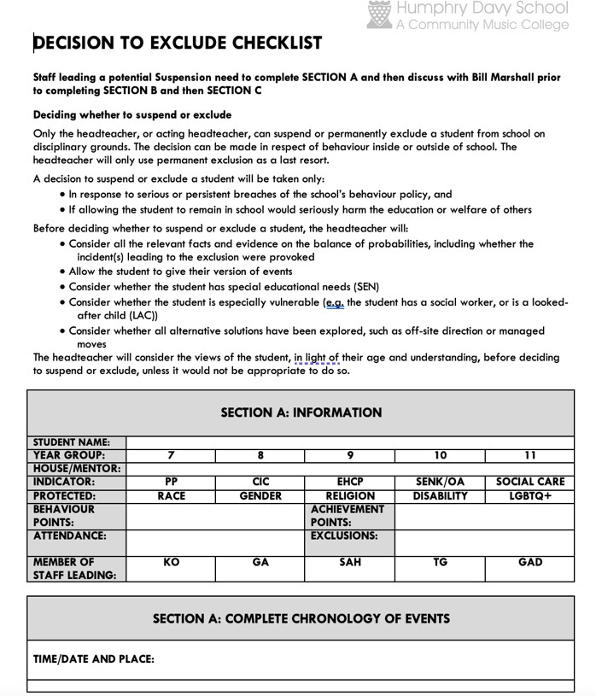
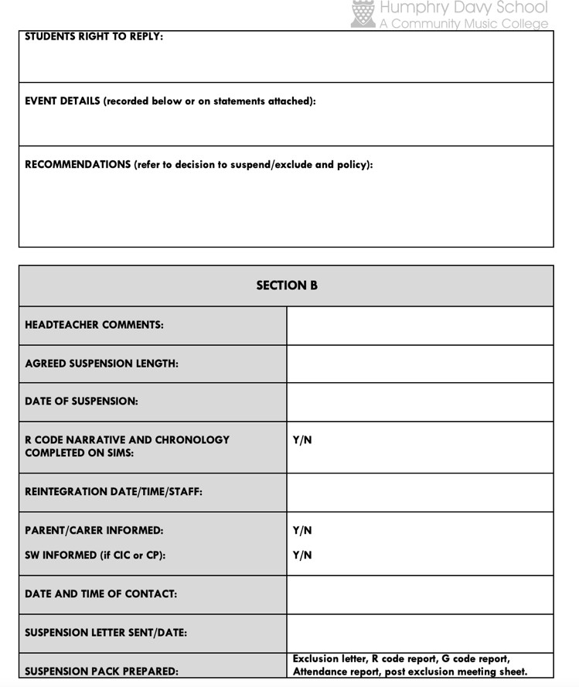

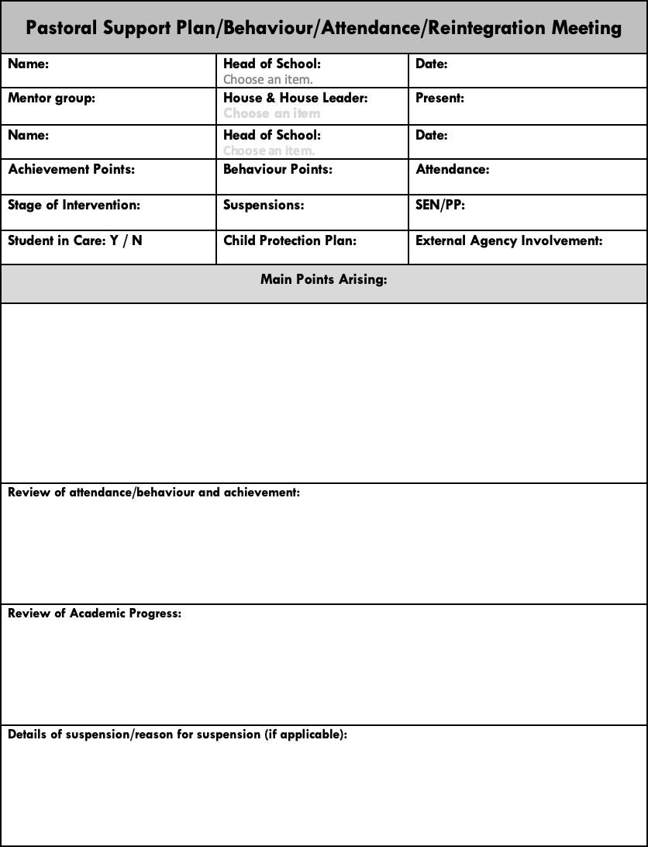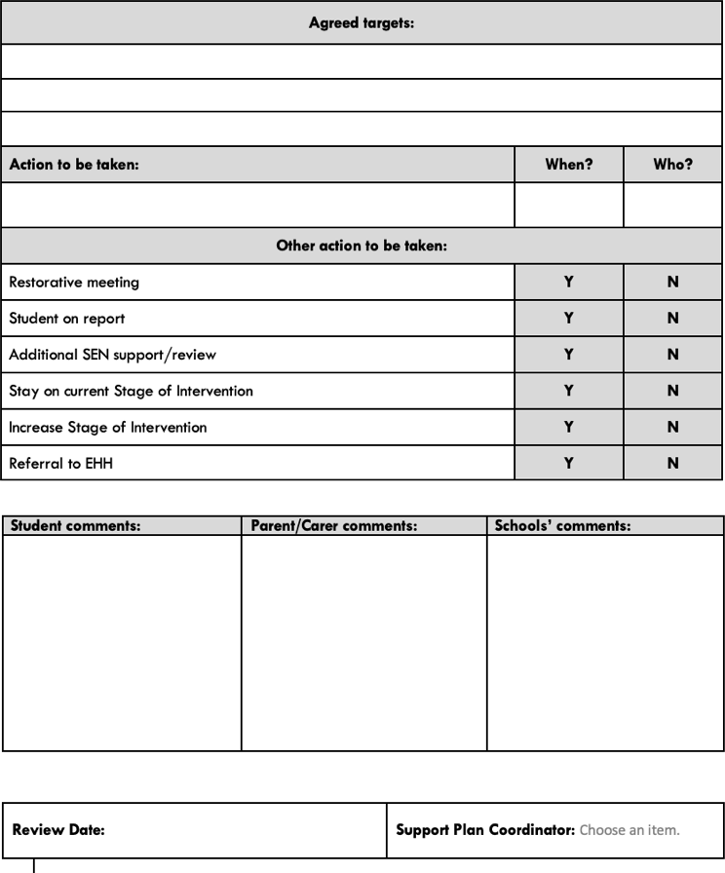

Appendix 3: Flow chart for exclusions
