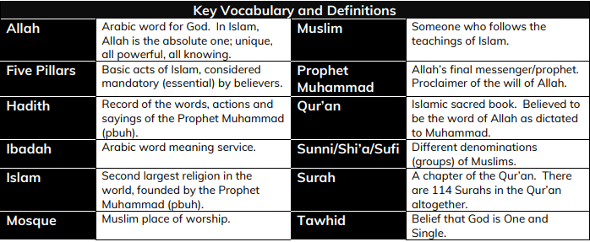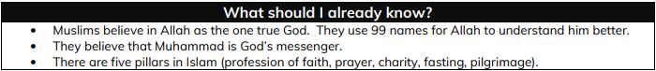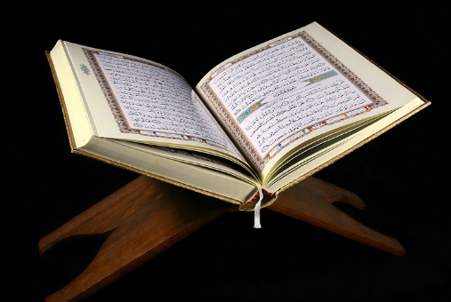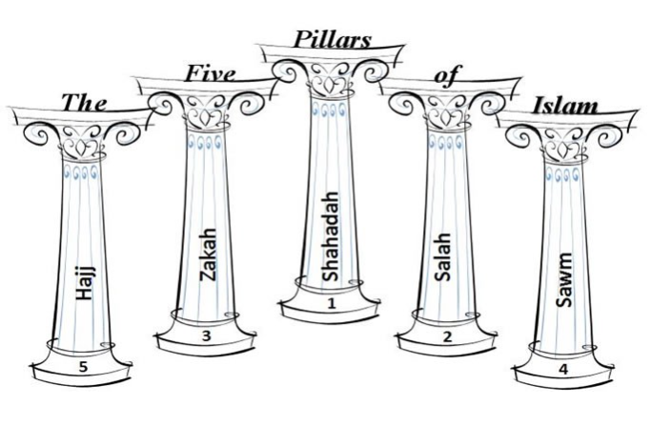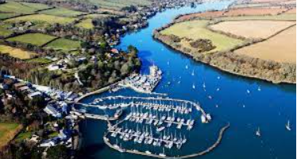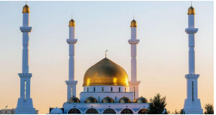

**What should I be able to do at the end of this topic?**

* Give some facts about Muslims in the UK.
* Understand the significance of the Qur’an.
* Explain why prayer matters to Muslims
* Summarise the Five Pillars of Islam.
* Know about the festival of Eid
* Describe what mosques are like, including what happens
* Discuss why charity is important to Muslims, making links with your own beliefs.
* Explain why Muslims fast during Ramadan.

The five pillars of Islam are essentials of the life of a Muslim. They are an expression of ibadah (worship and belief in action). The five pillars provide a structure for Islamic daily spiritual life. Muslims must not only believe in the five pillars, but also act on their beliefs.

The five pillars of Islam are:

* Shahadah - a belief in one God and Muhammad as God’s Messenger
* Salah - prayer, five times a day o
* Sawm – fasting during daylight hours in the month of Ramadan
* Zakat – the giving of alms
* Hajj – pilgrimage to Makkah (or Mecca)

**What should I be able to do at the end of this topic?**

**The Qur’an:** Muslims believe the words came directly from Allah and that they should follow the words and instructions of the Qur’an exactly. Muslims believe that the words of the Qur’an were revealed to the Prophet Muhammad (pbuh) through the Angel Jibril (Gabriel) in the desert near Makkah over 1,400 years ago. They believe that the Qur’an is God’s final message to humanity. The Qur’an is kept on a high shelf and Muslims wash before handling it. It is written in the Arabic language.

**MYLOR BRIDGE**

In the 2011 Census, of the 1720 people living in Mylor Bridge, there were only three that were Muslim.

In the Great Britain there are over 2 million Muslims (the third largest percentage after Christian and no religious preference.

What is a Mosque? A Mosque is a Muslim Holy Place of Worship. There are many physical features that can help you recognise a Mosque. However, not ALL mosques have to have them.

**What does it mean to be a Muslim living in Britain today?**