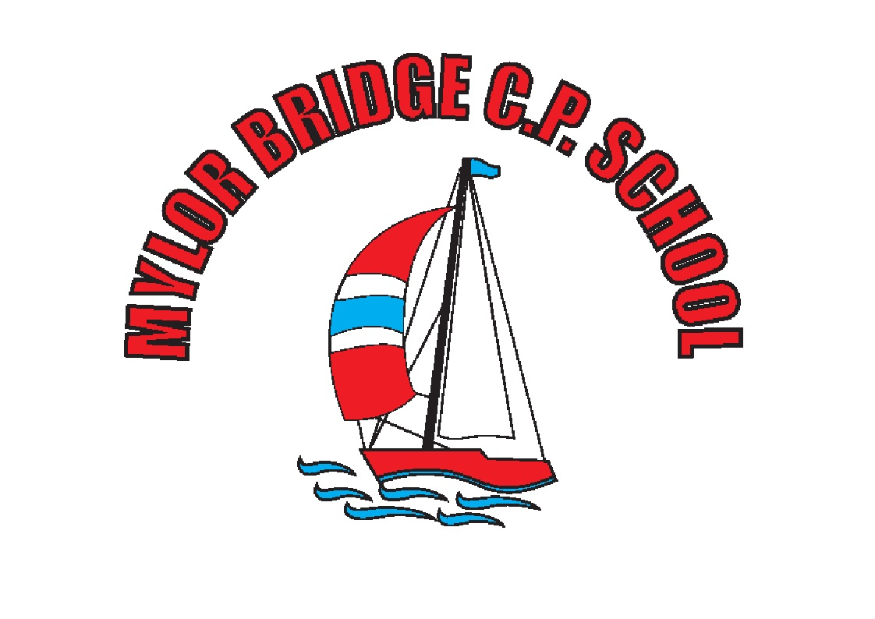
Who were the Vikings? Why did they invade Great Britain?

Background Information
When the quiet monks on the Holy Island of Lindisfarne saw the dragon ships approaching, they didn’t know what was coming. They were fully unprepared for the ferocity of the warriors, armed with sword, axe and shield. The attack and plunder of Lindisfarne, a rich and unprotected monastery, echoed throughout the next 300 years of European history. The Viking Age had begun.
Historians use the term the Viking Age to describe the turbulent expansion of the Scandinavian people
into Europe and Russia. Beginning in A.D. 793 with the Lindisfarne raid, Norwegians, Swedes and Danes set to raiding. Any unprotected community was a target. Vikings attacked places all along the coasts of Scotland, England, Ireland, France, Italy and inland Russia. They terrorized, plundered, traded, explored and finally settled and farmed all over the lands they encountered.

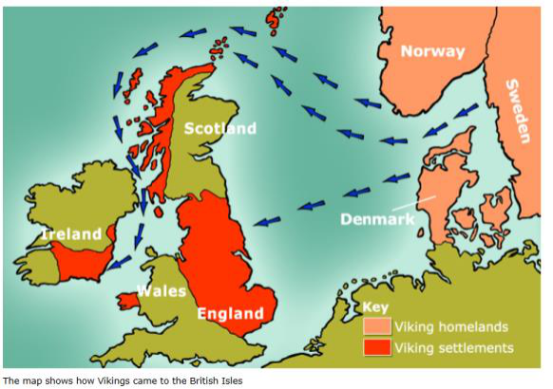
Key Vocabulary:
Anglo-Saxons: The main group of people living in Britain when the Vikings invaded.
Longship: A Viking ship used for fighting and carrying out
raids.
Monastery: A place where people who have dedicated their lives to religion, such as monks or nuns live.
Danelaw: The area of England ruled by the Vikings
Monastery: The building where monks live Thatched: A roof covered in straw
Trader: A person who sells goods

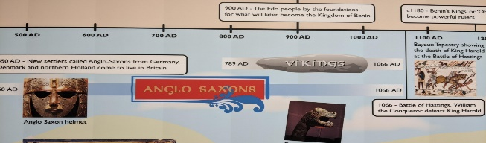

Key Questions

  - what image do we have of the vikings?
  - how did the vikings try to take over the country and how close did they get?
  - how have recent excavations changed our view of the vikings?
  - what can we learn about viking settlement from a study of place-name endings?
  - raiders or settlers: how should we remember the vikings?

