R.E: For Christians, what was the impact of Pentecost? (Kingdom of God).
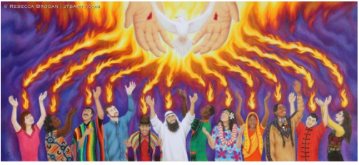
The solemnity of Pentecost celebrates what happened in Jerusalem 50 days after the resurrection of Jesus at Easter.
hih
VOCABULARY: Pentecost, Christian, worship, holy trinity, God, disciples, holy spirit, Lord’s prayer, Kingdom of God, heaven, resurrection,
Who or what do Christians think the Holy Spirit is?
Why do Christians think the Holy Spirit is important now?
Christians might say the Spirit of God is like a battery: Christians can’t do God’s work and live in God’s way without the Holy Spirit’s power.

How do Jesus’ disciples show everyone that God rules on Earth?
What happens next?

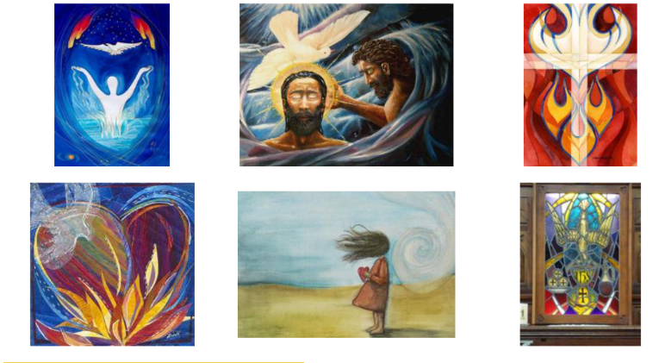
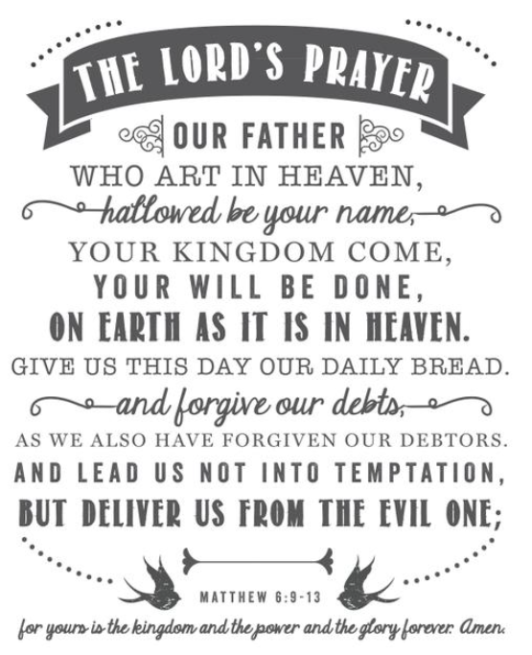
Make simple links between the description of the Day of Pentecost in Acts 2, the Holy Spirit and the Kingdom of God, and how Christians live their whole lives and in their church communities.

