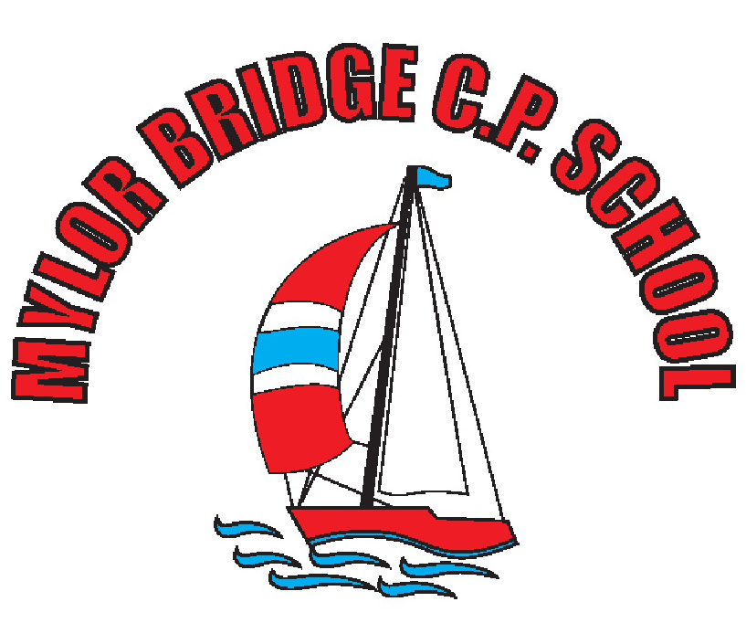
Mylor Bridge CP School
Early Years Foundation Stage
(EYFS) Policy

Contents
1. Aims
2. Legislation
3. Structure of the EYFS
4. Curriculum
5. Assessment
6. Working with parents
7. Safeguarding and welfare procedures

- Aims
This policy aims to ensure:
• That children access a broad and balanced curriculum that gives them the broad range of knowledge and skills needed for good progress through school and life.
• Quality and consistency in teaching and learning so that every child makes good progress and no child gets left behind.
• A close working partnership between staff and parents and/or carers.
• Every child is included and supported through equality of opportunity and anti-discriminatory practice.

- Legislation

This policy is based on requirements set out in the Statutory framework for the Early years Foundation stage (EYFS) that applies from September 2021.https://assets.publishing.service.gov.uk/government/uploads/system/uploads/attachment_data/file/974907/EYFS_framework_-_March_2

- Structure of the EYFS

In Mylor Bridge CP School, our Early Years provision includes places for 20 children in our mixed EYFS/ Year 1 class (approx. 10 children) (Class 1)
Our EYFS children share a large classroom with half of our Year 1 Children. We have a newly updated outdoor area which is used predominantly by the children in Class 1, but is also shared with the children in Class 2.

- Curriculum

Our Early years setting follows the curriculum as outlined in the latest version of the EYFS statutory framework that applies from September 2021.

The EYFS framework includes 7 areas of learning and development that are equally important and interconnected.
However, 3 areas known as the prime areas are seen as particularly important for igniting curiosity and enthusiasm for learning, and for building children’s capacity to learn, form relationships and thrive.

The prime areas are: September 2021
• Communication and language
• Physical development
• Personal, social and emotional development

The prime areas are strengthened and applied through 4 specific areas:
• Literacy
• Mathematics
• Understanding the world
• Expressive arts and design

  - Planning
The EYFS at Mylor Bridge provides a happy, safe, caring, stimulating, well -resourced and well organised environment in which children learn by building upon what they already know and can do.

The staff at Mylor Bridge School carefully observe the children in their care, consider their needs, their interests, and their stages of development to help to plan and deliver a challenging and enjoyable experience across all areas of learning and development. In order to do this, staff working with our youngest children are expected to focus strongly on the 3 prime areas.

When planning and guiding activities, staff reflect on the different ways that children learn and include these in their practice. Where a child may have a special educational need or disability, staff consider whether specialist support is required, linking with relevant services with other agencies, if appropriate.

  - Teaching

Each area of learning is implemented through carefully thought out and planned, purposeful play, and through a mix of adult-led and child initiated activities. Our staff are able to respond, knowledgably, to each child’s needs and interests, and learning styles, guiding their development through caring, and positive interactions. Our outdoor provision mirrors the opportunities available to the children in inside offering a mix of adult led and child initiated learning.

- Assessment

At Mylor Bridge School, ongoing assessment is an integral part of our learning and development process. Staff observe pupils to identify levels of achievement, interests, learning styles and needs. These observations are used to shape future planning. Staff also take into account observations and concerns shared by parents/ carers.

Within the first half term that a child starts in the EYFS, staff administer the Statutory Baseline Assessment. (RBA, May 2021)

Staff use a range of assessment tools to inform them of a child’s progress towards achieving Early learning goals.
At Mylor Bridge School we use Tapestry, Master the curriculum end of block assessment and children’s books to record progress and the characteristics of effective learning.

At the end of the EYFS, staff complete the EYFS profile for each child. Pupils are assessed against the 17 early learning goals, indicating whether they are:

- Meeting expected levels of development
- Not yet reaching expected levels (‘emerging’)

The profile reflects ongoing observations, involving all staff members of the Class 1 team, and discussions with parents/ carers. The results of the profile are shared with parents/ carers for their child.

The profile is moderated internally (referring to the Development matters guidance) and in partnerships with other local schools, to ensure consistent judgements. EYFS profile data is also submitted to the local authority.

- Working with parents
Key to ensuring high quality early years experience is to ensure continuity between all settings and to ensure that the children’s social, emotional and educational needs are addressed appropriately.
At Mylor Bridge School, transition is seen as a process, not as an event and is planned for and discussed with parents, children and practitioners of the pre-school settings that the children of Mylor Bridge School attend.
At Mylor Bridge we also recognise that parents are the children’s first and most enduring educators and that when parents and practitioners work together the results have a positive impact on children’s development and learning. We encourage parent partnership through:
• Showing respect and understanding for the role of the parent in the child’s education • Listening to accounts of their child’s development and any concerns they may have
• Making parents feel welcome by being friendly, approachable and having an open door policy
• Maintaining an on-going dialogue
• Being flexible in arrangements for settling children in
• Meeting with parents of Reception children regularly to discuss progress
• Inviting parents in to share their child’s Learning Journal and see a range of work
• Through the use of Tapestry, an online learning journal which parents can access at home
• Encouraging parents to make use of the home/school reading diary which is looked at daily by an EYFS staff member
• Inviting parents in the school to share their specialised skills
• Inviting parents to accompany staff on trips. We recognise that children learn and develop well when there is a strong partnership between staff and parents and/or carers.
- Monthly groups reading sessions for parents and carers
Parents and/or carers are kept up to date with their child’s progress and development.
The progress check and EYFS profile helps to provide parents and/or carers with a well-rounded picture of their child’s knowledge, understanding and abilities.

- Safeguarding and welfare procedures
It is important to us that all children in the school are ‘safe’.
We aim to educate children on boundaries, rules and limits and to help them understand why they exist.
We provide children with choices to help them develop this important life skill. Children should be allowed to take risks, but need to be taught how to recognise and avoid hazards.
We aim to protect the physical and psychological well-being of all children. We know that children learn best when they are healthy and safe, when their individual needs are met and when they have the chance to build positive relationships with the adults around them and their peers. The rest of our safeguarding and welfare procedures are outlined in our safeguarding policy.

