Science at Mylor Bridge CP School

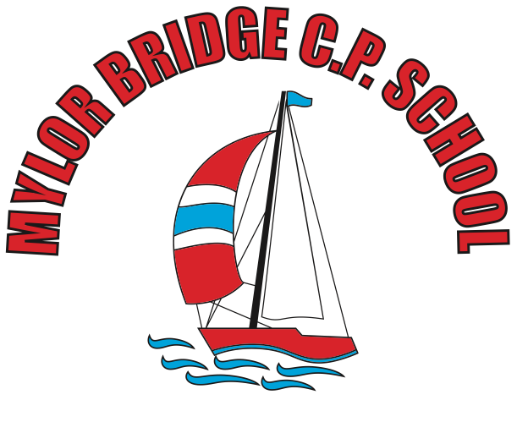

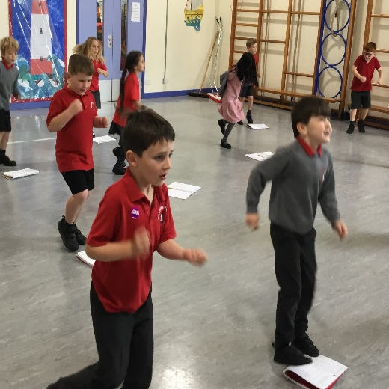
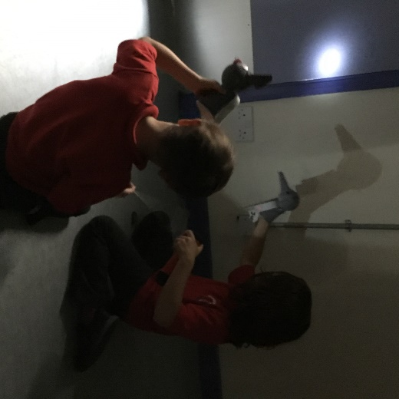

September 2023

Mylor Bridge School’s Science Vision
At Mylor Bridge School, our vision is to ignite scientific curiousity and encourage children to explore and discover the world around them.
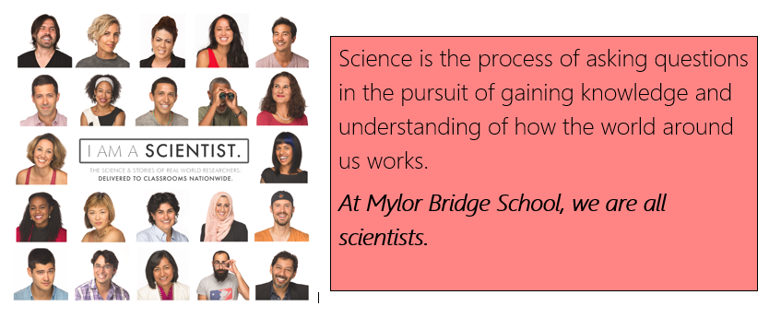

Objectives and Aims
At Mylor Bridge School, we follow the objectives of the National Curriculum. Our statement for intent can be found in the coordinator file as well as on the school website. The framework for the 2014 National Curriculum aims to:

Resources
Teachers use a variety of resources, both interactive and physical, to support our learners. Teachers use various resourcesto create our POP quizzes (see assessment). At Mylor Bridge School, we have a range of scientific equipment stored centrally in the cupboard. This is checked annually and updated when necessary to ensure our lessons can be enhanced with practical resources that support learning and allow the opportunity for children to design their own experiments based on their own lines of enquiry.
We have subscribed to Developing Experts to supplement our planning and use resources from the website to support our lessons.
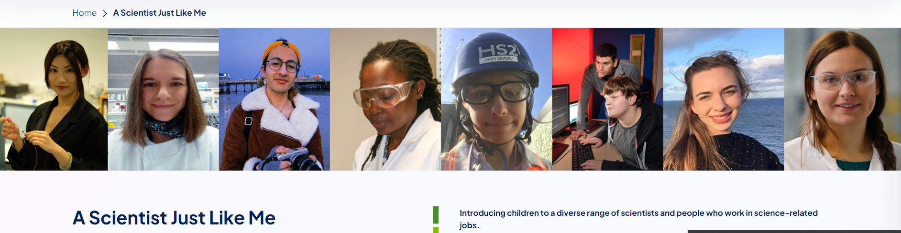
Enquiry Boxes
Each enquiry lesson has a bespoke enquiry box with resources that will supplement the learning taking place. The box comes with a specific question but these can be changed as children take ownership of their learning.
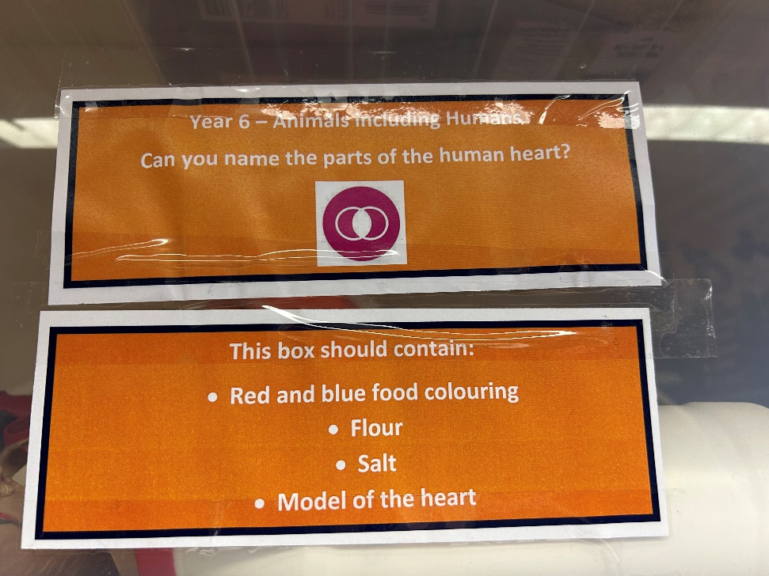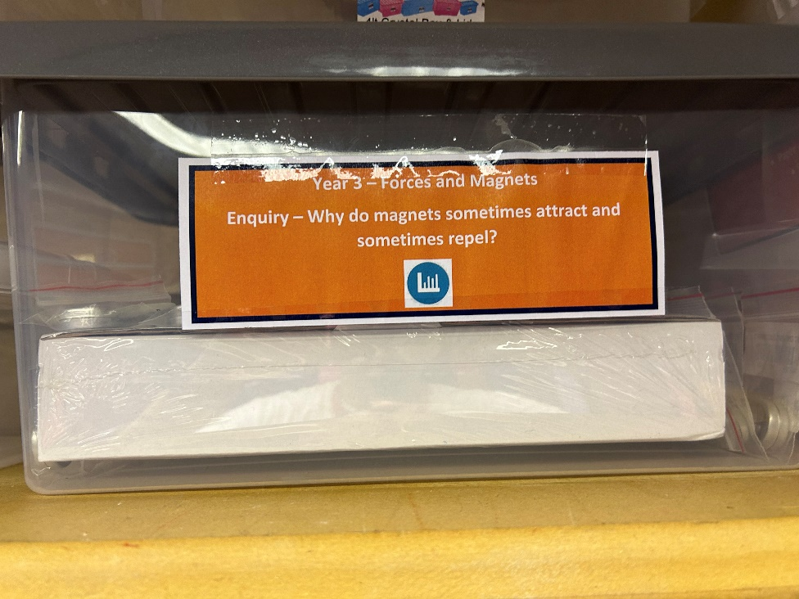

Teaching and Learning Style
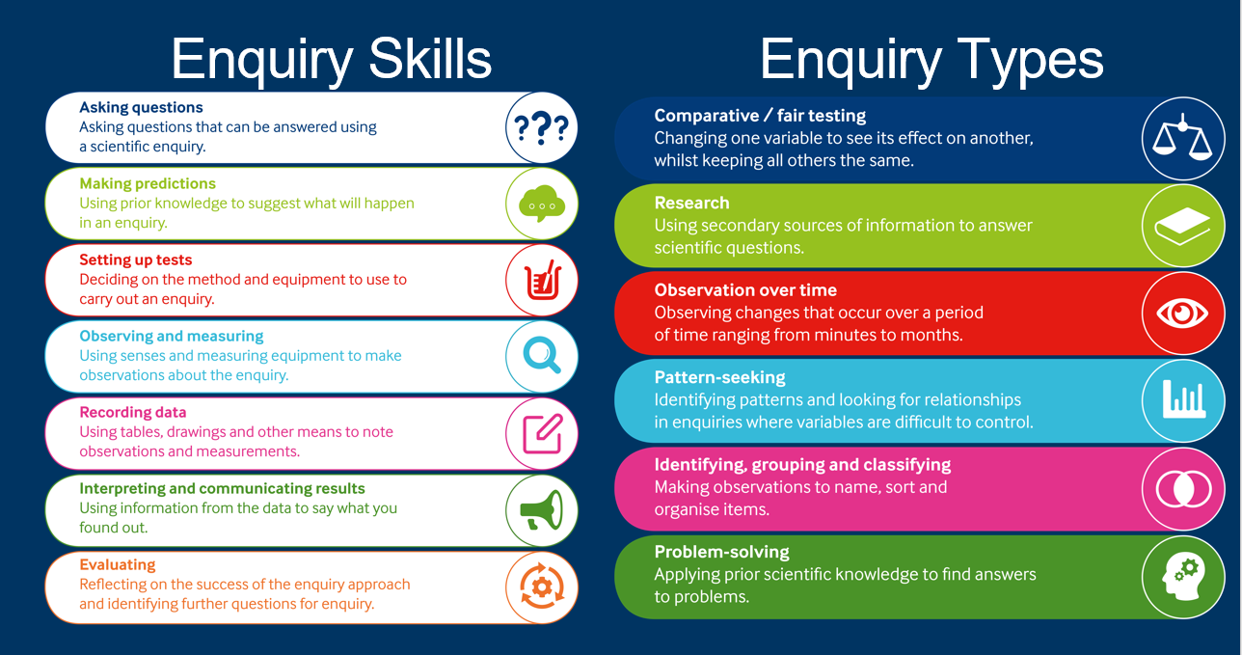
At Mylor Bridge School, we use the enquiry types designed by the Primary Science Teacher Trust to ensure our children are experiencing a range of activities during their time at our school.
These enquiry types have been mapped out across phases to ensure that each two year phase has at least two of each enquiry type.
We encourage our children to see themselves as scientists and the skills identified by the Primary Science Teacher Trust (above) are documented at the end of each lesson. We have the working scientifically butterfly (see next page) on our Science walls and class teachers mark on the butterfly in which lesson a skill has been used.

Teachers provide stimulating and engaging lessons that encourage a variety of different skills to enable the opportunity for all children to work at the best of their ability. The lessons will, when appropriate, provide a ‘real-life’ feel and apply the skills and knowledge to relevant everyday activities.
A Science lesson at Mylor Bridge School looks like:
- Recaps of prior learning (both from previous year groups and previous lessons)
- Sharing of key vocabulary (including reference to the unit knowledge organiser)
- The sharing of a scientist (using Developing Experts or A Scientist Just Like Me)
- Encouragement of children to use scientific language and ‘science talk’
- A range of resources to support learning and promote opportunities to discuss
- Encourage the children to be curious and channel this curiosity in enquiry task

Below demonstrates some of the slides used in lessons that follow this lesson design. This is consistent across the whole school.
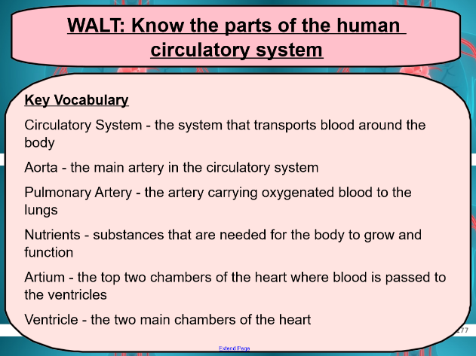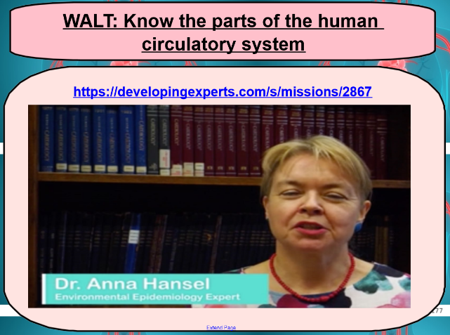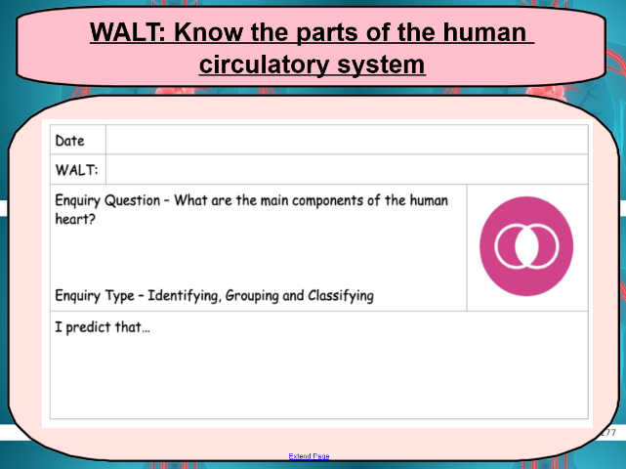

Golden Threads of Our Curriculum
- Important scientists and their impact in our world
- Cycles - how scientific processes repeat themselves
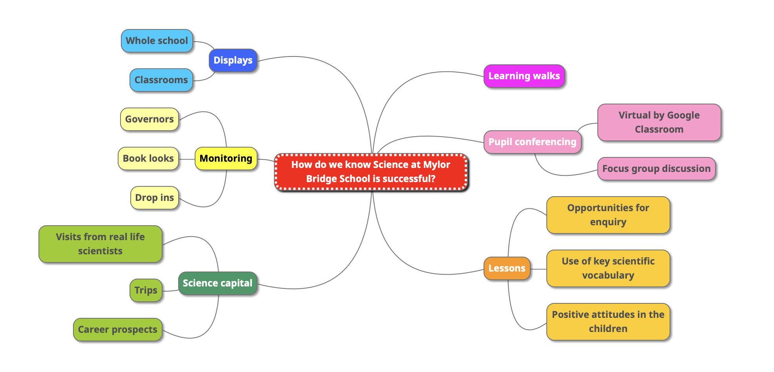
- Classification - why are things what they are?

Planning
Using the 2014 National Curriculum objectives, teachers plan for the short-term, medium-term and long-term. Our planning is supported by the Chris Quigley Essentials Curriculum and allows us to take advantage of our locality to support and engage our learners. Due to the nature of the Science curriculum, teachers ensure that skills are built on and developed, allowing consistency in approach to teaching and learning in our school.
Science in EYFS
In EYFS, the children are given opportunities to work scientifically in various activities. This primarily falls under the ‘Understanding the World’ area of learning. We use resources from Developing Experts to give the children in EYFS the chance to ask questions, discuss their discoveries by interpreting and communicating their results and explore their own interests to develop scientific skills.
Assessment
Each class teacher creates a POP quiz at the end of each unit to see if the children have understood the objectives taught. This is coupled with observations from the class teacher in lessons and as well as scrutinising work in books. During each unit, class teachers provide opportunities for the children to enquire and work scientifically. These are designed to allow the children to explain, demonstrate and/or describe what is taking place. Key questions are prepared by the teacher to encourage scientific vocabulary when the children are answering. This oral response may be recorded in written form, recorded with audio devices or scribed by adults in order to show evidence.

Children with SEN
At Mylor Bridge School, we teach Science to children of all abilities and needs. Science is a crucial part of our curriculum and helps provide a broad and balanced curriculum for our children. We use a mixture of TA support, mixed ability working groups and open ended activities to allow children with SEN to get the most out of their primary Science education.
Monitoring
As part of the Science coordinator’s role, they are responsible for monitoring the successes in our teaching and learning and supporting colleagues in the teaching of Science across the school. This could be providing opportunities for CPD (continuing professional development), informing and updating colleagues about upcoming changes to Science and provide a direction for the subject as we move forward.
The subject leader monitors termly by lesson drop-ins, book looks and pupil conferencing. This information is then fed back to staff in staff meetings. Following this, the subject leader meets with the Science Governor so they are up to date with what Science looks like at Mylor Bridge School.

