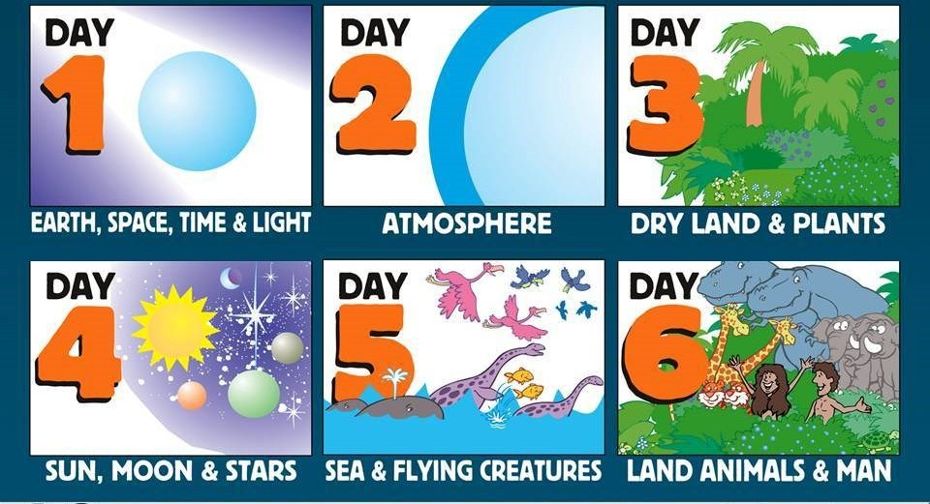
The Christian creation story is in Genesis, the first book of the Bible. It shows Christians that God created the world from nothing in just 6 days, resting on the 7th day. God is believed to have asked humans to look after the rest of creation which meant they had responsibility to look after the Earth and all its inhabitants.
Christians believe that God the Creator cares for his creation, including human beings
Christians believe that as humans do best when they listen to God.
The Bible shows that God wants to help people to be close to him
Christians believe God made our wonderful world and so we should look after it.
The Bible tells a story (in Genesis 3) about how humans spoiled their friendship with God (called ‘The Fall’)
The Fall means that humans can’t get close to God without God’s help
Christians believe it is important to say sorry when they do something wrong and ask God for forgiveness through prayers.

VocabularyChristianA person who believes in and follows the teachings of Jesus Christ. GodFundamental to Christian belief is the existence of God: Father, Son and Holy Spirit Christians believe that God is all powerful, all knowing and eternal.CreationChristians believe that the universe and human life were created by God. Humans are made in the image of God. BibleThe Christian holy book, which is made up of two main parts: the Old Testament (the law, prophecy and writing of the Jewish people) and the New Testament (the Gospels, letters and stories about Jesus). GenesisGreek word meaning ‘beginning’. Genesis is the first book in the Christian Bible. The FallThe separation between God and humans, caused when Adam and Eve disobeyed God and ate the forbidden fruit. When they fell from their state of innocence they brought sin into the worldCreatorChristians believe that God is the creator of the world and everything in it. ForgivenessTo stop blaming or being angry with someone for something they have done, or not punish them for something

.
Y3 Knowledge Organiser: The Christian Story of Creation

