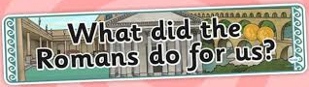
Knowledge Organiser: The Roman Invasion of Britain and its impact
Key Questions
Why were the Romans so powerful?
Why did the Romans want to invade Britain?
How significant were the Romans for Britain?
What was the significance of Boudicca’s revolt?
What was life like in Roman Britain?
Why did the Roman Empire Fall?

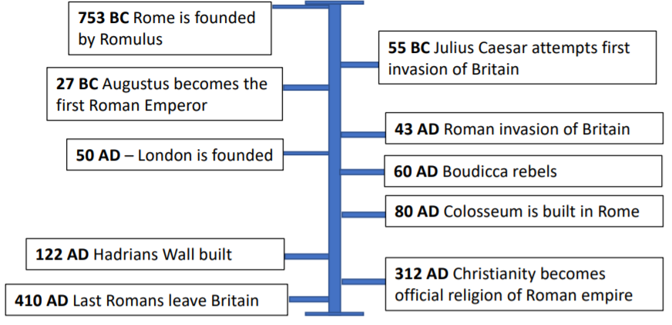
Chronology – the arrangement of dates or events in the order of which they occurred
BC – Before Christ. A way of dating years before the birth of Jesus. The bigger the number BC, the longer ago in history it was.
Anno Domini – ‘In the Year of Our Lord’. AD is used to show dates after the birth of Jesus. This year is AD 2019.
Archaeology - The study of the buildings, graves, tools and other objects that belonged to people who lived in the past, in order to learn about their culture and society.
Historical Evidence – Anything left over from the past is a source of evidence.
Boudicca – A Celtic queen famous for rising up against the Roman occupation in AD60 or 61
Roman Empire - The ancient Romans were based in Rome in Italy, but they ruled over land that stretched far beyond the borders of Rome. This was called the Roman Empire.

Roads, aqueducts, calendar, mosaics, Colosseum, Roman numerals, Bath houses, sanitation, religion, language, writing, number, towns

