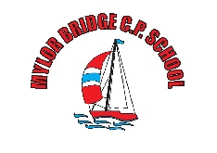
Mylor Bridge School
Date | Impact
20.9.21 | - Received update on the return to school and the plans for the year.  - Governance for the year was agreed.  - Ratifying of policies  - Understanding of attendance data  - Understanding and plan for staff absence.
20.11.20 | - Feedback from lock-down received.  - Remote learning plans were in place.  - Data projections were positive.  - School team was praised for continuing as normal whilst dealing with the impact of Covid.  - It was evident the wellbeing of the children was being looked after.
15.3.21 | - The Board gained an understanding of the standards and attendance data.  - The Budget and spending of other funding was discussed and challenged.  - This is the first opportunity for the Board to review the situation since lockdown.  - The Board are at full membership.
19.7.21 | - Data review and Ofsted planning for school and governors.  - Approval of PP plan and ICT policy.  - Budget was scrutinised.
Governor Impact Statement 2020-2021

