Context of the School

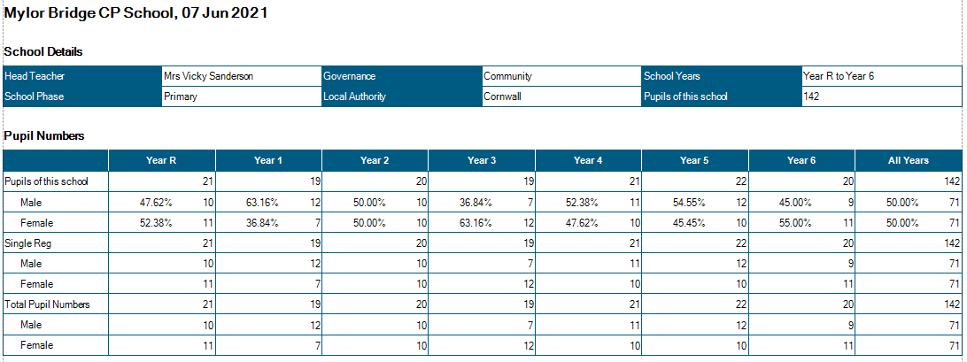

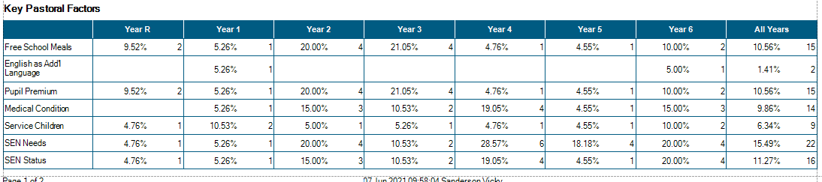

Attendance

Average attendance: 97.5%

4 children persistent absence (PA). Letters have been sent to families where PA has been flagged as a concern. See Attendance report.

From 8th March, classes resumed as follows:

Class Structure from
March 2021
Class 1:  EYFS -20 Year 1 - 10 | Mrs Mogridge (Mon – Wed)  Mrs French (Thurs-Fri)  Mrs Evans TA 08:45 – 3.00 pm  Mrs R Wilkes r 1:1 TA 08:45 – 3.00 pm  Miss Short TA 08:45 – 12.00 pm
Class 2:  Year 1 – 11 Year 2 – 16 | Mr Shainberg  Mrs Armstrong TA 9.00 – 3.15  Mr Collier 1:1 TA 9.00 – 3.15 pm
Class 3 Year 3 - 19 | Mrs Thomas (Mon-Wed)  Mr Sanderson (Thurs-Fri)  Mrs Medlin (9.00 – 12.15 pm )
Class 4 Year 4 - 21 | Mrs Wood  Mr Wilcox 1:1TA (M-F 9.00 – 3.15pm)
Class 5 Year 5 – 19 | Mr Martin  Mrs Stevens (Tues -Thurs – Fri 9.00 – 12.15 pm)
Class 6 Year 6 - 18 | Mr Collinge  Mrs Garland (Tues – Thurs 9.00 - 12.15)
PPA Cover  Subject leadership cover | Mr Mutsauers – PE Classes 2/4/5/6  Mrs Hamilton Classes 2/5/6  Mr Wilcox Class 4  Mr Mustaeurs
Intervention | Mrs Hamilton Monday 2.00 – 4.00pm Tuesday – Friday 1.00 – 4.oopm
Intervention | Miss Short Tues – Fri 1.00 – 2.30

Please note, guidance from the DFE states that all restrictions for primary schools are to remain in place, including staggered drop off and pick up times.

Significant Changes/Challenges Since the last Head Teacher’s Report

- Pupils have returned to school very positively.
- 1x member of FT teaching staff has requested to continue part time. Adverts have been placed for a job share and 1 candidate has applied. 12 month contract. This will mean 50% of classes have a job share. Significant discussions with these members of staff have taken place to ensure effective handover, planning and assessment.
- 1x TA has requested a reduction in hours – an advert has been placed.
- End of term assessments have taken place in KS 1 and KS 2 and Phonics screening checks will take place at the end of June– see results.
- Y5/6 residential to BF adventure taken place
- Y4 visit to Eden taken place
- Visitors in school have been welcomed back
- Well being week has been planned – (time table to be tabled at meeting)
- Clubs within bubbles have resumed.

- New resources of Art and Design, and DT have been purchased to help support subject teaching.
- Spell Shed and Maths Shed have been purchased to help support the teaching of spelling and Ready to Progress skills in maths

Quality of Education.

- Drop Ins from HT this half term, show that pupil engagement remains high – with very high engagement seen in a number of classes – notably, Class 1.
- Continued work on curriculum development, ensuring progression and coverage remains high profile on the School Development Plan (SDP) Subjects monitored this term: History/ PSHE/ Geography/ RE/ See feedback.
- Monitoring of English and Maths books by the HT, shows that pupils are using a wide range of resources, including concrete materials. Ready to Progress materials have been used in Maths to ensure that children are ready for the next year group (in line with government guidance).
- Close monitoring and assessment shows that the previously lower attaining and SEND pupils are the groups who have most suffered academically during the lockdown.
- High quality and well-planned intervention has been in place from the return of school in March. Results from this intervention has been encouraging, with pupils gaining in confidence and academic achievement – though progress within these intervention groups is slow for those with SEND.
- Resilience in pupils who attend these interventions, is in the main extremely high – with some pupils attending 3x weekly afterschool intervention.
- In KS1 intervention was focussed on phonics and nurture.
- All teachers have planned a full curriculum – to ensure breadth and balance. Feedback from monitoring shows gaps in RE coverage this year.
- The plan for child who need to isolate at home due to COVID19 remains in place – accessed through the website – active from 8.3.21
- Assessments in the form of Proof of Progress (POP) quizzes have been re-introduced for Science/ Geography/ History/ RE. Also in Y3, trialling for DT/IT/
- Ready to Progress assessments have taken place in Maths – and gaps are now being filled before moving onto the further focus areas.
- Reading and writing assessments have also taken place which have been used to identify gaps.

- Issues arising:
Less progress evident in writing esp. handwriting and presentation.
Spelling
RE coverage
Larger gaps evident between those working at expected standard (exs) and those children working towards this standard (WTS) and those with SEND.

Behaviour and Attitudes

- Feedback from pupils about returning to school has been positive. Notable requests from pupil conferencing include: more non-fiction texts in the library, more visitors and visits, more real-life experiences.
- No significant behaviour issues have arisen since the return to school.
- Some children who accessed key worker provision have found the transition back to full school trickier – due to changes in social groupings and also having the share the adults in class again.
- Subject conferencing in History/ Geography/ RE/ PSHE shows that pupils are able to remember aspects of the learning from lock-down, that they enjoyed some aspects of this learning and that they were able to recall and use some of this learning when back in school. Work needs to continue on ensuring pupils have time to recall and reflect on previous learning
- 1x member of staff completing Trauma Informed Schools training
- VS continues to work with 3 x schools in the Southerly Point MAT

We currently have:
- 1 x child with a Special Guardianship Order
- 1x child with active court order.
- 1x child is currently working with social care
- 1x Team Around the Child (TAC) plan in place
- 1x EHH referral since the last HT’s report
- 1 x ASD referral
- 1 x ADHD referral
- 2 children working with CAMHS
- 2 x requests for ASD support in school.

- There have been no Incidences of team teach physical intervention this half term.

Personal Development and Cultural Capital

- We have completed our work with Primary Futures – in which the children were able to meet with (virtually) 9 different professionals, in order to hear about their different career choices, where they work and what they enjoy about their professions. The feedback from the children was incredibly positive, with many children statin that they didn’t know that many of the professions shared (eg geologist) existed, let alone existed in Cornwall.
- British Vales (BV) are taught through all curriculum areas, with a focus on the PSHE curriculum wherein BV are highlighted every week and a map of coverage is in place to ensure that we meet these foci. This half term our assembly focus is on 20 Century Icons – with a sub-text of equality and diversity.
- Andrew Martin is tasked with linking our school to a range of other schools across the world – through registration with the British Council – the time scale for this has been increased due to schools globally being disrupted.
- Y1 children continue to access forest school provision at Eyns Woods – financially supported by The Barring Foundation.
- Children continue to eat lunches in the classrooms (KS2) which allows weekly updates on current affairs and world news. This time is also used to further support English – through listening to the class text.
- Playtimes continue to be split by bubbles and this allows very positive play for our children – in a space that is not so crowded and dominated by football.
- The playground equipment has been installed and the children LOVE it. This equipment is promoting physical fitness as well as peer cooperation, self-challenge and fun!
- Year 5/6 residential to BF adventure has taken place. The children took part in a variety of outdoor and adventurous activities (OAA).
- Well Being week has been planned and booked (subject to COVID restrictions not being reintroduced)
All activities have been planned to promote and develop children’s cultural capital.

In order for staff to continue to remain up-to-date and be empowered to move our school forwards, a comprehensive, SDP-based CPD programme has been put into place – however due to COVID19 restrictions much of this learning is on hold.

CPD: This year to date:
Matt Collinge and Andrew Martin have attended Maths Hub Training
All staff have completed Tier 1 safeguarding update.
All staff have completed in house attachment disorder training and separation anxiety training
All staff have completed APDR training
Kate and Matt have had some time with our SENCo to discuss her role.
VS worked with the CC H+S officer to complete audit of our school.
Sophie has completed first aid at work training.
VS – SIP training.
VS – supported HT appraisal process @ Mawnan School
VS – working with Kernow Teaching School and SIP advisor
SW – Enrolled on Trauma Informed Schools Training (completed 2x days)

All teaching staff have updated training on identification and support of SEND pupils.
VS – curriculum update and reading training
AM – Safeguarding training
SM – Educational Visits Training
KF and KM – new EYFS update
Class 1 Tas – in house EYFS update
RW and AS – completed level 3 Teaching Assistant qualification
LS - accepted onto ITT access course. (Sept)

Effectiveness of Leadership and Management

Focus for this year – in line with the OFSTED guidelines – has been the remapping of the curriculum to ensure that we have a broad and balanced offer.
Staff have audited and re-mapped content to ensure progress and coverage – supported by the Essentials Curriculum. Now, we need to ensure that we can answer questions about our subjects such as ‘ Why do we study the Ecuadorian rainforest in Y1 an not the Australian rainforest?’ Time for these focus questions has been set for Sept INSET.
Monitoring of lessons by the HT and subject leaders has recommenced, with History/ PSHE/ RE and Geography having taken place last half term , and English, Maths and IT being planned for this half term. Reports from monitoring have been shared with staff and governors.
English moderation has shown that writing, inc handwriting, continues to be a focus. Where the model text for writing has been closely followed, the results are more positive than when children are allowed to write with less structure, however feedback from the upper KS2 pupils is that they don’t like this heavy structuring. Jacque Thomas continues to lead on English and is working with staff to over come this.
Andrew continues to work with the Cornwall and West Devon Maths Hub and regularly disseminates this learning.

Mark Lees has been welcomed to school as our new School Improvement Partner, visiting us on the 15.3.21. His visit was very positive – please see feedback attached.

