Visitor Procedures

- Visitors must sign in at the Main Office.

- Visitor badges must be worn at all times whilst on the school site.

- Visitors should remain under the supervision of a designated member of staff whilst on site.

- All visitors must sign out at the main office and return their visitor pass before leaving the site.

Visitors wishing to speak to a particular member of staff should telephone the school to make an appointment, wherever possible.

If you are seeking an urgent appointment please report to the main office and we will arrange for you to see a member of staff on duty.

Photographs

The use of personal phones by anyone is not permitted unless there is an emergency.

Governors
Governors are aware of their role in safeguarding children; review the Safeguarding Policy annually and ensure independent contractors have the required child protection procedures.

Online Safety:
See Online safety policy

Safeguarding Statement:

We are committed to safeguarding and promoting the welfare of children. We expect all staff, volunteers and visitors to share this common commitment.

This leaflet contains information about our expectations of you whilst visiting the school. If you are unclear about anything in it please speak to any of the contacts named within. Please keep the leaflet in a safe place so that you can read it again if you need to.

If you are concerned about the safety of any child in our school, you must report this to one of the Designated Safeguarding Leads (DSL).

If you are concerned about the conduct of a member of staff or volunteer in your school (Allegations against Staff / Whistleblowing Policy), you must contact Headteacher Vicky Sanderson

Designated Safeguarding Lead:
Vicky Sanderson
Deputy Designated Safeguarding Lead: Andrew Martin

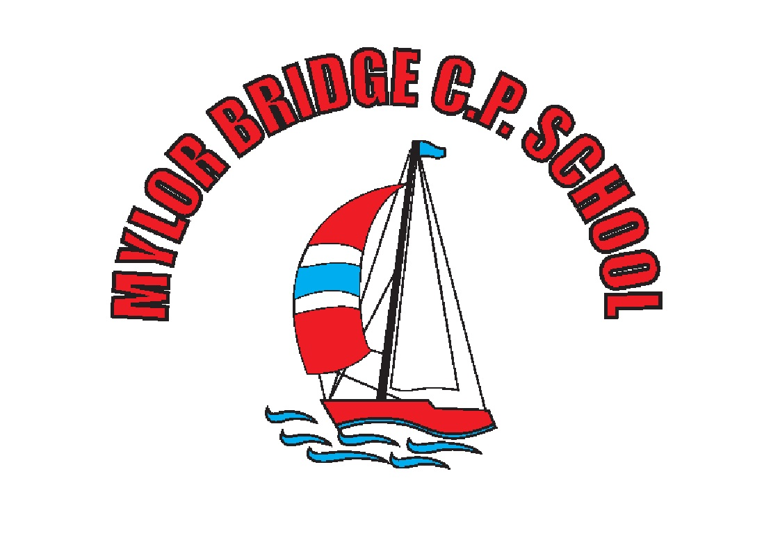

Safeguarding
Information Leaflet

for
School Visitors

All staff and Governors at Mylor Bridge School fully recognise that they have a duty to ensure arrangements are in place for safeguarding and promoting the wellbeing of children (Section 175 of the Education Act 2002). We adhere to the L.A’.s Safeguarding Children Board Procedures and Keeping Children Safe in Education 2021 (KCSIE)

secretary@mylor-bridge.cornwall.sch.uk
01326373724

January 2022

If a child discloses they might be subject to abuse:

- React calmly

- Listen carefully to the child, particularly what is said spontaneously.

- Do not promise confidentiality. Explain to the child that you must pass on the information if you are worried about their safety.

- Do not ask leading questions or make judgements. Clarify and check your concern if you feel that you are not sure, by using, for example, ”tell, explain, describe or outline” but as soon as you believe that there might be a genuine issue, ask no further questions. This would compromise further enquiries.

- Reassure the child that they are doing the right thing.

- Record carefully what the child says in their own words including how and when the account was given. Date, time and complete a Concern Form which is available from the Main Reception. This will be passed on to one of the Designated Safeguarding Leads.

If you feel that a child may be at risk of harm but are not sure, then inform one of the Safeguarding Leads immediately. They will offer advice and take appropriate action.

Child abuse can happen to any child regardless of elements such as gender, culture, religion, social background, ability of disability.

A copy of the schools Safeguarding Policy is located in the school staff room.

Types of harm

We all have a responsibility to keep children (under the age of 18) safe, both at home and in school. Harm is identified in four ways:

Physical - when a child is deliberately hurt or injured.

Sexual - when a child is influenced or forced to take part in a sexual activity. This can be a physical activity of no-physical, e.g. being made to look at an inappropriate image.

Emotional - when a child is made to feel frightened, worthless or unloved. It can be by shouting, using threats or making fun of someone. It can also be when children see their parents, or visitors to the home, fighting or using violence.

Neglect - when a child is not being taken care of by their parents/ guardians. It can be poor hygiene, poor diet, not keeping appointments for additional support, not coming to school are being left home alone.

Vulnerable adults (over the age of 18) are at risk of being abused, harmed or threatened. Any concerns about a young person or an adult should be reported to the Safeguarding Lead.

Staff Conduct

If you are concerned about the conduct of a member of staff, following an observation or disclosure, the following actions must be taken:
- Immediately inform the Headteacher

- In their absence, immediately inform the Assistant Headteacher

Keeping Yourself Safe

- Be professional. Be careful how you interact with or speak to a child, the child may interpret it differently.

- Avoid physical contact with children unless you are preventing them from immediately harming themselves or others.

- Avoid being on your own with a child, always ensure that a door is open and that you are visible to others.

- It’s best not to do anything for a child the he or she can do for himself or herself. Always tell someone if a child touches you or speaks to you inappropriately. Log down the incident, time and date it and pass it on to one of the Safeguarding Team.

- If you have concerns about the conduct of staff, it is your responsibility to inform the Principal.

Remember...if in doubt...ask

