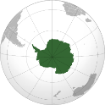
Poles Apart!
KNOWLEDGE ORGANISER
Map and Overview |  |  | Human Geography Features
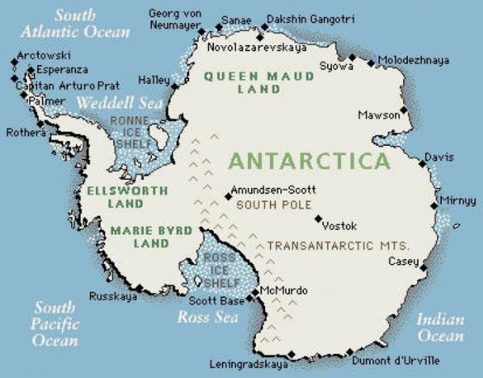  -Antarctica is the world’s southernmost continent. It is the location of the geographic South Pole.  -Antarctica is the fifth largest continent by size – it is 14.2 million km² about twice the size of Australia.  -About 98% of Antarctica is covered by ice – this averages about 1.9km in thickness.  -Antarctica is the coldest, driest and windiest continent, with the highest average elevation.  -The population is only around 2,000 people, who are temporary scientists and research teams (this fluctuates between summer-winter). |  |  | Race to the South Pole | 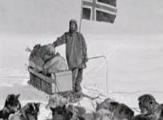  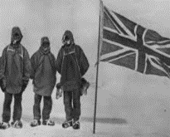 | In late 1911, Robert Scott’s British team and Roald Amundsen’s Norweigian team were in direct competition to reach the South Pole first. Amundsen’s team won the race by 33 days. Amundsen landed at the Bay of Whales on the Ross Ice Shelf, whereas Scott landed at McMurdo – this gave Amundsen’s team a shorter route by 95km. Amundsen had also mastered using sled dogs to make his journey quicker. Scott and his team died on their return from the pole, freezing to death in their tents. | When?  At around 3pm on the 14th December 1941, Scott raised the Norweigian flag at the South Pole. Scott was disappointed to learn the race was lost upon reaching the pole on 17th January 1912. | Key Fact:  Both teams were widely celebrated, with Amundsen receiving telegrams from the American President and British King. The Amundsen-Scott station at the pole is named after them.
 |  |  | Melting Ice | 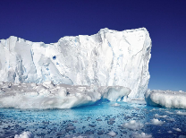 | Antarctic ice has been rapidly melting over recent years, as a consequence of global warming. In recent years, even the ice in East Antarctica, the coldest area in the world, have begun to show signs of warming. | What?  This is alarming news as it would raise sea levels, drowning low-lying countries | Key Fact:  Some studies have shown the rate of melting has increased 280% in 40 years.
 |  |  | McMurdo Station | 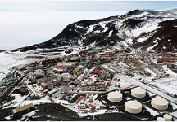 | The McMurdo research station is the largest research centre in Antarctica. Situated on the southern tip of Ross Island, it is capable of housing 1,258 people. It is the largest of three US Antarctic research stations. | Why?  The station takes its name from its geographic location – McMurdo Sound. | Key Fact:  All trips to the Amundsen-Scott research centre pass through here.
 |  |  | Antarctic Treaty | 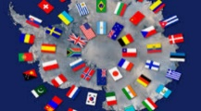 | The Antarctic Treaty was declared to end disputes over territory in Antarctica. The current claims are now fixed, and no country can claim any area south of 60˚ of latitude. | When?  The treaty was signed in 1961. | Key Fact:  Any treaty-state has legal access to the whole of Antarctica.
Places in Antarctica
Largest Territories in Antarctica
- Australia – 5.9 million²
- Norway – 2.7 million²
- United Kingdom – 1.7 million²
- Argentina – 1.5 million²
- Chile – 1.3 million²
Largest Settlements in Antarctica
- McMurdo Station (USA)
- Frei Station (Chile)
- Amundsen-Scott (USA)
- Mirny – (Russia)
- Esperanze – (Argentina)
There are no countries in Antarctica, and no permanent residents. Antarctica is divided into foreign-run ‘territories.’
 |  |  | Physical Geography Features
 |  |  | Weather Extremes | 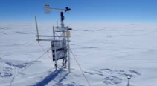 | Antarctica is the coldest place on earth. In the mountains, temperatures regularly drop below -60˚C in the winter. It is slightly warmer around the coastal areas, but only rarely exceeds 0˚C. | Where?  It is coldest on mountain ridges. -93.2˚C was once measured. | Key Fact:  Precipitation is hard to measure, as it always falls as snow!
 |  |  | Ice Sheet | 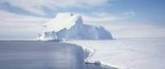 | The Antarctic Ice Sheet is the largest on earth. In winter, it extends beyond the continent, growing from 3 million km² to 18 million km² | Where?  Growth occurs mainly at coastal ice shelves. | Key Fact:  The Ross and Ronne Ice Shelves grow the most.
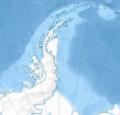  Antarctic Peninsula  The Antarctic Peninsula is the northernmost area of land on Antarctica. It is a part of Western Antarctica, and protrudes about 1,300km north towards South America. The northernmost tip of the peninsula is only about 1,000km away from the southernmost part of South America. Some sections contain little/ no sheet ice, the only place in Antarctica. | 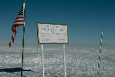  The South Pole  The South Pole is the most southerly place in the world, and is one of two places in the world upon which the earth’s axis is centred. The South Pole was first reached by Norwegian Roald Amundsen and his team on December 11th, 1911. They were followed a month later by UK explorer Robert Scott and his team. The USA’s permanently-manned Amundsen-Scott station is positioned at the pole.
 |  |  | Animals | 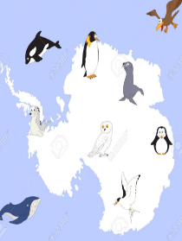 | Despite its hostile climate, including freezing temperatures, gale force winds, and perpetual winter darkness, Antarctica is home to many specially adapted animals. Emperor penguins are one of the best-known, and one of the only animals to remain on Antarctica throughout winter. A number of whale species live in the seas around Antarctica, whilst seals and many birds also call the coastal areas home. | How?  All of the animals that live in and around Antarctica are specially adapted for the cold climate, with thick fur, feathers, or blubber to keep them warm. | Key Fact:  There is far more life on the Antarctic Peninsula and around the coast than there are in the more central areas. There is almost no life on the mountains.
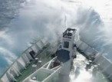  Drake Passage  The Drake Passage is the body of water between the northernmost part of the Antarctic Peninsula and the southernmost tip of South America. It is known to be the quickest route to Antarctica from other land, but contains incredibly rough seas. Many ships have been destroyed here. | 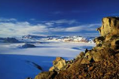  Victoria Land  Vitoria Land is the first known point at which man set foot on Antarctica. This was probably by Captain James Clark Ross in 1841. The region includes the Transatlantic Mountains, the Labyrinth flatlands, and also the McMurdo Valleys. It is situated just to the west the Ross Ice Shelf. |  | Southern Ocean |  | The Antarctic is surrounded by the Southern Ocean. It is a relatively deep ocean (up to 4,000m - 5,000m deep in places) | What?  It is also known as the Antarctic Ocean. | Key Fact:  The Southern Ocean is all ocean on earth below 60˚ south.
 |  |  | Mount Vinson | 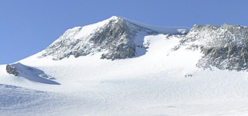 | Mount Vinson is the highest mountain in Antarctica, at 4,892m above sea level. It is a part of the Vinson Massif, and lies in the Ellsworth Mountains. It overlooks the Arctic peninsula. It was not officially seen until 1958. | When?  Vinson was first climbed in 1966 by a US team, led by Nicholas Clinch. | Key Fact:  The Eastern route is so difficult to climb that it was not climbed until 2001.
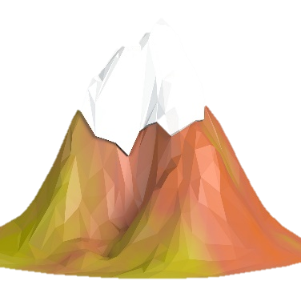
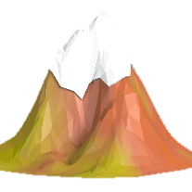
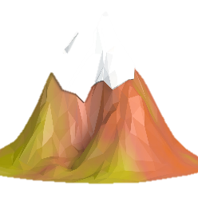
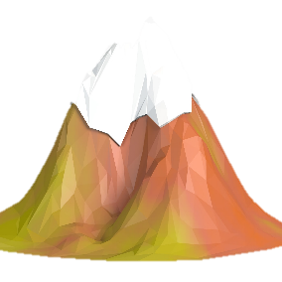
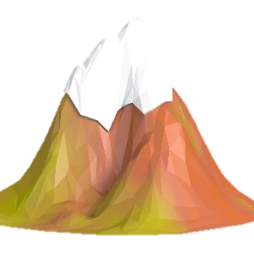
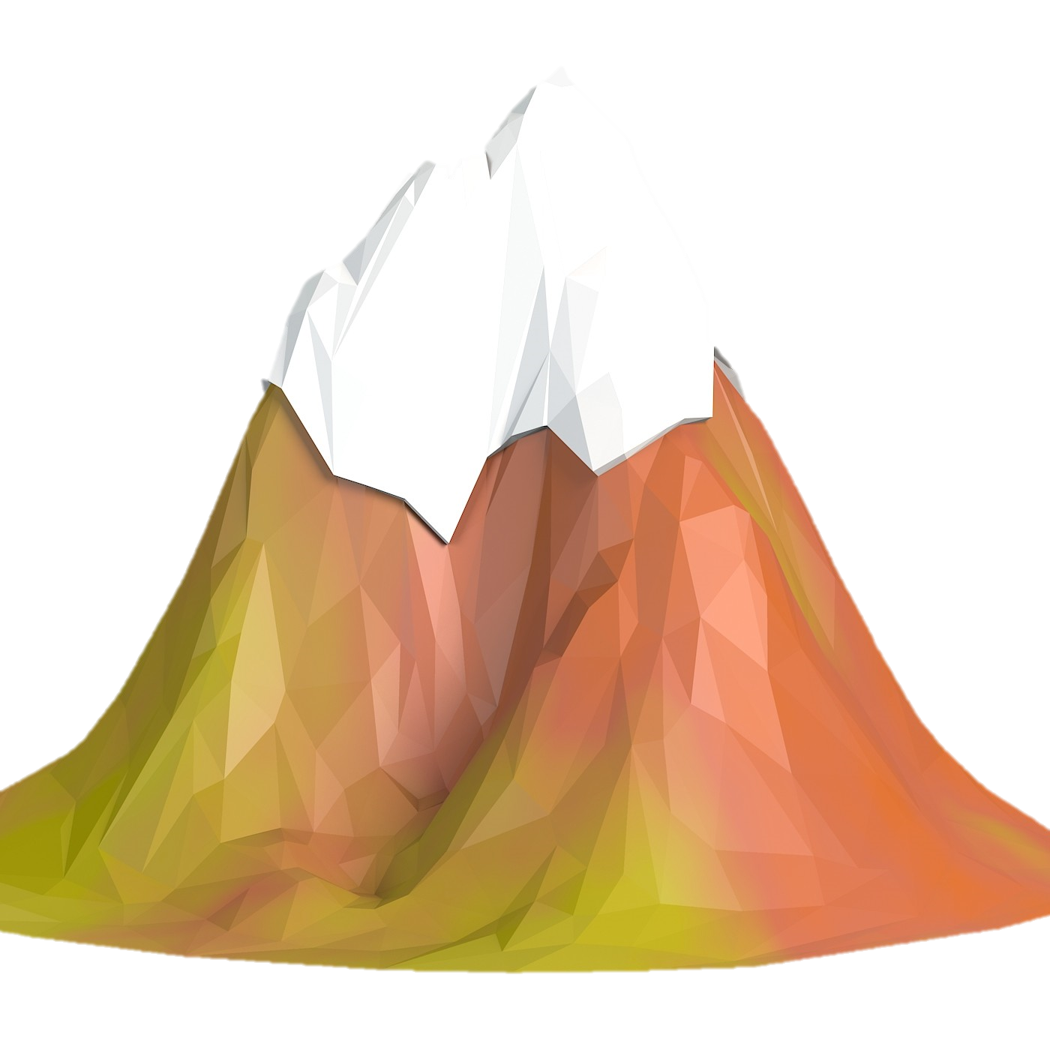
Priscu Stream – 3.8km
Elizabeth – 4,480m
Kirkpatrick – 4,528m
Shinn – 4,660m
Mount Vinson – 4,892m
Rezovski – 500m
Jemmi Creek – 10.3km
Gardner – 4,685m
Longest Rivers
Highest Mountains
Lawson – 400m
Aiken Creek – 6km
Onyx – 32 km
Tyree – 4,852m

