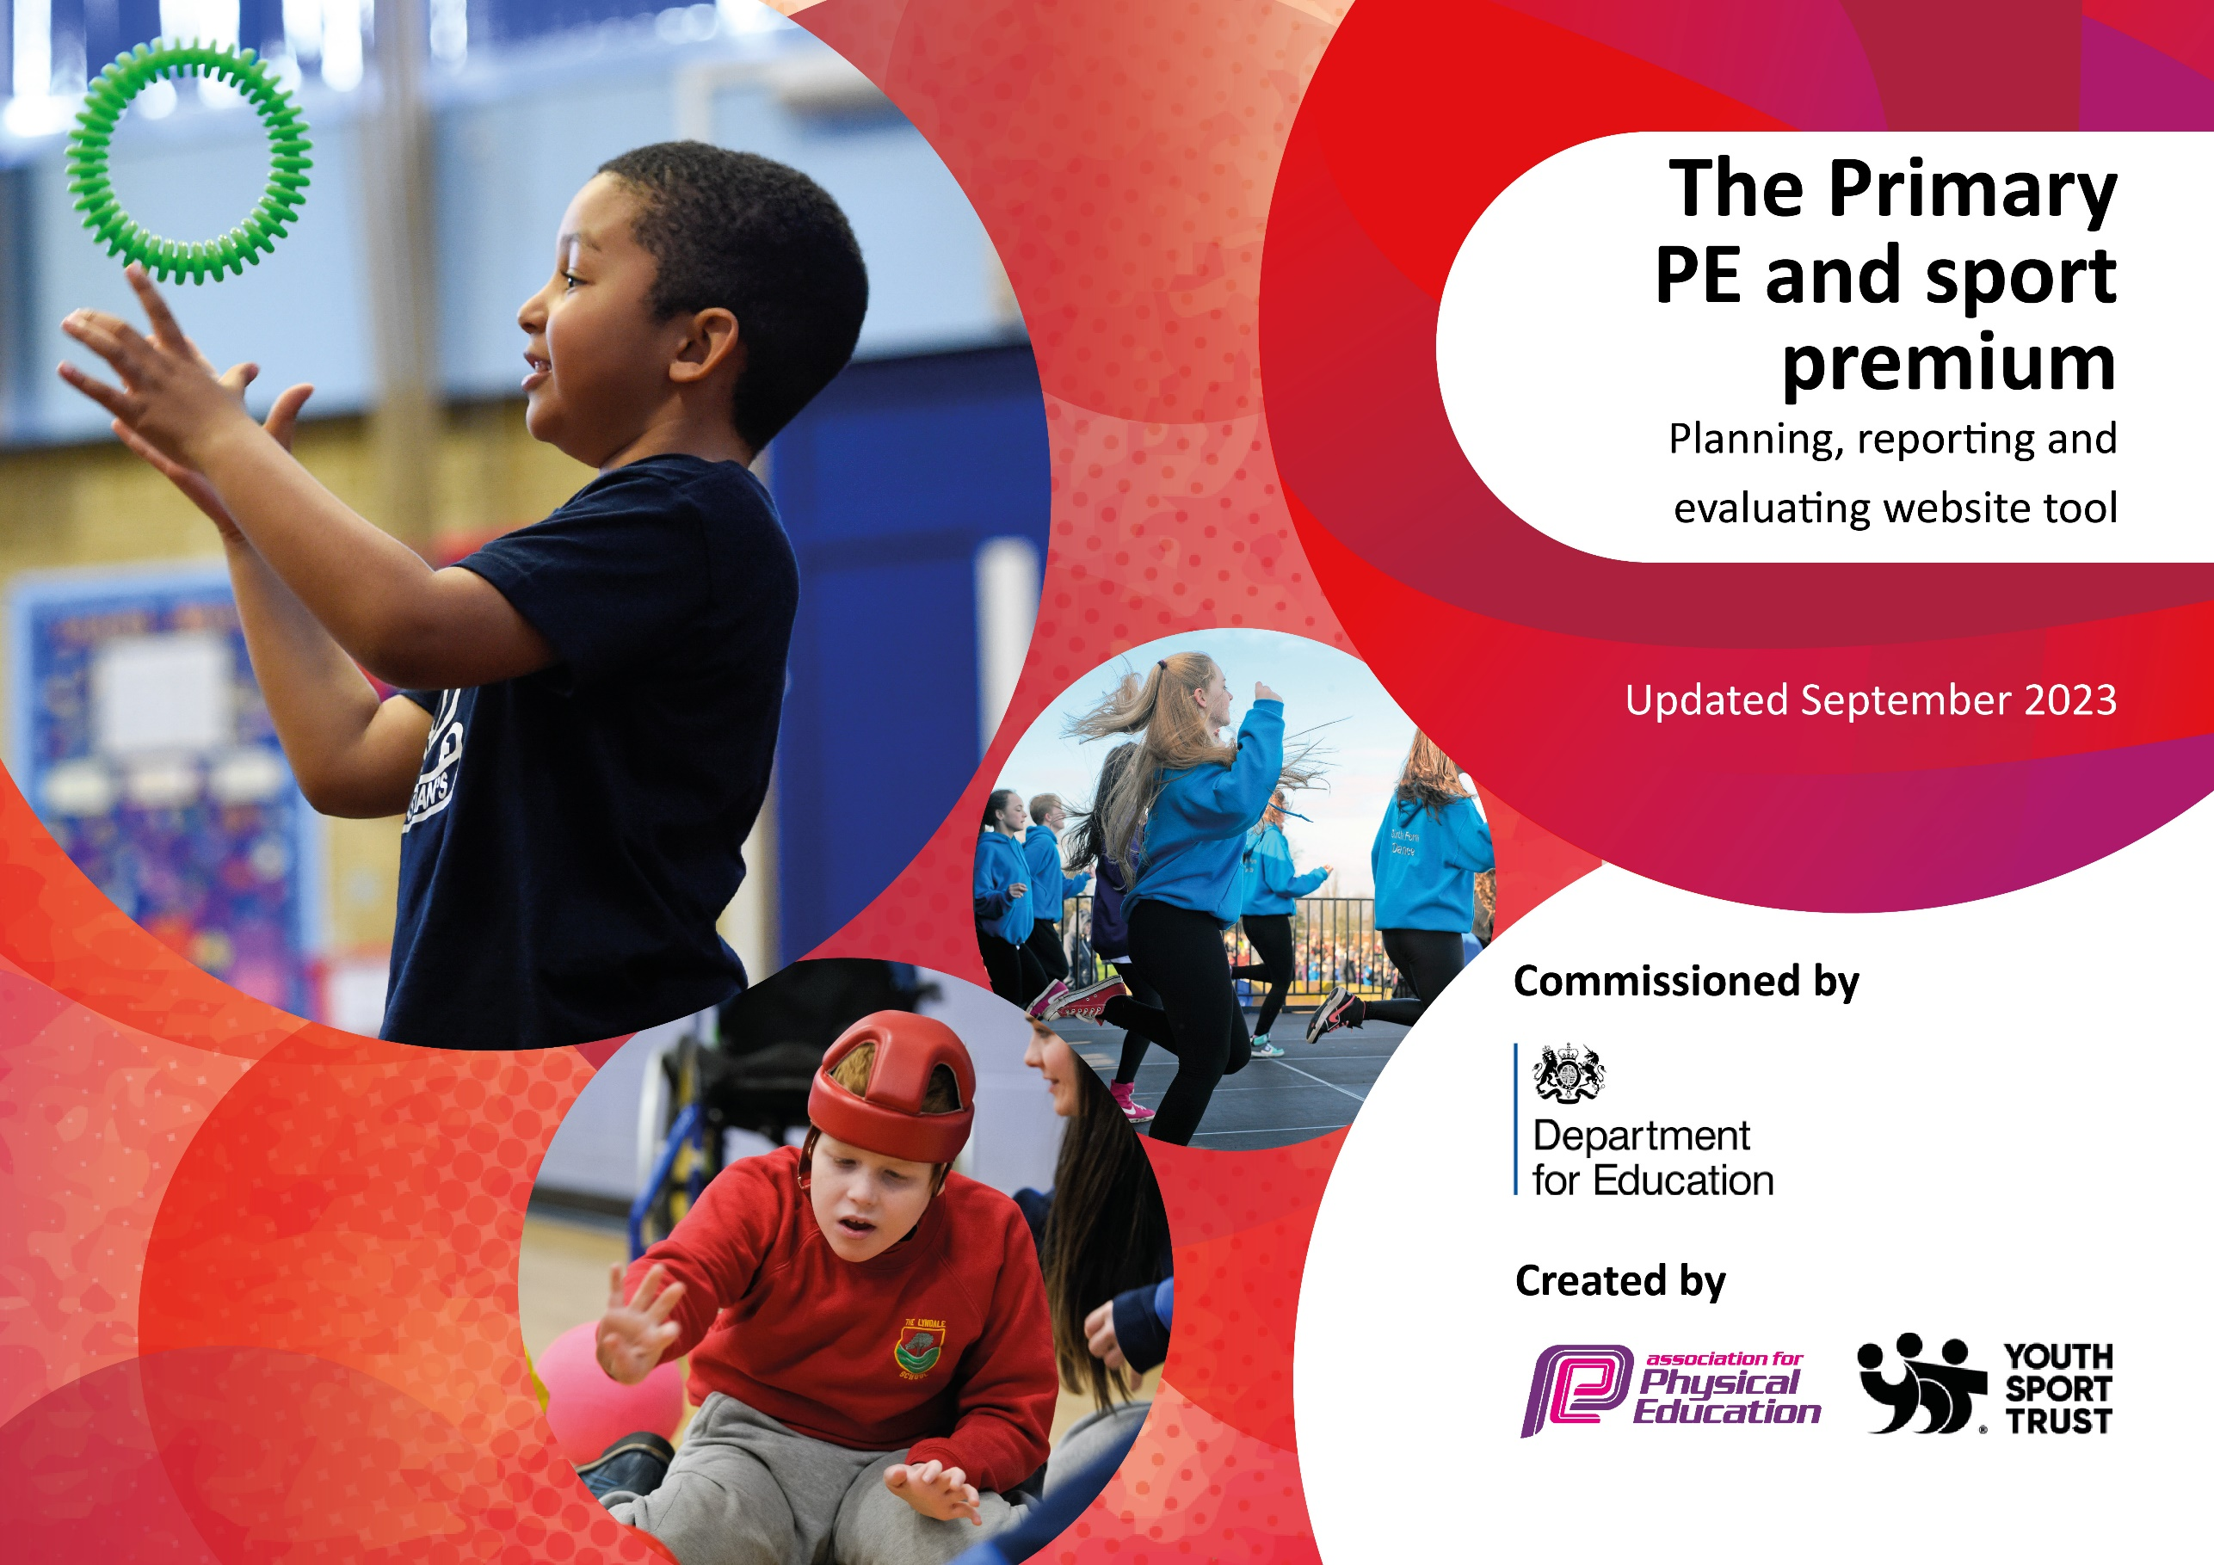

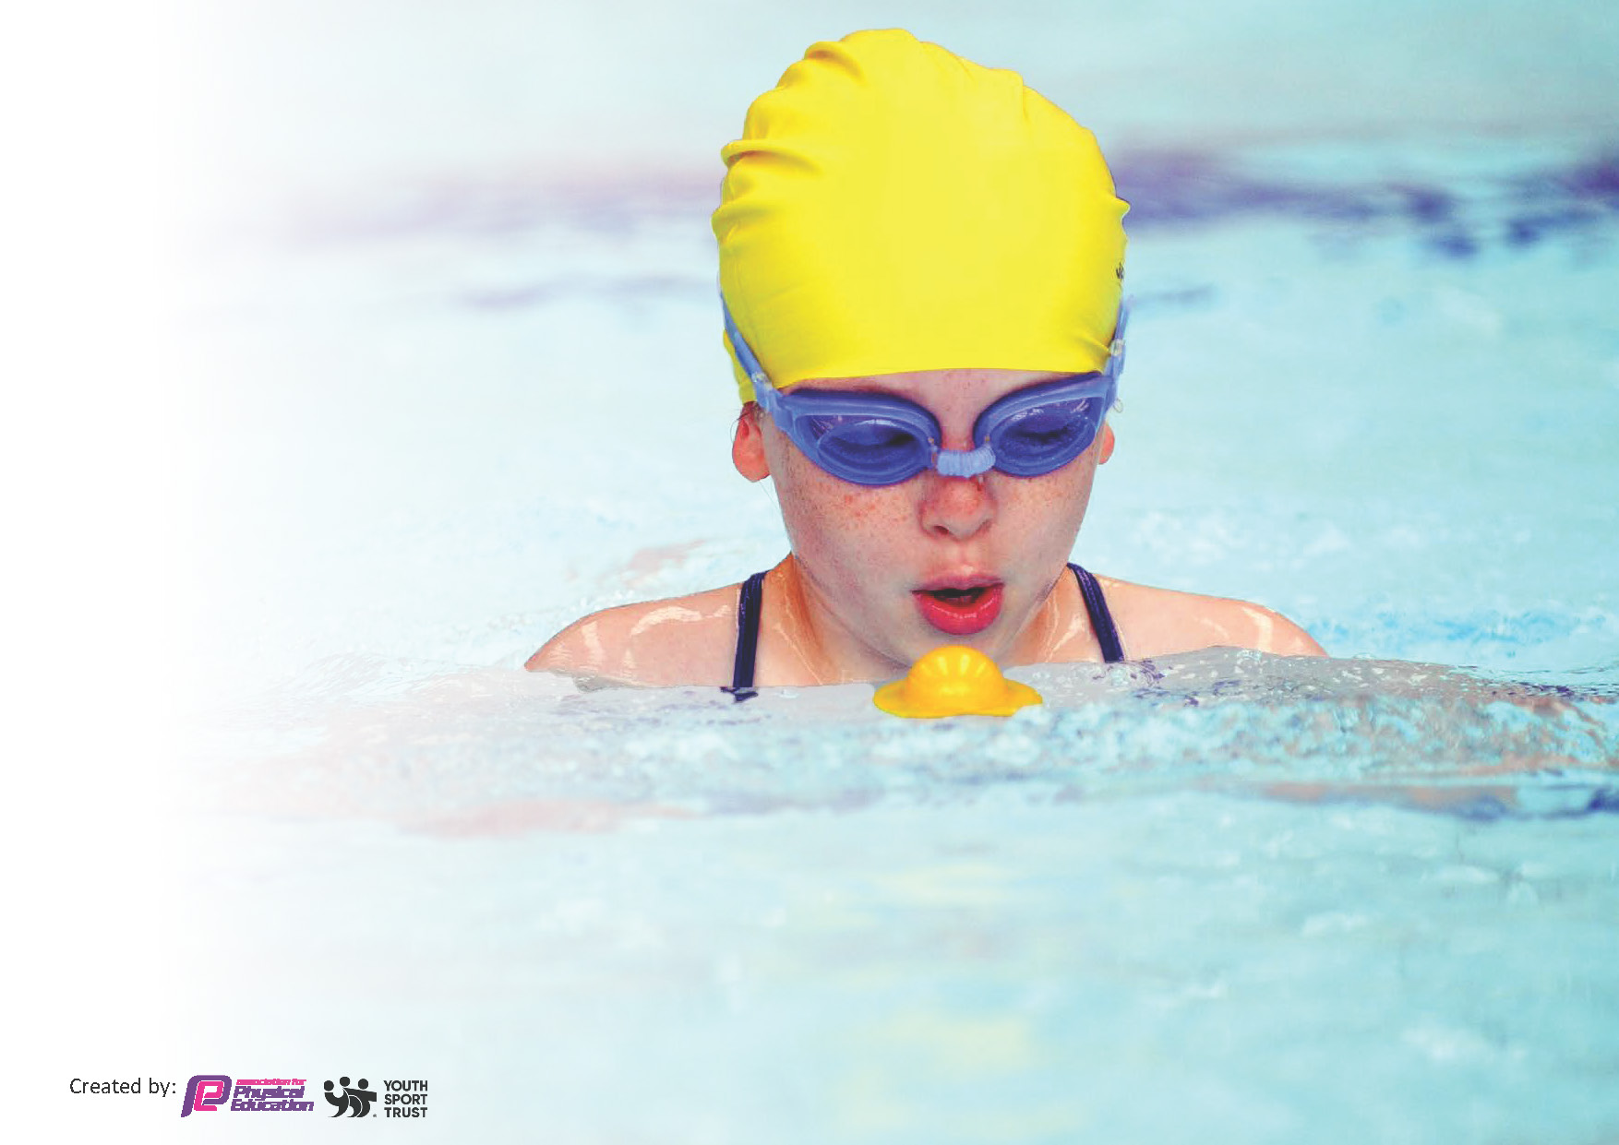
This template can be used for multiple purposes:
by:
- It enables schools to effectively plan their use of the Primary PE and sport premium
- It helps schools to meet the requirements (as set out in guidance) to publish information on their Primary PE and sport premium
- It will be an effective document to support Ofsted inspections enabling schools to evidence progress in Physical Education (PE) and evidence swimming attainment, which forms part of the PE National Curriculum. We would recommend schools consider
the Intent, Implementation and Impact of any spend, as examined within the Education Inspection Framework.

It is important that your grant is used effectively and based on school need.

Schools must use the funding to make additional and sustainable
improvements to the quality of the PE, School Sport and Physical Activity (PESSPA)
they offer. This means that you should use the Primary PE and sport premium to:

- Build capacity and capability within the school to ensure that improvements made now will benefit pupils joining the school in future years
- Develop or add to the PESSPA activities that your school already offers.

The Primary PE and sport premium should not be used to fund capital spend projects; the school’s core budget should fund these. Further detail on capital expenditure can be found in the updated Primary PE and sport premium guidance.

The Primary PE and sport premium guidance, outlines 5 key priorities that funding should be used towards. It is not

necessary that spending has to meet all the key priorities, you should select the priorities that you aim to use any funding towards.

Although completing this template is not a requirement for schools, schools are required to publish details of how they spend this funding. Schools must also outline what the impact this funding has had on pupils’ PE and sport participation and attainment and how any spending will be sustainable in the future. All funding must be spent by 31st July 2024.

The Department for Education has worked closely with the Association for Physical Education (afPE) and the Youth Sport Trust (YST) to develop this template and encourages schools to use it. This template is an effective way of meeting the reporting requirements of the Primary PE and sport premium.
Review of last year’s spend and key achievements (2022/2023)

We recommend you start by reflecting on the impact of current provision and reviewing your previous spend.

Activity/Action | Impact | Comments
PE specialist brought into teach PE and deliver CPD  Access to Penryn College Sporting fixtures  Using external bodies to provide Sporting extra curricular clubs  Supporting transport costs | Pupils received high quality PE lessons. Skills were improved and confidence was gained. PE specialist was able to deliver PE training to other school staff increasing CPD and staff confidence  Fuller participation in school sports and extra curricular sporting fixtures. Increased engagement with non-engaged pupils.  Pupils were given access to a wide range of sporting experiences, above and beyond the ‘usual’ offer  This reduced the burden on school budget and allowed pupils to attend more activities. | Continue this provision next year.  Paying for staff to support PE fixtures rather than relying on volunteer teachers has been a big success this year  Again, using staff paid for rather than expecting volunteers to run clubs was very positive./  Continue next year.

Key priorities and Planning
This planning template will allow schools to accurately plan their spending.

Action – what are you planning to do | Who does this action impact? | Key indicator to meet | Impacts and how sustainability will be achieved? | Cost linked to the action
Introduce playground ‘Learning Challenges’ at break and lunchtimes.  Introduce sports coach in order to provide high quality physical activities across the school  Access to Penryn College extra curricular sport competitions and provision + staffing for these activities.  Minibus costs for transports to and from sporting activities | Lunchtime supervisors / teaching staff, coaches - as they need to lead the activity  pupils – as they will take part.  Pupils – taking part and staff CPD  Pupils – taking part and staff CPD  Pupils – taking part and staff CPD | Key indicator 2 -The engagement of all pupils in regular physical activity – the Chief Medical Officer guidelines recommend that all children and young people aged 5 to 18 engage in at least 60 minutes of physical activity per day, of which 30 minutes should be in school.  Key indicator 4: Broader experience of a range of sports and activities offered to all pupils.  Key indicators as above  As above  Key Indicator 2 and 4 | More pupils meeting their daily physical activity goal, more pupils encouraged to take part in PE and Sport Activities.  Skills acquisition and development of pupils  Staff CDP knowledge and confidence  As above  Engagement of pupils inc those more reticent to take part in sporting activities.  Skill development. Confidence of pupils taking part in competitive sports.  Development of higher achieving athletes. | £1000 costs for additional resources to support lunchtime/ breaktime sessions  £3840 cost for sports coach  £1200 SLA + £1000  £1200

e.g. CPD for teachers.  Investment in bikes and trikes for Class 1 | PE leader to take part in CPD and attend PE conferences and meeting | Indicator 3. The profile of PE and sport is raised across the school as a tool for whole school improvement  Indicator  1 Increased confidence, knowledge and skills of all staff in teaching PE and sport  IIndicator 2 | PE lead up to date with current pedagogy. PE lead able to disseminate key information to all staff  From an early age, pupils are enjoying being physically active. | £500  £1000

Key achievements 2023-2024
This template will be completed at the end of the academic year and will showcase the key achievements schools have made with their Primary PE and sport premium spending.

Activity/Action | Impact | Comments

Swimming Data
Meeting National Curriculum requirements for swimming and water safety.
Priority should always be given to ensuring that pupils can perform safe self-rescue even if they do not fully meet the first two requirements of the National Curriculum programme of study

Question | Stats: | Further context  Relative to local challenges
What percentage of your current Year 6 cohort can swim competently, confidently and proficiently over a distance of at least 25 metres? | 80% | Of those children who cannot yet swim 25 m – intensive lessons are in place this term.
What percentage of your current Year 6 cohort can use a range of strokes effectively [for example, front crawl, backstroke, and breaststroke]? | 80% | Prior teaching at school combined with private lessons at home show that this data is correct

What percentage of your current Year 6 cohort are able to perform safe self-rescue in different water-based situations? | 80% | As above
If your schools swimming data is below national expectation, you can choose to use the Primary PE and sport premium to provide additional top-up sessions for those pupils that did not meet National Curriculum  requirements after the completion of core lessons. Have you done this? | No | School supports those children who cannot yet swim 25 m in Y6, to be able to access swimming lessons – including using charitable funding over the summer holidays to provide free lessons to some identified pupils.
Have you provided CPD to improve the knowledge and confidence of staff to be able to teach swimming and water safety? | No | We use trained coaches from Helston Community Pool to deliver our swimming lessons.

Signed off by:

Head Teacher: | Vicky Sanderson
Subject Leader or the individual responsible for the Primary PE and sport premium: | Vicky Sanderson
Governor: | Mary Heard
Date: | 13.9.23

