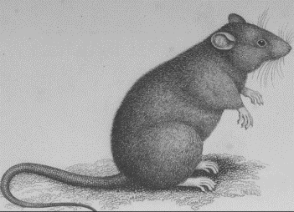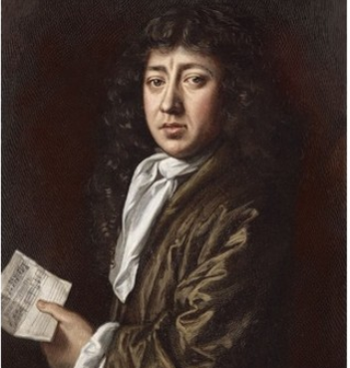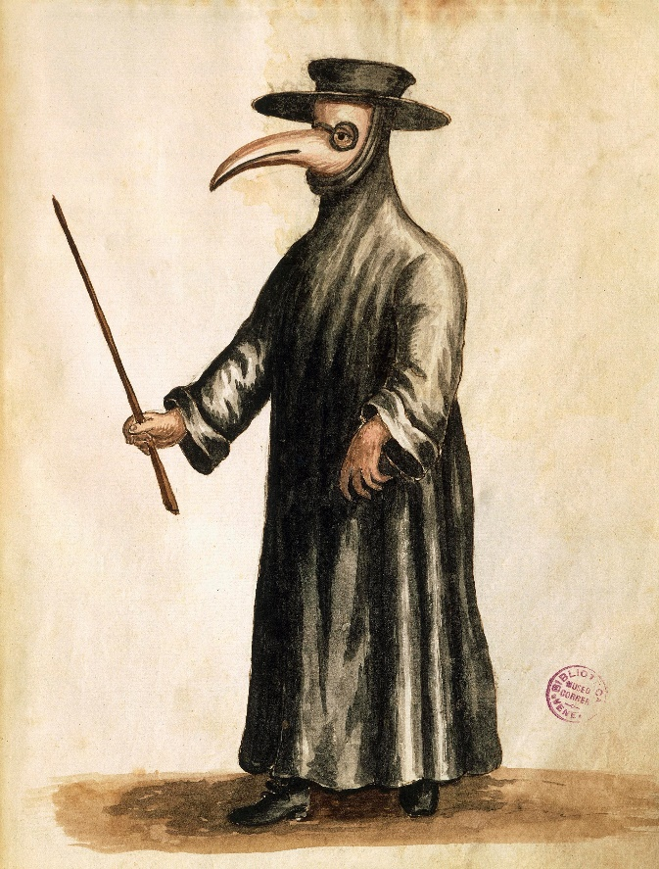

**Key vocabulary**

**Epidemic -** A major outbreak of a disease that spreads rapidly to a lot of people.

**Bubonic plague –** One of three types of plague that is mainly spread by infected fleas.

**Pneumonic plague** - was airborne, and spread by sneezing. People who caught pneumonic plague often died within a day.

**Medicine** – used to treat an Illness or disease

**Desease/illness** – a disorder that causes symptoms and can dometimes end in death

**Physicians –**  a person qualified to practise medicine

It was later discovered that rates carrying fleas were the cause of Bubonic plague.

**Useful websites**

<https://www.bbc.co.uk/bitesize/guides/zd3wxnb/revision/1> (key information)

<https://en.wikipedia.org/wiki/Great_Plague_of_London>

<https://www.theschoolrun.com/homework-help/the-great-plague> (Including timeline and key facts

The Great Plague

**Key Questions**

1. **Why do we know so much about the plague and its experience?**
2. **Why did the Plague disappear? Was it the Great Fire of London in 1666?**
3. **Why do you think the true number of deaths linked to the plague was more like 100 000 not the 68 596 that were recorded?**
4. **What sources of information can we use to learn about the effect that the plague had?**
5. **What is different about the way a plague victim was treated in the 17th Century and how they would be treated now?**
6. **Can you name a diary that we can use to learn more about life in London during the great plague?**

**Samuel Pepys**

The diary of Samuel Pepys (1633–1703) gives us a fly-on-the-wall account of life during the 17th century.

**The Plague Doctor**

The Black Death was the deadliest epidemic of bubonic plague in history, wiping out some 25 million Europeans alone in just a few years. Out of desperation, cities hired a new breed of physician — so-called plague doctors — who were either second-rate physicians, young physicians with limited experience, or who had no certified medical training at all.

The costume of a plague doctor featured an all-leather ensemble, a beak-like mask stuffed with burning herbs, and a top hat — which signaled that the person was, in fact, a doctor.

**The Great Plague Knowledge Organiser - History**