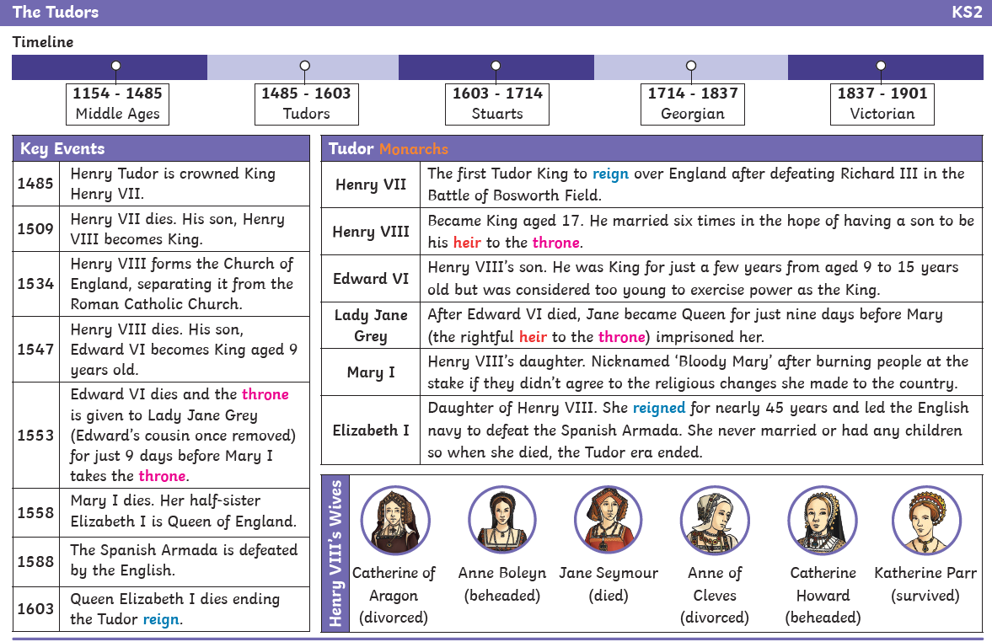

St Mawes and Pendennis Castle were built in 1539-1540

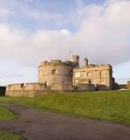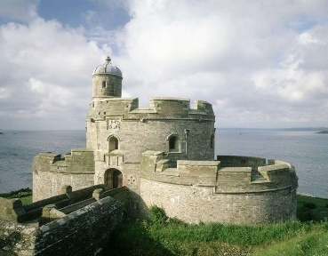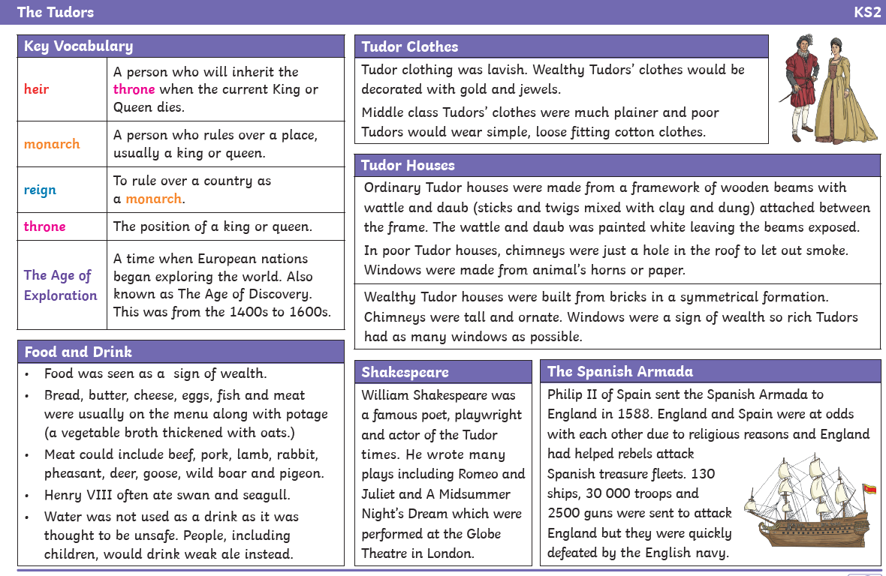

Pendennis Castle was built from 1539 to 1545 when England faced a possible invasion from the united powers of Catholic Europe. To defend against this, Henry VIII implemented a national programme of military and naval preparations. St Mawes Castle is perhaps the best surviving example of a Henrician artillery fort. The castle is a snapshot of its time, and visitors can still see elaborate carvings and text lauding Henry VIII on its walls including new coastal artillery forts.