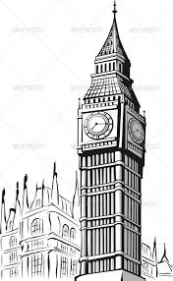
How and why do settlements change over time?
Changing settlements.
No town or village remains the same forever. Over a period, the following may change:
- The shape of the settlement
- The function of the settlement (this can be transport, housing, shopping, business etc.)
- The land use of the settlement.
- The number and type of people living in the settlement.
- The economic activity (different types of business/jobs)

Changing settlements
What is Geography? People who study geography are called geographers. Geographers are interested in Earth's physical features, such as mountains, deserts, rivers, and oceans. They are also interested in the ways that people affect and are affected by the natural world. The study of Geography is split into:
Physical Human Environmental
Types of settlement
Isolated house | A single house isolated from others
Hamlet | A small settlement without a church.
Village | A group of houses in the countryside, sometimes with a church and small shop
Town | A place where there are lots of houses and shops. A town may have a local council that makes decisions for the people who live there
City | A city is a large urban area where many people live close to each other. There are often lots of shops and services in a city
Key Vocabulary
Rural | Countryside
Urban | Characteristics of towns and cities
Settlement | A place where people have established a community
Conurbation | Where several towns have merged.
population | The amount of people who live in a particular place.
metropolis | The capital or main city of a country
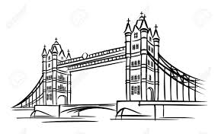
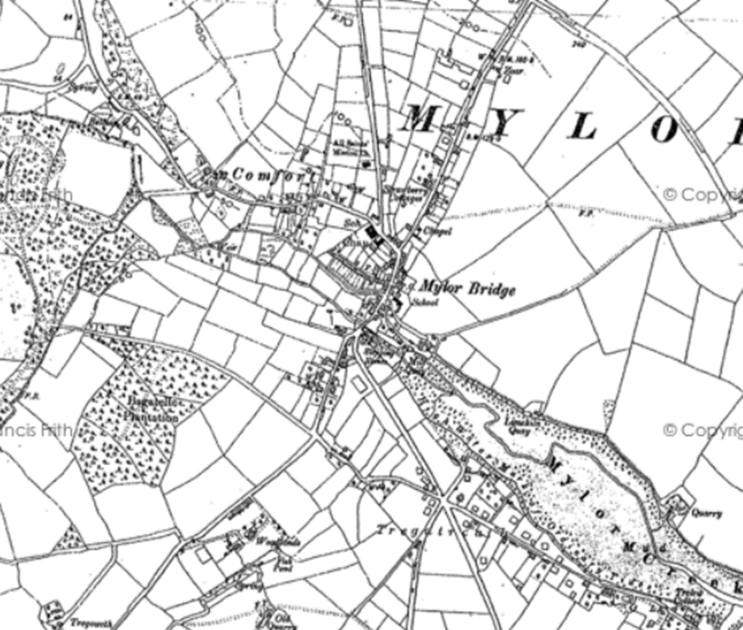
Key Questions
- Can you name different types of settlement in order of their size?
- Can you explain a link between the population size of a settlement and the amount of services within that settlement?
- What are the different types of services that may be available in a large city?
- Can you think of how a settlement may change over a period of time?
- What are the main differences between London in the 17th century and London in the 21st Century and why did these changes happen?

How has Mylor Bridge changed over time?
What are the key reasons for these changes?

