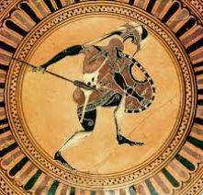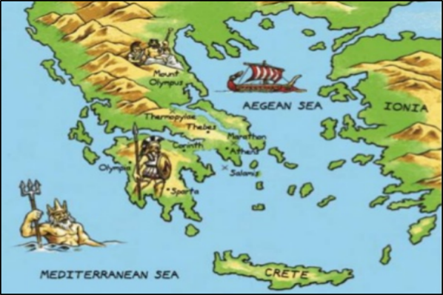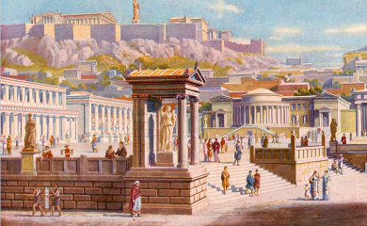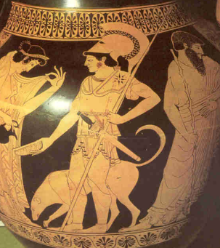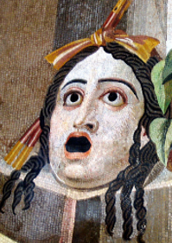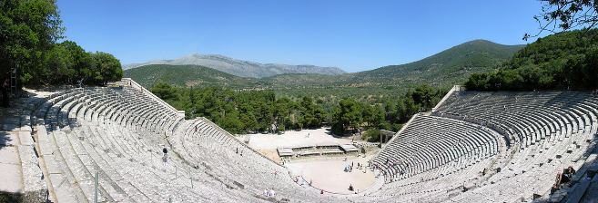

**Other Questions**

1. **What was happening in Britain during the time of the Ancient Greeks?**
2. **What were the major differences between the Athens and Sparten societies?**
3. **How did Historians find out so much about the Ancient Greeks?**
4. **What are the main differences between the Ancient Olympics and the Modern ones?**
5. **What can we tell about the Ancient Greeks from their interest in the theatre and festivals like the Olympics?**
6. **What influences does the modern world take from the Ancient Greeks?**

Our Key questions during this learning journey

* What can the geography of Greece tell us about the Ancient Greek civilisation?
* What happened at the Agora in Athens?
* What was life really like for women in Ancient Greece?
* How was Athens able to become a powerful state?
* Despite being outnumbered, why were the Athenians so successful at the Battle of Marathon?
* What role did democracy play in the life of the Athenians?
* What else can we learn about the Greeks from a study of evidence about their Olympics and how have these games left a legacy?
* Do words we use today come from Greece?
* In your opinion, which Greek left the greatest legacy?

Vocabulary

* Polis (city states)
* Coastline Islands
* Athens (Athenians)
* Sparta, (Spartans)
* Ancient society
* Persians
* Peasant, Slave, Rich
* Agora
* BC, BCE, AD CE
* Minoan, Greek Myth
* Alphabet,
* The Acropolis,
* The Parthenon,
* Mount Olympus,
* Historical sources
* Evidence
* Hypothesis, justify
* Democracy/ Governement
* Battle of Marathon, Pottery, Arts, Theatre
* Ancient Olympics
* Modern Olympics
* Marathon
* Socrates,
* Aristotle
* Alexander the Great,

Greece Geography

Greece’s position next to the sea (there are over 1400 islands) meant Ancient Greeks were a seafaring people. Trade between the islands led to the creation of ‘city-states’ (polis). Each city-state was ruled by a powerful city, led by a ruler or (later) government. Greece is a warm country, but winds from the Mediterranean, and rains from the north, kept temperatures livable and created fertile farming conditions. As it was mountainous, cities were isolated from each other.

**What was life like for Ancient Greeks and what legacies did they leave? - History**