***Natural Disasters – Year 6 Geography Knowledge Organiser***

***Key Dates/Case Studies***

- Mt. St Helens volcanic eruption (1980)

- Lomo Prieta earthquake (1989)

- New Orleans/Hurricane Katrina (2005)

- California wildfires (2019)

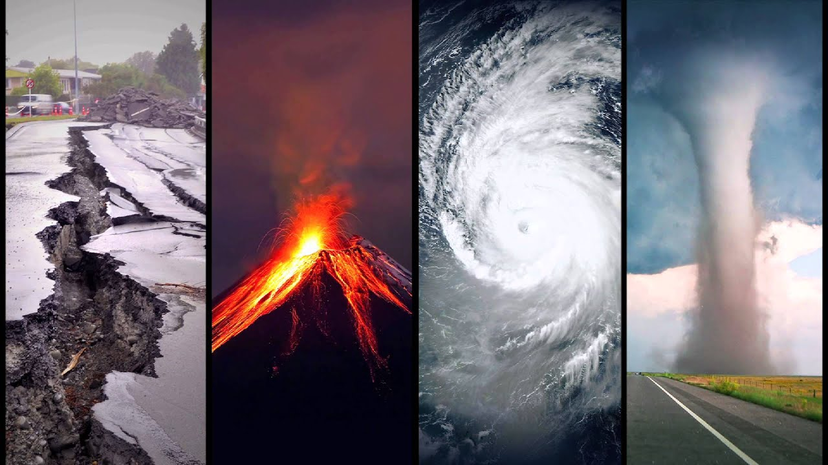

***Key Vocabulary***

Natural disaster – a natural event (such as a flood, earthquake, volcano etc.) that causes a great deal of damage or loss of life.

Earthquake – a violent shaking of the ground due to a sudden shift of tectonic plates, typically causing great damage.

Tectonic plates – plates of solid rock under the Earth’s surface, under immense pressure.

Continental crust – the part of the Earth’s crust that underlies the ocean

Oceanic crust – the part of the Earth’s crust that forms large land masses

Volcanic eruption – a violent discharge of steam and volcanic material.

Dormant – in an inactive state (a dormant volcano is one that isn’t erupting)

Hurricane – a storm with a violent wind

Evacuation – removing people from an area that will be impacted by a natural disaster

Primary responses – the initial efforts after the disaster occurs

***Key Questions***

What is a natural disaster?

What causes natural disasters to occur?

How are the Americans prepared for future disasters? What safety measures have been put in place?

How did a particular natural disaster impact the people who lived there?

What happened before/after the disaster occurred?

Which tectonic plates shifted for the earthquakes in California to happen?

What is the difference between hurricanes, cyclones and typhoons?