Context of the School

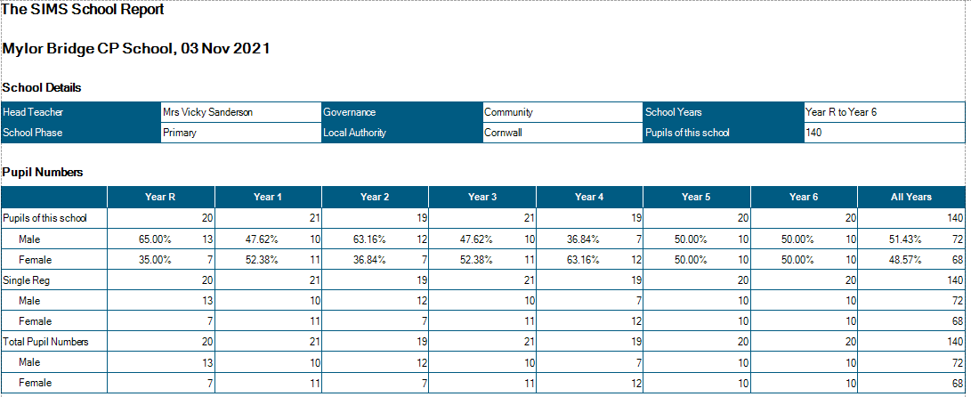

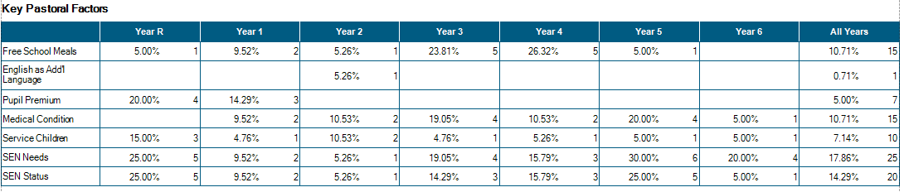

Attendance

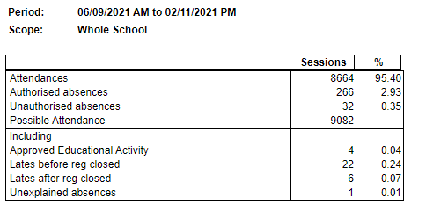
The effects of continuous COVID19 PCR testing is taking a toll on the attendance in school – lots of this attendance is due to children being slightly unwell, taking a PCR test and then awaiting the results.

From September, classes run in the following manner:

Class Structure from
September 2021
Class 1:  EYFS -20 Year 1 - 10 | Mrs Mogridge (Mon – Wed)  Mrs French (Thurs-Fri)  Mrs Evans TA 09:00 – 15:15  Mrs R Wilkes 1:1 TA 09:00 – 15:15  Miss Short TA 09:00 – 12.00  Mrs E Lloyd 1:1 TA 09:00 – 15:15
Class 2:  Year 1 – 9 Year 2 – 21 | Mr Shainberg  Mrs Armstrong TA 09.00 – 15.15
Class 3 Year 3 - 19 | Mrs Thomas (Mon-Wed)  Mr Sanderson (Thurs-Fri)  Mr Collier 1:1 TA 09.00 – 15:15
Class 4 Year 4 - 21 | Mrs Medlin / Mrs Wood – progressive hand over of time until Easter then 2 days / 3days split  Mrs Stevens Mon - Fri 09.00 – 12.15
Class 5 Year 5 – 19 | Mr Martin  Mr Wilcox 1:1TA M-F 09.00 – 15.15  Mrs Pearson 1:1 TA Mon-Fri 09:00 – 12:15
Class 6 Year 6 - 18 | Mr Collinge  Mrs Garland (Tues – Thurs 9.00 - 12.15)
PPA Cover  Subject leadership cover | Mr Mutsauers – PE Classes 2/4/5/6  Mrs Hamilton Classes 2/4/6  Mr Wilcox Class 5  Mr Mustaeurs
Intervention | Mrs Hamilton Monday 14:00 – 16:00 Tuesday – Friday 13:00 – 16:00  (Funded through national catch-up funding)
Intervention | Miss Short Tues – Fri 13.00 – 14.30 Phonics
Intervention | Mrs Pearson Mon- Fri 13:00 – 15:00 NELI/ Number Stacks (Funded through national catch-up funding)
Intervention | Mr Wilcox 08:15 – 09:00 Mon- Fri (funded through national tutoring programme)

Significant Changes/Challenges Since the last Head Teacher’s Report

- A very positive start to school in September – all pupils inc Reception, have settled well into school routines.
- A very positive SIP visit took place on the 19/10/21 – supported by head teachers from Flushing and Mawnan Schools – please see report.
- Mr Wilcox has initiated before school intervention for 7 children, focussing on number and place value/ phonics and high frequency words.
- 2 new members of staff have joined school: Mrs Emma Lloyd is working with a child with an EHCP 1:1 full time hrs in Reception. Mrs Jo Pearson is working as 1:1 TA in year 5 with a child for whom we are applying for an EHCP. Mrs Pearson is also putting into place the NELI programme for Reception and Number Stacks intervention for Y1/2.
- Mrs Wood and Mrs Medlin have begun a job share in Year 4.
- Well-being week took place and was extremely successful
- Y6/5 pupil performed an enjoyable end of year pantomime – to a live audience.

COVID19 is still impacting upon attendance – we have had 1 case within school, but many PCR tests resulting in days of absence in awaiting results, and a significant number of children with positive cases within their households.

Quality of Education.

- Lesson observations by myself/School Improvement Partner – Mark Lees/ HTs from Flushing and Mawnan schools, show that pupil engagement remains high – with very high engagement seen in a number of classes. Reception children have settled very quickly and listen well during lessons.
- Curriculum development remains a large focus for school – this year’s monitoring timetable has been planned to ensure that all subject leaders have the opportunity to observe their subject being taught, alongside the triangulation of pupil conferencing/ book looks/ planning monitoring/ resource auditing
- Monitoring of English and Maths books by the HT, shows that pupils are using a wide range of resources, including concrete materials. Ready to Progress materials have been used in Maths to ensure that children are ready for the next year group (in line with government guidance). RTP planning have been amalgamated into the yearly overview for Maths to ensure that key skills are fully embedded and any gaps are eradicated quickly.
- Close monitoring and assessment shows that the previously lower attaining and SEND pupils are the groups who have most suffered academically during the lockdown. High quality, well-planned interventions have been put into place quickly to ensure that these pupils’ needs are being addressed and gaps are being filled; SEND pupils are slower in filling gaps than non-SEND.
- Resilience in pupils who attend these interventions, is in the main extremely high – with some pupils attending 3x weekly afterschool intervention.
- In KS1 intervention is focussed on same-day catch-up alongside a focus on daily reading with the teacher/ TA. After Christmas, the NELI project will be used as a support for our Reception children
- All teachers have planned a full curriculum and knowledge organisers have been shared with parents via the school website. Evidence of a broad and balanced curriculum is clear, through book looks, pupil conferencing and whole school displays.
- The plan for child who need to isolate at home due to COVID19 remains in place – accessed through the website.

- Issues arising:
Less progress evident in writing esp. handwriting and presentation.
Spelling
Larger gaps evident between those working at expected standard (exs) and those children working towards this standard (WTS) and those with SEND.

Behaviour and Attitudes

- Observations this half term show highly engaged pupils, who present with enthusiasm about their school, a love of learning and good manners.
- Feedback from pupils about returning to school has been positive.
- No significant behaviour issues have arisen since the return to school.
- Subject conferencing in History/ Geography/ PSHE shows that pupils are able to remember prior learning and able to use this to reason about new learning eg Understanding the chronology of the Mayan civilisation can help place the Iron Age in Britain.
- Children report that there is no bullying in school, but where there are fall outs, they know that staff will help sort these out and are satisfied by the outcomes.
- Children who present with trickier behaviour, are supported through Trauma Informed Schools provision and/or Draw and Talk.
- High expectations of behaviour, manners and attitudes are modelled by all staff, and staff have high morale and a great sense of team work.
- Attendance (considering the current pandemic) is still above national expectations – pre COVID. Those children who have attendance of less than 90% are closely monitored by the HT and attendance officer, where these concerns continue, parents are contacted and support is put into place.

We currently have:
- 1 x child with a Special Guardianship Order
- 3x children with active court orders.
- 2x children with court allocated mentors
- 3x children currently working with social care – with allocated social workers.
- 1x Team Around the Child (TAC) plan in place
- 1x MARU referral – resulting in full section 47 risk assessments for 3 children.
- 1x referral to the teachers of the deaf
- 1x referral to First Light – domestic violence support
- 1 x ASD referral
- 2 children working with CAMHS

- There have been no Incidences of team teach physical intervention this half term. There has been 1 incident of racial intolerance in July 2021 – dealt with by the HT.

Personal Development and Cultural Capital

- We have been accepted to be 1 of 5 primary schools taking part in the Hall for Cornwall School Partnership Programme – a 2 year programme of dance/ drama/creative studies focussing on local Cornish Myth and Legend.
- PSHE (Personal, Social, Health Education) taught using the JIGSAW programme continues to be highly effective at delivering core value and understanding to our children. Issues such as living in a diverse, multi-cultural, multi-ethnic world in which differences are celebrated. Children are clear that intolerance of peers due to gender identity/ ethnicity/ skin colour/ is unacceptable.
- In July 2021 our children completed a large number of exciting and educational visits during Wellness Week – see timetable.
- In October, we celebrated Black History month, with assemblies and PSHE lessons learning about and celebrating the achievements of black people around the world.
- Y1 children continue to access forest school provision at Eyns Woods – financially supported by The Barring Foundation.
- We continue to run split lunchtimes in order to given our younger children a less crowded space in which to eat and play. The hall is now used for all lunchtime eating on a rolling programme of year groups and timings. This has taken some tweaking as the children have returned to this routine.
- A variety of new library books have been purchased and shared with the children focussing on the lives of black people and people from diverse ethnicity.
.

In order for staff to continue to remain up-to-date and be empowered to move our school forwards, a comprehensive, SDP-based CPD programme has been put into place.

CPD: This year to date:
Matt Collinge and Andrew Martin continue to attended Maths Hub Training
All staff have completed Tier 1 safeguarding update.
SW has completed TIS training and is implementing this support in school with 6 children.
Phonics training for TAs has taken place (SS lead this)
Reading training for TAs has taken place (JT lead this)
All teachers attended INSET training lead by the Maths Hub – Multiplication
SS/JT/AM/VS lead SIP visit with Mark Lees
Teachers from Landewednack School completed CPD observations in Class 1.
RW/JP/KM have completed NELI course 1
VS – OFSTED roadshow
VS – Curriculum Seminar – CC
VS – Safeguarding training
MC – Metacognition and Learning Skills – EEF
MC – Middle Leadership Programme

Effectiveness of Leadership and Management

All teachers are subject leaders of at least one subject area. IN these leadership roles, they are becoming more confident and more able to take control and lead their subjects across the school.
CPD and subject leadership time has been carefully matched to the priorities of the school development plan, and all subject leaders have the opportunity to observe, monitor and discuss their subject being taught across the school, inc. meeting with lead governors to discuss development plan and areas of celebration.
Monitoring by the SIP showed that strong leadership is in place for reading/ phonics/ maths and history.
Re-mapping of the curriculum last year ensured that subject leaders know that there is consistency and progression within their subjects
The use of knowledge organisers – see example, allow for clarity for children and provide opportunities to look back to prior learning.

Work-life balance is supported by the HT and governors:
Teaching staff are encouraged to complete PPA at home.
Parents evening consultations are started at 13:00 to reduce pressure on late night consultations.
All teaching staff run an after school activity reducing the burden on a few members of staff running more than 1 club.
Blended staff meetings (held on Zoom and in real life) to allow part time staff to join us if they are able to.
Safeguarding is an integral aspect to all leadership and management decisions.

