Context of the School

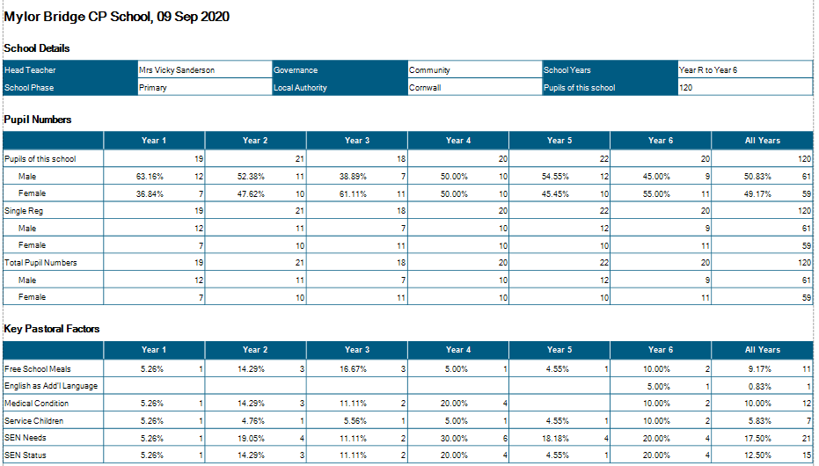

Class Structure September 2020
Class 1:  EYFS -20 Year 1 - 10 | Mrs Mogridge (Mon – Wed)  Mrs French (Thurs-Fri)  Mrs Evans TA 9.00 – 3.15 pm  Mrs R Wilkes r 1:1 TA 9.00 – 3.15 pm  Miss Short TA 9.00 – 12.00 pm
Class 2:  Year 1 – 11 Year 2 – 16 | Mr Shainberg  Mrs Armstrong TA 9.00 – 3.15  Mr Collier 1:1 TA 9.00 – 3.15 pm
Class 3 Year 3 - 19 | Mrs Thomas (Mon-Wed)  Mr Sanderson (Thurs-Fri)  Mrs Medlin (9.00 – 12.15 pm )
Class 4 Year 4 - 21 | Mrs Wilkes (Mrs Wood)  Mr Wilcox 1:1TA (M-F 9.00 – 3.15pm)
Class 5 Year 5 – 19 | Mr Martin  Mrs Garland (Mon -Thurs – Fri 9.00 – 12.15 pm)
Class 6 Year 6 - 18 | Mr Collinge  Mrs Stevens (Tues – Thurs 9.00 - 12.15)
Intervention | Mrs Hamilton Tuesday – Friday 1.00 – 4.oopm
Intervention | Miss Short Mon – Fri 1.00 – 2.00

PPA Cover  Subject leadership cover | Mr Mutsauers – PE Classes 2/4/5/6  Mrs Hamilton Classes 2/5/6  Mr Wilcox Class4  Mr Mustaeurs

Significant Changes/Challenges Since the last Head Teacher’s Report

- COVID19! Please see Recovery plan for full details of the school adaptations.
- Testing capacity for COVID19 is affecting attendance

- 2x New staff are embedding practise
- Significant training has taken place in order for these new members of staff to feel ownership of our school and to understand the values and vision of our school.
- Interventions in place from week 1 – focusing on children who have not engaged in home learning.
- 2x children with EHCPs have started at school (this brings us in line with national average 3%)
- 1x teacher on long term sick leave – supply cover has been positive and consistent. Safeguarding information has been moved to My Concern
- 6 in-year inward movements and 2 outward movements have taken place we are now full to capacity.
.

Quality of Education.
Please see attached SIP report

Behaviour and Attitudes
- Pupils have returned to school very positively. There has been no incidences of school refusal to date and none of our families have chosen to remain electively home educating (EHE).
- All staff completed training on attachment disorder and separation anxiety during INSET in September.
- Focus on being well-mannered continues this term, with Mylor Manners becoming embedded within our rewards system.
- Student council plan in place – lead by Andrew Martin. Focus on student voice and pupil empowerment – pupils have written manifestos and presented these before being elected to post.
- Learning to Learn assemblies now take a different format with children sitting in community groups. Older children are expected to model positive behaviour for younger children – this is working well.

- We currently have:
- 1 x children with a Special Guardianship Order
- 1x children with active court orders.
- 1x child is currently working with social care
- 1x TAC plan in place
- 2x EHH referral since the last HT’s report
- 1x SALT referral
- 1 child working with CAMHS
- 1x ASD referral made to CC

- There have been no Incidences of team teach physical intervention this half term.
- Action: The playground needs more opportunities for the children to express themselves in a variety of different ways.- crowd fundraising in place - £1000 raised. 3x quotes have been requested by playground equipment suppliers – we are awaiting plans. PFI have been contacted re: proposal.
- Pupil conferencing feedback shows that children like and engage with most lessons – children feel positive about their learning and feel that lessons are in the main interesting.

Personal Development and Cultural Capital

Our teaching staff plan for the teaching of British values – through the curriculum, for example when discussing religious beliefs in RE, or discussing the musical genre – The Blues and the origins of ‘singing the Blues.’
In PSHE our children learn about keeping themselves safe, having positive relationships and how to manage conflict and resolution. Our Online Safety curriculum allows children to develop knowledge and understanding of their roles and responsibilities in their online worlds and how to keep themselves safe.
We are working with Primary Futures to raise understanding of future career choices and how they are accessible within our local communities.

In order for staff to continue to remain up-to-date and be empowered to move our school forwards, a comprehensive, SDP-based CPD programme has been put into place

CPD: This year to date:
Matt Collinge, Vicky Sanderson and Andrew Martin have attended Maths Hub Training
Kernow Talks Oracy project Vicky Sanderson
Draw and Talk Training: All TAs – this is now being actioned with 5 children in KS2.
Emotion Coaching – All staff 2 x twilights.
Safeguarding Training – All Staff
Sight and Vision Awareness – Sam and Vicky A
Team Teach – Vicky S/ Sophie M
Minibus Training - Vicky S, Adrian, Nikki, Phil
Trauma Informed Schools Training – Whole Staff
H+S training – Sophie
Fire warden Training – Caz, Sean and Sophie
LFS – Sophie
KS1 Assessment - Sam
Tapestry Training - Class 1 staff
SIP shadowing - Vicky S
English Hub Training – Vicky S
Wave 3 Safeguarding - Andrew

Effectiveness of Leadership and Management

Focus for this year – in line with the OFSTED guidelines – has been the remapping of the curriculum to ensure that we have a broad and balanced offer.
Staff have audited and re-mapped content to ensure progress and coverage – supported by the Essentials Curriculum.

We have invested in the Essentials Curriculum which tracks progress of content and skills, so that there is a clear build across the school in all curriculum areas.

Staff have created long-term maps of the year and are currently embedding the development of ‘Knowledge Organisers’ for Science, History and Geography, alongside POP quizzes to assess learning.

Individual subject leaders have been allocated – with job descriptions. Every member of staff has been given subject leadership time and has taken ownership of their subject area.

Subject leaders have all produced an intent statement and policy for their subjects and to date have all completed pupil conferencing and planning scrutinies. This half term our focus is on book looks and ensuring intent is being implemented.

Our maths curriculum, which had focused on developing reasoning and problem solving, needs to ensure a balance between this and fluency or arithmetic – inc speed. We are also working with Ross barnes – Maths Mastery Specialist to develop our math pedagogy.

