Context of the School

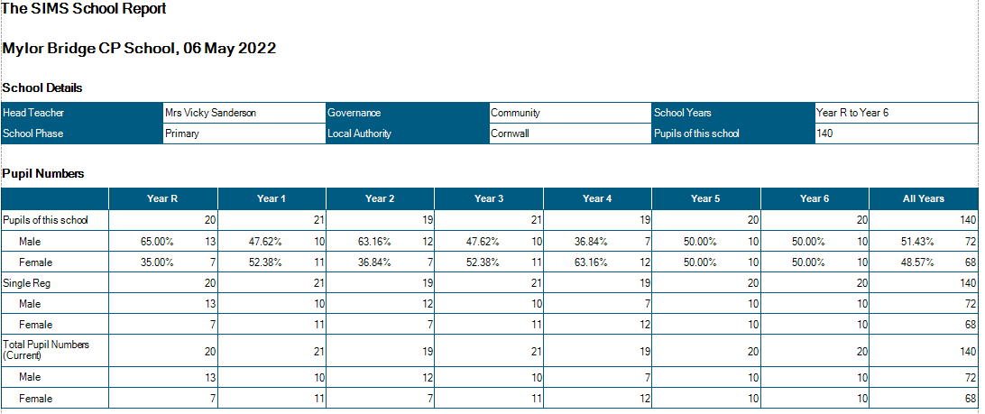

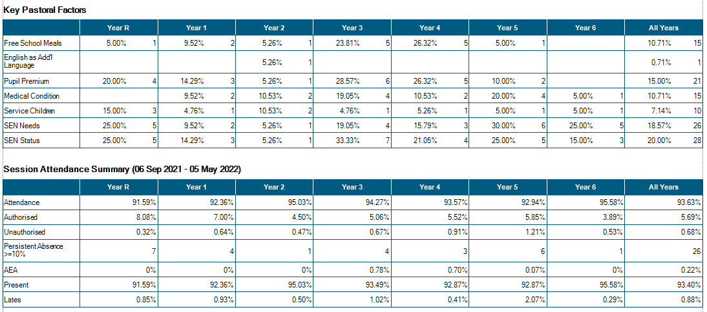

Attendance

The effects of continuous COVID19 PCR testing is taking a toll on the attendance in school – lots of this non-attendance is due to children having being slightly unwell, taking a PCR test and then awaiting the results. Children are now, in the most back at school-but very few have 100% attendance this term (26%)

From September, classes run in the following manner:

Class Structure from September 2021
Class 1:  EYFS -20 Year 1 - 10 | Mrs Mogridge (Mon – Wed)  Mrs French (Thurs-Fri)  Mrs Evans TA 09:00 – 15:15  Mrs R Wilkes 1:1 TA 09:00 – 15:15  Miss Short TA 09:00 – 12.00  Mrs E Lloyd 1:1 TA 09:00 – 15:15
Class 2:  Year 1 – 9 Year 2 – 21 | Mr Shainberg  Mrs Armstrong TA 09.00 – 15.15
Class 3 Year 3 - 19 | Mrs Thomas (Mon-Wed)  Mr Sanderson (Thurs-Fri)  Mr Collier 1:1 TA 09.00 – 15:15
Class 4 Year 4 - 21 | Mrs Wood (Mon-Wed)  Mrs Medlin (Thurs – Fri)  Mrs Stevens Mon - Fri 09.00 – 12.15
Class 5 Year 5 – 19 | Mr Martin  Mr Wilcox 1:1TA M-F 09.00 – 15.15  Mrs Pearson 1:1 TA Mon-Fri 09:00 – 12:15
Class 6 Year 6 - 18 | Mr Collinge  Mrs Garland (Tues – Thurs 9.00 - 12.15)
PPA Cover  Subject leadership cover | Mr Mutsaers – PE Classes 2/4/5/6  Mrs Hamilton Classes 2/4/6  Mr Wilcox Class 5  Mr Mutsaers
Intervention | Mrs Hamilton Monday 14:00 – 16:00 Tuesday – Friday 13:00 – 16:00  (Funded through national catch-up funding)
Intervention | Miss Short Tues – Fri 13.00 – 14.30 Phonics
Intervention | Mrs Pearson Mon- Fri 13:00 – 15:00 NELI/ Number Stacks (Funded through national catch-up funding)
Intervention | Mr Wilcox 08:15 – 09:00 Mon- Fri (funded through national tutoring programme)

Significant Changes/Challenges Since the last Head Teacher’s Report

- Since February, we have had a more settled experience in school – the vast majority of staff have been back into school, with only a few absences for COVID.
- Attendance continues to be of concern – though the majority of pupils have increased attendance, a number of identified pupils have been effected by COVID and ongoing health issues – VS has a meeting with the EWO this term
- VS has worked with Mawnan and Flushing Schools to peer review the Safeguarding Audit – S175, which was completed with the help and input from T.Gittens (Safeguarding Governor)
- Helen Trelease (Safeguarding consultant) completed safeguarding assessment – see appendix

- New SENCo employed for after February half term has resigned due to ill health – a replacement SENCo – permanent contract has been employed, starting in September. Jackie Frost to remain in post until July 22
- Request from parents to offer after school wrap around care – audit has taken place and VS is working with a parent to investigate the options.
- Training for KS2 staff on Google Classrooms
- TWINKL phonics has been accredited at a DFE approved Phonics Scheme – Twinkl training for staff to take place in June.
- VS has become a governor at Trewergie Infants School
- New School Improvement Partner has been employed (Justine Hocking – OFSTED)
- HT was involved in interviews for HT at Flushing School – we hope that this partnership between Mawnan and Flushing will continue with a new HT in post.

Quality of Education.

- Learning walk by HT this half term continues to show positive learning culture in school. Vast majority of pupils actively engaged in learning.
- Feedback from children, shows that they are enjoying lessons, able to voice and exemplify the values of the school and can highlight where they need to make changes/ improvements to learning.
- Reading lead ( JT -KS2) continues to monitor the progress of the lowest 20% of readers – improvements in reading decoding and comprehension have been assessed – feedback to staff given.
- Reading lead (JT) has monitored and ensured that adults – including teachers are prioritising reading with the lowest 20%, that reading is high profile in school and that reading books are matching AR book levels in all classes.
- Phonics lead (SS KS1) has been closely monitoring the impact of phonics across KS1 – re-streaming groups on a 6 weekly basis. We have now brought on-board a 7th phonics group to deliver to smaller group sizes.
- HT monitoring on phonics shows that high quality phonics is being delivered in the majority of groups – with support in place for 1x lead and training in place in June for all staff.
- Informal monitoring of handwriting and presentation shows that improvements across the school can be seen in this area. Spelling continues to be a focus, but improvements can also be seen with children using a wider range of strategies to find the correct spelling and repeated mis-spelt words being monitored. – Please see appendix (Sept – present. Y1/ Y4/Y5/Y6 examples)
- KO from previous years are shared prior to new topics.
- Writing moderation shows that improvement and progress has been made since September
- HT completed a Maths and English book look (Summer 1) marking in place and in line with policy.
Feedback given is in the vast majority, actioned. Purple polishing evident.
- Slower than previously planned progress in being made in Maths – with every class still working through Autumn objectives – due to the need to plug gaps are revisit learning from previous years. (Action: monitor carefully by Maths subject leader and HT to ensure that Ready to Progress indicators are prioritised.)

- Curriculum development remains a large focus for school – this year’s monitoring timetable has been planned to ensure that all subject leaders have the opportunity to observe their subject being taught, alongside the triangulation of pupil conferencing/ book looks/ planning monitoring/ resource auditing
- Assessment takes place within all subject areas. Foundation subject assessment takes place at the end of each topic. Reading and maths assessments take place at least half termly – with formalised assessment at the end of each term.
- Close monitoring and assessment shows that the previously lower attaining and SEND pupils are the groups who have most suffered academically during the lockdown. High quality, well-planned interventions have been put into place quickly to ensure that these pupils’ needs are being addressed and gaps are being filled; SEND pupils are slower in filling gaps than non-SEND. (see appendix for intervention tracker)
- Resilience in pupils who attend these interventions, is in the main extremely high – with some pupils attending 3x weekly afterschool intervention. (Action: HT to write to parents of non-attendees)
- In KS1 intervention is focussed on same-day catch-up alongside a focus on daily reading with the teacher/ TA.

Behaviour and Attitudes

Behaviour and attitudes of pupils to very positive –feedback from pupil questionnaires in April 22 shows that:,(see appendix)
- 100% feel safe in sch
- 100% know who they can talk to if they are unhappy about anything in sch
- Pupils understand why School and British values are important.
- 94% of pupils believed that pupils behaved well at school
- 91% of children said they were happy – very happy in school (45% very happy)
Feedback from parents was incredibly positive
- 100% of parents saying that their child is happy/very happy at school
- 100% saying their child is safe at school.
- 100% saying that school has high expectations of pupils
- 95% of parents said that pupils were well behaved
Assemblies and shared learning times show that children are aware of and understand the importance of School and British Values.
Some low-level behaviour on the playground has highlighted the continued need to talk through and understand the presentation of tricky behaviour – esp with a number of our children now working with outside agencies for mental health and wellbeing.
Pupils move around school in a mostly calm and well-mannered manner. Those who are most excitable are reminded of the expectations.
Class 4 have a number of children with heightened anxiety, a bespoke wellbeing curriculum is in place throughout the day for this class to support and calm these children.
Children who present with trickier behaviour, are supported through Trauma Informed Schools provision and/or Draw and Talk.

High expectations of behaviour, manners and attitudes are modelled by all staff, and staff have high morale and a great sense of team work.

We currently have:
- 1 x child with a Special Guardianship Order
- 2x children with active court orders.
- 1x child with court allocated mentor
- 2x children currently working with social care – with allocated social workers.
- 1x Team Around the Child (TAC) plan in place
- 1x teacher of the deaf involved in planning and adapting provision in school
- 1 x teacher for the visually impaired working with 2x pupils
- 1x referral to First Light – domestic violence support, allocation awaiting.
- 1 x Noah’s Ark support in place (in school time, alternative provider)
- 2 x pupils awaiting SEND Southwest Assessment
- 3 x children working with CAMHS
- 2x pupils working with FSW
- School have made 1 X MARU referral which has gone to section 47 Social Care assessment (40 day assessment)
- 2x Children have been assessed by the Learning and Cognition Service
- 2x SALT referrals
- 1x child ASD assessment confirmed
- 2x Children on ADHD pathway
- 2x child on ASD pathway

- There have been 0 incidents of Team Teach since the last HT’s report. These incidents have currently abated.
- There have been 0x parental concerns raised regarding unkind behaviour in school
- There has been 1x case of inappropriate sexual language this term – dealt with by HT
- There has been 1x reportable accident this term

Personal Development and Cultural Capital
In order to offer our children a wide range of learning experiences and opportunities, we ensure that we take the learning beyond the classroom as often as possible. Since February half term, the following opportunities have been offered to support learning, develop cultural understanding, engage learners and develop skills…

- All sports events – inc leagues have returned this year. To date this term we have taken part in :
        - Quad Kids
        - Indoor athletics
        - Hockey league
        - Tag Rugby league
        - Cross country

Children have also taken part in a number of educational visits/ trips/ experiences including
  - Emersion visit to Meanporth Beach, English (Y6)
  - Science biodiversity unit lead by Exeter University (y5)
  - Rural culture and agriculture show – cultural capital (Y3/4)
  - Visits to the community Garden – Science (Y2/1)
  - Forest School – All aspects of curriculum (Y1/YR)
  - Geevor Tin mine – History (Y4)
  - Gwenap Pit - RE (y4)
  - RNLI – water safety (whole school)
  - Tate St Ives and Barbra Hepworth – Art (Y4)
  - The Cornwall Islamic Community Centre – RE (Y3)
  - Student Council Litter Picks (all year groups)
  - Buns for Books – charity events (all classes)
  - Sunflowers for Ukraine – Charity event (all classes)
Extra-Curricular Clubs 2021-2022
Autumn Term
Club | Year group | Teacher
Football league | Y5 and 6 | Mr Collinge
Football Club | Y3/4/5/6 | Mr Martin
Netball league | Y5 and 6 | Mr Sanderson
Samba Club | Y2 | Mr Shainberg
Huff and Puff | Y1 and 2 | Mrs Mogridge
Lego Club | Y3/4/5/6 | Mrs Wood
Yoga | Y3/4/5/6 | Mrs Ashbury (£4 per session)
Running Club | Y3/4/5/6 | Mr Martin

Spring term
Club | Year group | Teacher
Basketball league | Y5 and 6 | Mr Collinge
Basketball/ netball Skills Club | Y3/4/5/6 | Mrs Medlin
Youth Speaks | Y5 and 6 | Mr Sanderson
Samba Club | Y2 | Mr Shainberg
French Club | Y1 and 2 | Mrs Mogridge
Drama Club | Y3/4/5/6 | Mrs Thomas
Yoga | Y3/4/5/6 | Mrs Ashbury (£4 per session)
Running Club | Y3/4/5/6 | Mr Martin
Dance Club | Y3/4/5/6 | Embrace Dance (£4 per session)

Summer term
Club | Year group | Teacher
Tag Rugby league | Y5 and 6 | Mr Martin
Cycling Club | Y2 | Mr Shainberg
Reading Club | Y1 and 2 | Mrs French
Drama Club | Y3/4/5/6 | Mrs Thomas
Yoga | Y3/4/5/6 | Mrs Ashbury (£4 per session)
Running Club | Y3/4/5/6 | Mr Martin
Dance Club | Y3/4/5/6 | Embrace Dance (£4 per session)

In order for staff to continue to remain up-to-date and be empowered to move our school forwards, a comprehensive, SDP-based CPD programme has been put into place.

CPD since February Half term :
VS - Safeguarding training – Helen Trelease
MC – Metacognition and Learning Skills – EEF
All staff – County Lines safeguarding training
All Staff – Equality and Diversity Training
MC and AM – Maths Hub training
JT – English Hub training in reading engagement
SS – English Hub – Early Reading update

Effectiveness of Leadership and Management

- Since February half term, the focus for subject development has concentrated on the development, adaptation and roll out of Knowledge organisers – see appendix for examples.
- Staff shared KO and a strategy for utilising these to reignite prior learning for KS2 pupils is now in place.
- Feedback from reading monitoring has been actioned to ensure that all KS2 pupils have reading ages and book band levels clearly displayed in reading diaries and bespoke reading diaries are being designed to ensure that reading is kept as high priority within school.
- English Hub have completed a Phonics Review and verbal feedback has been positive (written report pending)
- RE feedback shows that pupils are able to talk about their learning in RE – children are able to remember some prior learning and make links across some aspects of their learning egg: the Christian story of creation.

- RE (History and Geography) governor visits shared information on current position of RE (and Geog/Hist) and outlined future next steps – see appendix for Gov reports

Other governor visits to have taken place include: Science/ English/ Maths/ SEND/Safeguarding – please see appendix for reports. Governor visits are a very positive experience for staff (and I hope for governors) as it allows leaders to share what has been achieved to date and to talk through key action points for next steps. Thank you Governors for your help and time in completing these visits.
(Action: from Feb HT’s report = golden threads for RE, Science are now in place . Threads for Geog to be in place by Sept 2022)
CPD and subject leadership time has been carefully matched to the priorities of the school development plan, and all subject leaders have the opportunity to observe, monitor and discuss their subject being taught across the school, Inc. meeting with lead governors to discuss development plan and areas of celebration.

Work/Life Balance is supported
Ongoing support:
Teaching staff are encouraged to complete PPA at home.
Parents evening consultations are started at 13:00 to reduce pressure on late night consultations.
All teaching staff run an after school activity reducing the burden on a few members of staff running more than 1 club.
Blended staff meetings (held on Zoom and in real life) to allow part time staff to join us if they are able to.
Subject leadership is given ring-fenced time to ensure quality and depth of understanding.
Support from leadership and governors for family commitments (e.g. appointments/ children’s plays etc.)
Embedded positive ethos of team work well established across all team members.

Safeguarding
Safeguarding is an integral aspect to all leadership and management decisions.
Safeguarding is a standing item on the staff training agenda (weekly) and the TA (weekly) briefings. All staff know that they are accountable for safeguarding and take this role very seriously.
MyConcern is now used to record all concerns, and conversations had with parents regarding pupils.
Safeguarding training is up to date and DSL and DDSL have up to date safeguarding training. (Action: Safeguarding training in place for governing board KCSIE part 2)
County Lines training has taken place for all staff
Peer on Peer training scheduled for June 2022

Abbreviations:
9 Protected Characteristics (age, disability, gender reassignment, marriage and civil partnership, pregnancy and maternity, race, religion or belief, sex, and sexual orientation.)
ASD – Autistic Spectrum Disorder
British Values - Democracy. The rule of law. Individual liberty. Mutual respect. Tolerance of those of different faiths and beliefs.
CAHMS – Child and Adolescent Mental Health Service
CT – Class Teacher
EYFS – Early Years Foundation Stage (First year in school aged 4-5 yrs.)
FSW – Family Support Worker (Works with the Social Work Team)
HT – Headteacher
KCSIE – Keeping children safe in education- national safeguarding document which outlines accountability for safeguarding in education.
NELI – Nuffield Early Language Intervention – support for EYFS pupils to develop early language skills
POP (Quizzes) – Proof of Progress
SENDCO – Special Needs Coordinator – trained teacher who also holds the SEND qualification and over sees provision for our pupils with SEND.
SEND – Special Educational Needs and Disabilities.
SW – Social Worker
TIS – Trauma Informed Schools (practitioner) School-based trauma support.
Team Teach – Physical Intervention (e.g. to stop a child hurting themselves or others)
TA – Teaching Assistant

