Phonics and Early Reading
Intent Statement
Intent
At Mylor Bridge, we are passionate about ensuring all children become confident and enthusiastic readers and writers. We believe that phonics provides the foundations of learning to make the development into fluent reading and writing easier. Through daily, systematic and consistent high quality phonics teaching, children learn to segment words to support their spelling ability and blend sounds to read words. To allow our children to develop a strong phonic awareness and effective blending and decoding skills, we have chosen to use a synthetic phonics programme called ‘Twinkl phonics’. This is a DfE approved scheme of learning, centred around recognising the correspondence between individual, or groups of, letters and the sound they represent, blending sounds together to read and spell words and applying these skills across the curriculum. Using Twinkl Phonics, the children learn to read fluently so that they can put all of their energy into comprehending what they read. Alongside the teaching of phonic knowledge and recognition, we appreciate the importance of reading fluency, comprehension and using these skills within a range of contexts. It is our intent, therefore, to provide our children the opportunity to access a variety of engaging, content rich books. We also understand that it is vital for the content of these books to be closely matched to their phonic knowledge, which allows them to consolidate their recent learning, building confidence and therefore encouraging rapid progress. We believe that teaching children to read and write independently is one of the core purposes of a primary school, enabling them to access a broad and exciting curriculum and ensuring they flourish as learners throughout their time at our school. These fundamental skills not only hold the keys to the rest of the curriculum but also have a huge impact on children’s self-esteem and future life chances.

Implementation
The use of the Twinkl phonics scheme allows our teaching and learning of phonics to be progressive from reception all the way through to Year 2 and into lower KS2 for those children who need this.
Through Twinkl Phonics, the children are taught the 44 phonemes that make up all the sounds required for reading and spelling. These phonemes include those made by just one letter and those that are made by two or more. Children work through the different levels (or phases) and, as they grow in confidence and experience, they are introduced to alternative ways of representing the same sound. The table below details the time expected for children to work through the phonics programme. Whilst we recognise that children progress at different rates and may not conform to this timeframe, we use this as a guide to ensure the majority of children are on track and to identify children who are not, and therefore in danger of falling behind.

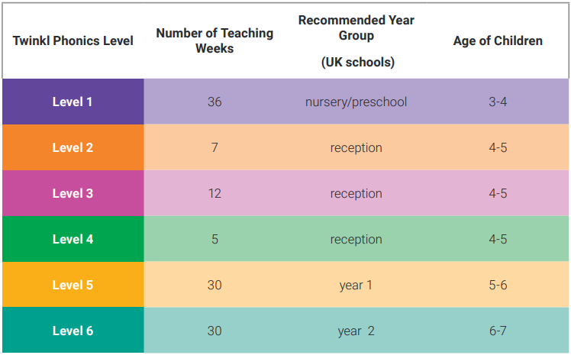

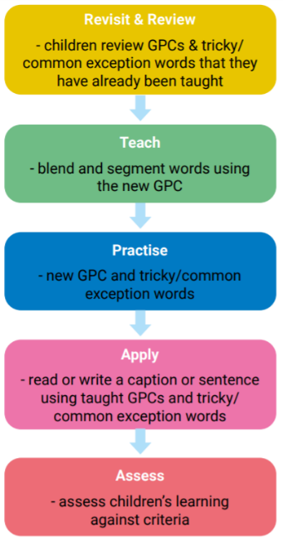
All children in EYFS and KS1 have discrete, daily phonics sessions, lasting 45 minutes (although this is shortened to 30 minutes for EYFS in Autumn term). Lessons are taught by both teachers and teaching assistants who are supported by the phonics lead in their planning and delivery. As children build up their knowledge of sounds, they are able to apply their decoding skills to any unfamiliar words. During lessons each day, children will practice their decoding skills by sounding out real and nonsense words. In the case of nonsense words, children are unable to rely on recognition of words, and instead have to use their phonic knowledge to decode these. This is an important part of the Phonics Screening Check that the children complete at the end of Year 1. Although every group is likely to be at different stages of their learning, every lesson will follow the lesson structure as set out in letters and sounds:

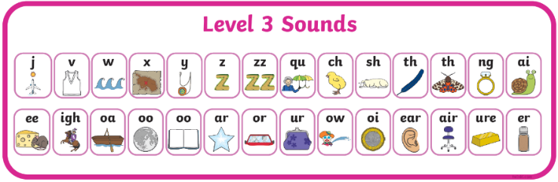
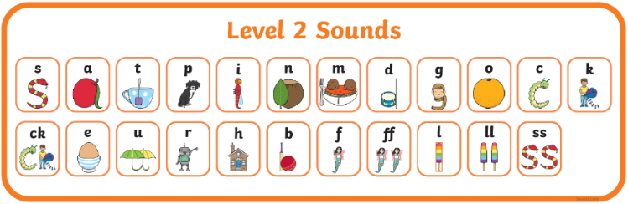
We begin in reception, by teaching level (or phase) 2, which is the beginning of the systematic phonics programme. The children are then able to work through the scheme systematically, taking small steps to ensure they are able to embed and apply what they have learnt. The order in which children learn the 44 sounds and their related graphemes is as follows:

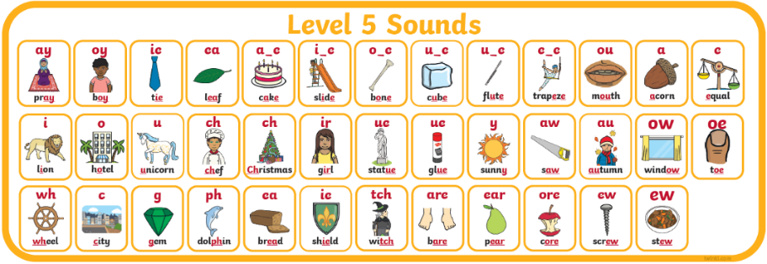

Throughout EYFS and KS1, children are taught in small, focussed groups to target their specific phonic needs, alongside children of the same ability. These groupings are based on half-termly assessments, carried out at the start of each school year and then again half termly. This information is then collated and children are regrouped based on their current skill level, allowing progression for most children and opportunities for repetition and support for those needing more time on a specific set of sounds.
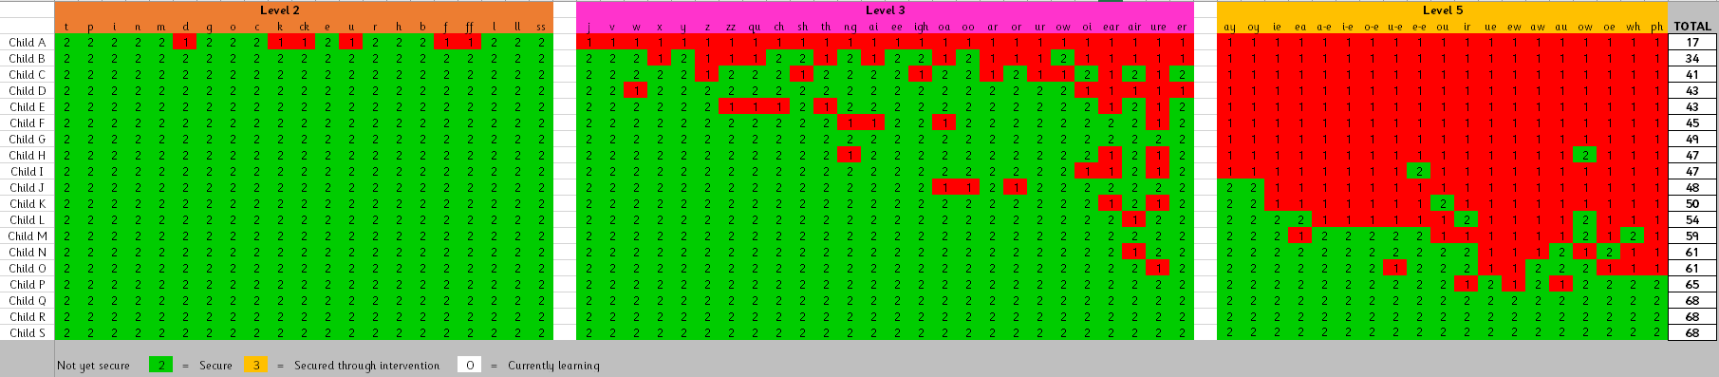
The half termly assessments are also used to identify any children who are in danger of falling behind. These children are then ‘picked up’ for targeted interventions in the afternoons. After half termly assessments have taken place, the results for each individual child are entered into a progress tracking spreadsheet (example below) where gaps in each child’s phonic knowledge are clearly represented as red cells. This allows the phonics lead and class teachers to identify children needing interventions and the specific phonemes these children not secure with.

Interventions are used predominantly for 2 reasons:
- Provide additional support for children who are not progressing through the SSP at the expected pace.
- Fill gaps for those children who are ready to move on but have a small number of previous sounds that are not yet secure.
We make sure that pupils read books that are closely matched to their increasing knowledge of phonics and ability to read ‘tricky words’ so they experience early reading success and gain confidence as readers, as well as consolidating the learning that takes place in school. Our book band system has been designed so that children can be placed in an appropriate book band level and sub-set and can be allocated home-school reading books that match their level of phonic knowledge. In this system, children will only encounter words with sounds, or tricky words, they have already learnt. More information regarding this is available in the ‘Early Reading Scheme Overview’ document.

Impact
Through the consistent, systematic and daily teaching of the Twinkl Phonics programme, our aim is for children to become fluent, confident readers by the end of Key Stage One. Children are assessed at the end of Year 1 using a Statutory Assessment Tool known as the Phonics Screening Check. This screening check confirms whether the child has learnt phonic decoding to an appropriate standard and will identify sounds needing further support in Year 2. The children are assessed one to one, by a member of staff who is familiar to them. Those who do not pass the screening check will continue their phonics lessons in Year 2 by being streamed into the appropriate group within the EYFS and KS1 phonics sets, allowing them to consolidate and develop their confidence within a group working at their specific ability. This will ensure they will be ready to retake the screening check at the end of Year 2 and ensure they are ready for the expectations of Lower Keys Stage 2. Through the Twinkl phonics programme, children will be equipped with the skills to decode unfamiliar words using strategies that they have been taught in their daily lessons. This ensures children can focus on developing their fluency and comprehension as they move through the school. We envisage and hope that this leads to a love of reading and children taking pleasure in exploring the rich literary world around them with a firm phonic basis to support them.
The effectiveness of the approach outlined in this document will be continuously reviewed by all members of staff involved, these being the group leaders, class teachers, the phonics lead and the head teacher. The summative assessments carried out at the end of every half term and the phonics screening check for the end of Year 1 support staff in this process. If a significant number of children are not making the expected progress, as outlined in the progression overview above, staff would need to address this and consider the steps needed to improve the success of this approach.

