**Knowledge organiser. Geography Year 4. Spring term 2. Local area. Where is Mylor Bridge?**

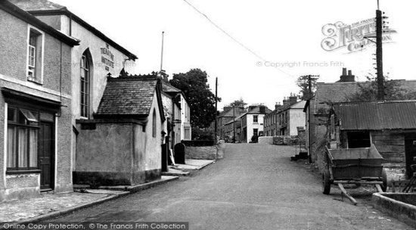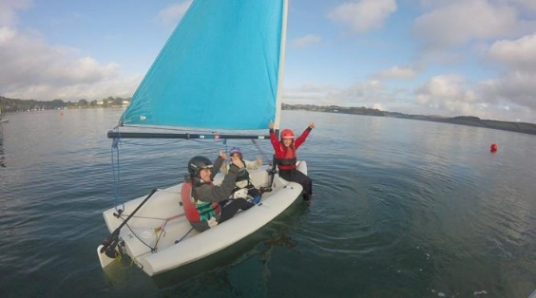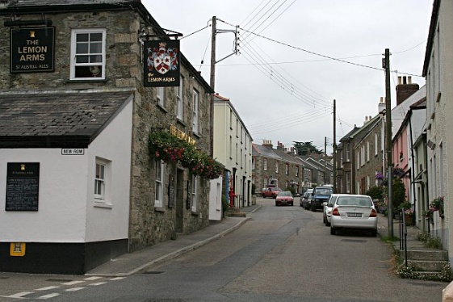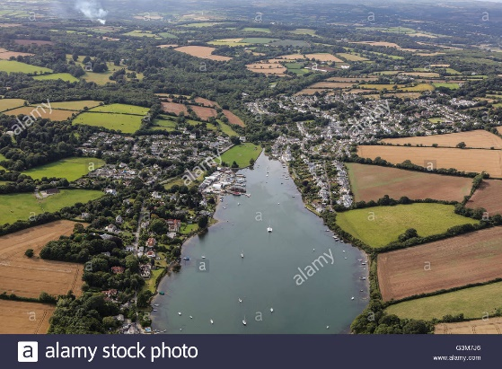

**Where is Mylor Bridge?**

Mylor Bridge is a small village located in the South West of England, in a county called Cornwall. It is about 4 miles from the town of Falmouth and 8 miles from the city of Truro. 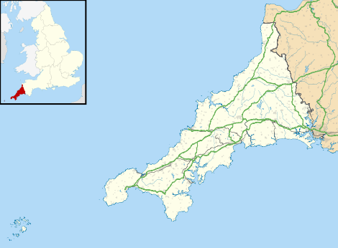

**Key Vocabulary:**

**Locality :** where something is positioned

**Human features:** come from human ideas and actions

**Physical features:** natural occurring features on the land

**Landuse**: how surrounding land is used

**Graphs:** a way to display information

**Tourism:** industry where people travel for recreation and leisure

**Village**: group of houses and associated buildings

**Landscape:** all the visible features of an area of land

**Agricultural, Residential, industrial, recreational**

**Who visits the area and why?**

Tourists due to the area being AONB and excellent recreational facilities.

Royalty to celebrate award winning boat building.

Popular eateries with The Lemon Arms and The Pandora.

**What is the landscape like?**

Mylor Bridge is bounded by water on 3 sides. Carrick roads to the east and Falmouth Harbour to the south. The area itself is an Area of Outstanding Natural Beauty (AONB). There is a variety of walks and interconnecting pathways across rich farmland.

The village itself is situated at the end of the river creek and is very well served with houses, village hall, doctors, dentists, hairdressers and 2 village pubs.

**How has the locality changed over time?**

Housing developments expanding the building around edge of village. Residential homes replacing small businesses.

Use of outdoor spaces like the village park.

**How is the land used?**

**Agricultural** with rich farmland surrounding the village. **Industrial** with 2 working boat yards. **Recreational** with access to footpaths, water usage both on creek and from Mylor Harbour. **Residential** Housing, both old and new builds.