Cornwall and tin mining.
Ag – Silver | As – Arsenic | Au – Gold | Cu – Copper
Mn – Manganese | Pb – Lead | Sn – Tin | W – Tungsten

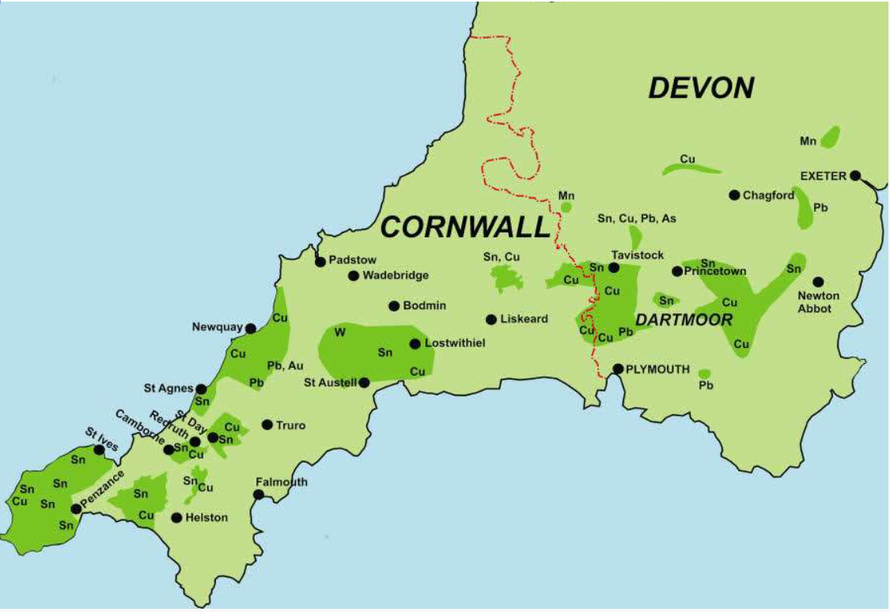
Cornwall and Devon are rich in a variety of metal ores, and are the UK’s only source of tin. It was found in veins associated with five major granite intrusions (Land’s End, Carnmenellis, St Austell, Bodmin Moor and Dartmoor) and eleven small ones (St Michael’s Mount, Tregonning-Godolphin, Carn Brea, Carn Marth, St Agnes, Cligga Head, Castle an Dinas, Belowda Beacon, Kit Hill Hingston Down and Hemerdon Ball) of Lower Permian age (280 Mya). As the granites cooled metal-rich fluids from them entered faults and cooled to form mineral veins, some of which were rich in metallic sulphides, oxides or carbonates. These included: tin, copper, iron, arsenic, lead-silver, zinc, tungsten and manganese.
Tin was being worked in Cornwall and Devon up to 4000 years ago, and by mediaeval times, along with lead and wool, it was one to England’s main exports. From 1198 the Cornish tinners had royal protection for their activities and bodies called stannaries’ were established to oversee and regulate the mining, smelting and sale of tin.

Early Bronze age 2,400 – 1,500 BC (4,000 years ago)
Settlers used Cornwall’s rich natural resources of tin and copper.
Open cast mining
Tin streaming
1720 (300 years ago)
Dolcoath tin mine Camborne Most celebrated tin mine opens

1778 was 160 workings deep
By 1864 employed 1200 people
10 engines
7 water wheels
Man engines
1721: Botallack Mine opens
By 1800, over 100 workings, including long distance ones under the sea.
One of the richest tin mines
1740: expansion of deep copper mining was rapid, this was the beginning of INDUSTRIAL REVOLUTION.
Invention of machine driven steam pumps allowed mines to become more money making
1801- 1840 rapid expansion of mining following the invention of Trevithick’s high pressure engine
75 mines working iin Cornwall employing 16,000 people.
1823: (200 years ago)
Gwennap Tin mine produced 30.1 % of Great Britain’s copper and 37.7% of total Cornwall copper and tin.

1840’s significant migration to Mexico to the silver mines, iron mines in Canada and Australia.
1866: collapse of copper prices. Deindustrialisation of Cornwall began.
Increase in Cornish migration.
1914: Mining ceased at Botallack.
1920: (100 years ago)
Dolcoath: underground mining ceased.
Tin mining had ceased by 1990.
2006 : UNESCO heritage status was granted.

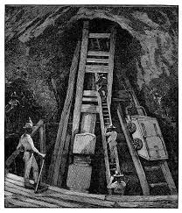
Why was tin so important?
Tin, and later copper, were the most commonly extracted metals. Some tin mining continued long after the mining of other metals had become unprofitable.
The tin works of Devon and Cornwall were of such importance that the medieval kings established stannary courts and stannary parliaments to administer the law in Cornwall and part of Devon. Up to the mid 16th century, Devon produced about 25–40% of the amount of tin that Cornwall did, but the total amount of tin production from both Cornwall and Devon during this period was relatively small.
The areas of Cornwall around Gwennap and St Day and on the coast around Porthtowan were among the richest mining areas in the world. At its height the Cornish tin mining industry had around 600 steam engines working to pump out the mines (many mines reached under the sea and some went down to great depths)

The Levant tin mine disaster.
In 1919, the man engine suffered a disastrous failure when a link between the rod and the engine snapped, killing 31 men.

The mine never opened again.

What was the impact on the landscape/community?
Life of a miner and Bal Maiden- conditions they worked in and out of mine. Dangers from explosions, temperature changes, rickety ladders.
Red rivers – deposits from the copper and tin were drained out into the water system and local streams and rivers became ‘red’.
Steam engine houses were built with tall chimneys. You still see them on the landscape today.
Destruction on the landscape- great engines lifting water, valleys ripped apart by work and buildings, now lay silent.
‘cornwall was made by nature, then remade by miners.’
What the miners did in their spare time- small holdings, wrestling, Methodism.
On 13 July 2006 select mining landscapes across Cornwall and West Devon were inscribed as UNESCO World Heritage Sites, placing Cornish mining heritage on a par with international treasures like Machu Picchu, the Taj Mahal and the Great Wall of China.

Bal Maiden | Cornish language for female of the mine.
wheal | Cornish language for place of work
shaft | Long deep tunnels through which the workers could access the underground tunnels of the tin mines
Industrial revolution | Period of time, where industry was at it’s peak- largely due to the invention of machines to enable maximum productivity within the workplace.
lode | Vertical or horizontal ‘vein’ of mineral to mine.
ore | The mineral found within the ground rock.
The Levant tin mine disaster.
In 1919, the man engine suffered a disastrous failure when a link between the rod and the engine snapped, killing 31 men.

The mine never opened again.

