Music Policy
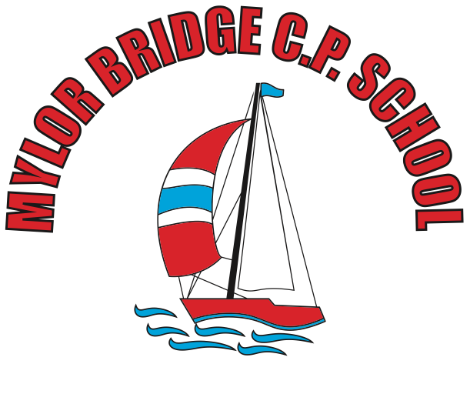

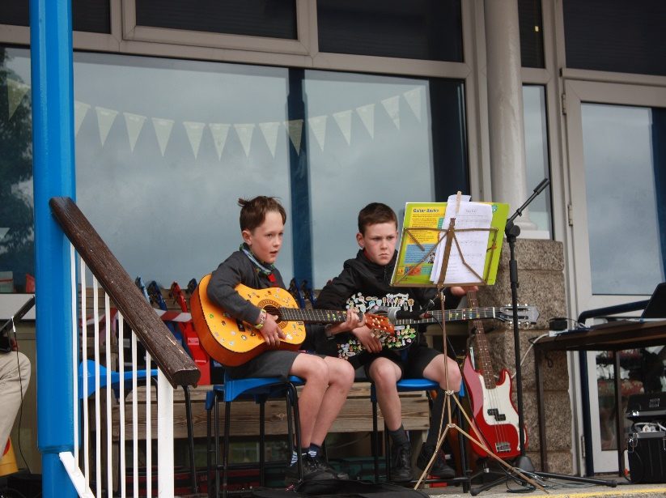

2023-2024

Our Vision
At Mylor Bridge School, we aim to provide all our children the opportunity to fulfil and exceed their potential within Music. We have various opportunities for the children to learn, perform and thrive in Music in each academic year.
These are the aims of the National Curriculum (2014). At our school, we believe it is pivotal for children to have the opportunity to learn how to listen to, appreciate, perform and create music. It is a means of communicating, expression and understanding the world around them.
Our school objectives are as follows:
- Know and understand how to make sounds and how they can be assembled together
- Appreciate and know different instruments make music
- Understand how music can be written down and transcribed
- Know how time and place influences its music
- Developing skills in listening, composing, recording and performance of music.

Planning and Assessment
At our school, we follow the Charanga scheme. This allows teachers the opportunity to assess the children throughout lessons. Following a performance or upon completion of a piece of work, teachers can give oral or written feedback as necessary to inform future progress. As the children progress through the school, they are encouraged to be more evaluative of their performances in keeping with the Listen, Compose, Record, Perform cycle.
Additional Music Tuition
At Mylor Bridge School, we have tuition in guitar, piano, violin, brass and woodwind instruments. These are all taught by peripatetic teachers who come in from the Cornwall Music Trust to work with our children.
Visits and Performances
Throughout the academic year, each class puts on a community performance. This creates a link between our music learning in school and shares with other members of our village community. The outline for each of these is shared below:
Class 1 | Key Stage 1 Singing Celebration | Songs learnt throughout the year
Class 2 | Key Stage 1 Singing Celebration | Songs learnt throughout the year
Class 3 | Mylor Café | Christmas carols and songs
Class 4 | Mylor Café | Christmas carols and songs
Class 5 | Local luncheon club | Songs from the Christmas production
Class 6 | Leavers’ Concert | A celebration of their musical journey at MBS
In addition to these community performances, we also celebrate Music at Mylor Bridge School in the following events:
- Christmas Plays –before each performance, the children who are learning musical instruments have a chance to perform for the parents. The audience is usually around 100 people. We liaise with the instrumental teachers so they can help the children to prepare a piece to perform for these occasions.
- Easter Concert – each year, we hold a concert at our local village hall. This is usually an hour in duration and celebrates all aspects of music at Mylor Bridge School. We have had former pupils come back and perform, Key Stage 1 and 2 students, parents who work in the music industry and teachers who have played in these events. It is also allows children to perform with a full PA system on a stage before an audience of over 100.
- Choir club - the school has a choir club that meets after school weekly to enjoy singing together

Half-Termly Genre Focus

As part of our appreciation of music, each half term, we focus on a different genre of music and at the end of that half term we host a concert with a professional musician specialising in that genre come in and perform.
 | Autumn 1 | Autumn 2 | Spring 1 | Spring 2 | Summer 1 | Summer 2
Year A | Classical  - Bach  - Vivaldi  - Beethoven  - Mozart  - Wagner | Jazz  - Miles Davis  - Les Paul  - Herbie Hancock | Folk  - James Taylor  - Bob Dylan  - Joni Mitchell  - Simon & Garfunkel  - Brother and Bones* | Country  - Glenn Campbell  - Willie Nelson  - Brad Paisley  - Chris Stapleton | Pop  - Bee Gees  - Phil Collins  - Spice Girls  - One Direction  - Billie Eilish | Funk  - The Gap Band  - Earth, Wind and Fire  - Chic  - Prince  - Daft Punk
Year B | Rhythm and Blues  - Etta James  - Aretha Franklin  - Stevie Wonder  - James Brown  - Michael Jackson | Soul  - Otis Redding  - Sam Cooke  - Whitney Houston  - Luther Vandross  - Amy Winehouse | Blues  - Robert Johnson  - Muddy Waters  - BB King  - Eric Clapton  - Joe Bonamassa | Rock ’n’ Roll  - Buddy Holly  - Chuck Berry  - Elvis Presley  - Rolling Stones  - The Beatles | Rock  - The Who  - Jimi Hendrix  - Queen  - Def Leppard  - Kings of Leon | Metal  - Led Zeppelin  - Black Sabbath  - Iron Maiden  - Van Halen  - Metallica

Coverage
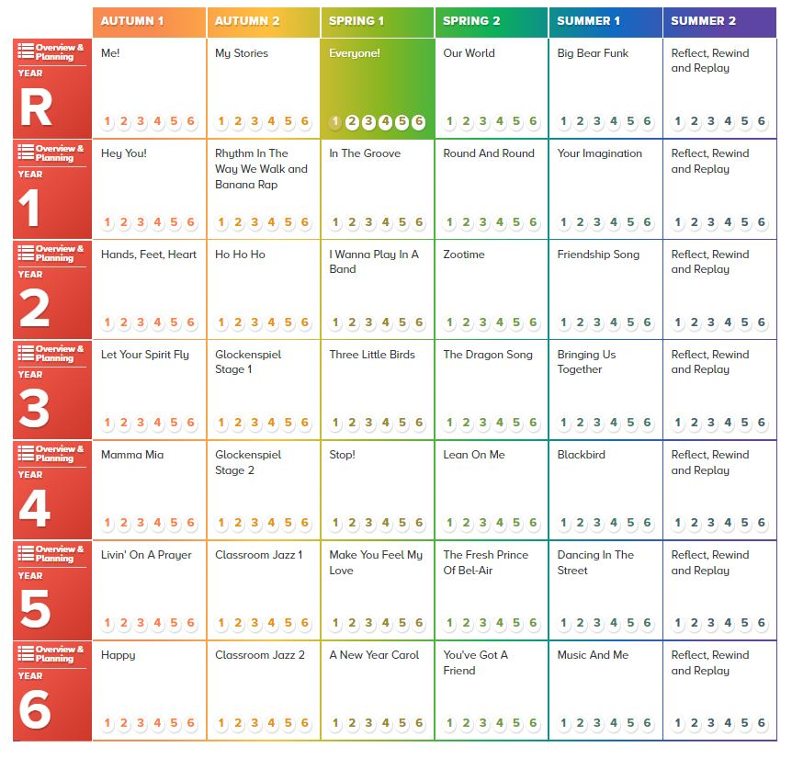
These genres and song foci are starting points for our curriculum. For example, Year 5 start by listening and appraising Livin’ on a Prayer by Bon Jovi, but also consider other rock songs from that time period. This gives our children a wider range of songs to listen to and get inspired by.

We have ensured our musician foci are diverse and take inspiration from different communities around the world.

In the Summer term, we celebrate the pieces we have learnt during the year and record some of our favourite songs we have learnt to contribute to an album.

History of Music

Once per half term, Mr Collinge visits each class to share our genre focus for that half term. This acts as our ‘History of Music’ events as discussed on the Charanga website:

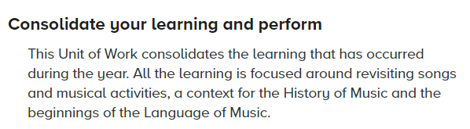
Resources
We have a variety of musical instruments at school including keyboards, guitars and a range of percussion instruments. We check the quality and condition of the instruments each year and upgrade them when we can. Teachers also use the interactive resources associated with the Charanga scheme to support their teaching.
Each year group focuses on a particular instrument to try and build proficiency in this instrument. By the time each child has left Mylor Bridge School, they would have had two years of teaching using each of our class instruments.
Year Group | Instrument | Taught by
Class 1 | Boomwhackers | Mrs Mogridge
Class 2 | Keyboards | Ms Pearson
Class 3 | Ukuleles | Mr Collinge
Class 4 | Boomwhackers | Mrs Thomas
Class 5 | Keyboards | Mr Martin
Class 6 | Ukuleles | Mr Collinge
Roles and Responsibilities
The subject leader is responsible for monitoring the teaching of Music across the school. This is to be done by lesson drop-ins, discussions with children in all year groups and ensuring the school is well equipped to teach Music effectively.
Class teachers are responsible for teaching Music regularly, following the Charanga scheme to ensure full coverage has been achieved in each year group. In order to keep up to date with current changes or curriculum developments, the subject lead should report to the staff to ensure we are delivering the highest quality lessons we can for our students.
Fundraising
Working with parent volunteers, some of our concerts and performances are ticketed in a bid to raise funds to update and improve instruments and resources for the school. This is reviewed annually to identify what the funds would be best used for.

