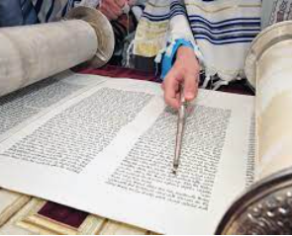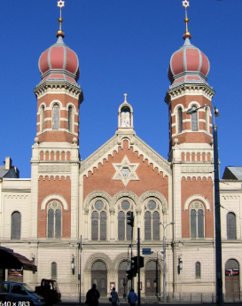

**What should I be able to do at the end of this topic?**

* Jews believe that God tells them in the TeNaKh (the whole Jewish Bible) the way of life that they must follow.
* The TeNaKh should be treated with utmost respect.
* The TeNaKh is equivalent to the Christian Old Testament.
* The Sefer Torah is kept at the synagogue. It is made using traditional methods including using animal skin for the parchment which are sewn together to make one long scroll.
* If the Torah were to be dropped, traditionally you would be expected to fast for one day.
* When a Torah becomes old and worn out, it should be buried, often in the same grave as a Torah scholar.

**Key Knowledge**

**What should I already know**

* **Know some Jewish beliefs about God, sin and forgiveness.**
* **Jewish beliefs about God and his relationship with the Jewish people including how they live their lives.**
* **How Jews show their beliefs through worship in festivals.**

**MYLOR BRIDGE**

In the 2020 Census, there are six people who have a jewish religion

In the Great Britain there are over 302 000 Jewish people (and is home to the world’s fifth largest population of Jews.

What is a Synagogue? Is a Jewish place meaning ‘*come together’* Usually made of three parts: to pray, to study and to meet.

|  |  |
| --- | --- |
| Sefer Torah | a handwritten scroll kept in the synagogue. |
| TaNaKh | the written Jewish Bible (pronounced Ta-nak) |
| Torah | equivalent to the first five books of the Christian Bible |
| Synagogue - | where Jews go to worship |
| Orthodox Jew | more traditional |
| Progressive Jew | Less traditional |
| Kosher | Food that Jewish people are allowed to eat |
| Shabbat | The Jewish day of rest |

* **Explain Jewish beliefs about God and how Jewish people interpret the texts about god.**
* **Describe what the Torah is and say how it is treated.**
* **Recall some of the most important Jewish laws, e.g. what can and cannot be eaten.**
* **To understand Shabbat and the reasons why it is important to the Jewish people.**
* **Explain what happens during worship at a synagogue.**
* **Know the differences between a progressive Jew and an orthodox one**

**The differences between a progressive synagogue and an orthodox one**

**Why is the Torah so important to Jewish people?**