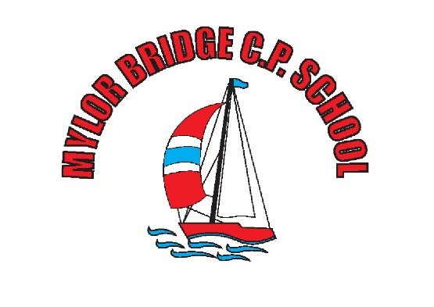
Safeguarding Compliance for External Providers working within Mylor Bridge School.
I, _______________________________________, on behalf of,_____________________________________________________________________, can confirm that all safeguarding policies and procedures, as recommended in the DFE document : Keeping children safe during community activities, after-school clubs and tuition. April 2022 are in place.
Also,
- I confirm that all staff working for the above mentioned company, at Mylor Bridge School, have undertaken appropriate safeguarding training.
- I confirm that all staff working for the above mentioned company, at Mylor Bridge School have read and understood the school’s policy on safeguarding children.
- I confirm that all staff working for the above mentioned company, at Mylor Bridge School have understood their role in keeping children safe as outlined in Keeping Children Safe in Education 2023.
- I confirm that all staff working for the above mentioned company, at Mylor Bridge School have undertaken app necessary safeguarding checks, including enhanced DBS checks.
Signed: _______________________
Company: _____________________
Date: ________________________

