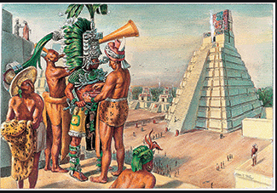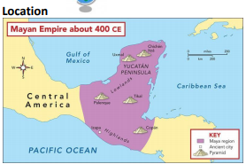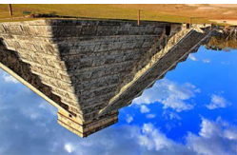 only m 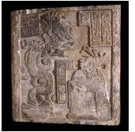

**Vocabulary**

**abandoned**: left for a long time

**astronomer**: someone who studies stars and planets

**ceremony**: a formal event at which

special things are done

**glyphs**: Symbols used in the Mayan writing system. Each symbol represents a word or sound.

**irrigation**: supplying land with water

**terracing**: steps built into sloping land

**traditions**: customs that have existed for a long time

**sacrifice:** to kill an animal or person in a religious ceremony

**uninhabitable**: cannot be lived in

**Key questions**

**Where in the world did the Mayan civilisation start?**

**What was the golden age of the Maya, and what was this time referred as in Europe?**

**How did the Maya use astronomy?**

**Which farming methods did the Maya use?**

**Can you name a significant invention or achievement of the Ancient Maya.**

**What is a sacrifice?**

**Name a famous Mayan city**

**Why might the Maya civilisation have ended?**

**Chronology**

The Maya are Native Americans of Central America, who built a great civilisation in the tropical rainforest that lasted for over 2000 years. The earliest Maya settlements were built in about 1800 BC. The golden age of the Maya was between 250 and 900 AD

**Civilisation:**

Whilst Europeans were living through a period often called the Dark Ages, the Maya were making huge innovations in mathematics, engineering, astronomy and writing. The Mayans were expert mathematicians and astronomers. They used this expertise to make calendars. This told the Maya when to plant crops, when to harvest and even when to make a sacrifice to the gods. Temples and other public buildings were built so that sunlight would hit certain places at particular times of the year, often in time for a religious ceremony. The Maya was the only major civilisation in the Americas to develop a writing system that was able to represent their spoken language in symbolic form. It had over 500 symbols or glyphs to represent words and ideas

**Location**

Temple of the Serpent, Chitchen Itza, Mexico

**The Mayan Civilization Knowledge Organiser - History**