History at Mylor Bridge CP School
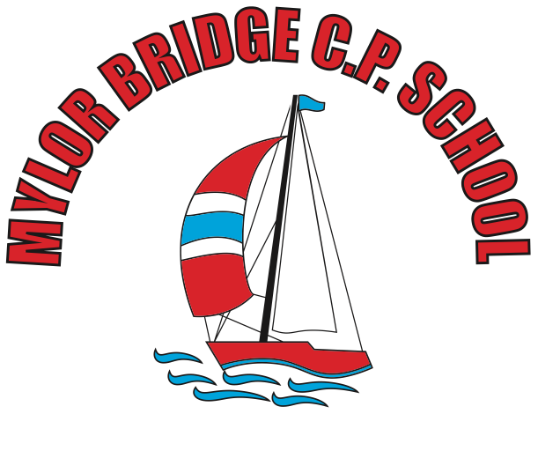

April 2020

Objectives and Aims
At Mylor Bridge School, we follow the objectives of the National Curriculum. Find our statement in the coordinator file as well as on the school website. The framework for the 2014 National Curriculum aims to:

Aims
The national curriculum for history aims to ensure that all pupils:
- know and understand the history of these islands as a coherent, chronological narrative, from the earliest times to the present day: how people’s lives have shaped this nation and how Britain has influenced and been influenced by the wider world
- know and understand significant aspects of the history of the wider world: the nature of ancient civilisations; the expansion and dissolution of empires; characteristic features of past non-European societies; achievements and follies of mankind
- gain and deploy a historically grounded understanding of abstract terms such as ‘empire’, ‘civilisation’, ‘parliament’ and ‘peasantry’
- understand historical concepts such as continuity and change, cause and consequence, similarity, difference and significance, and use them to make connections, draw contrasts, analyse trends, frame historically valid questions and create their own structured accounts, including written narratives and analyses
- understand the methods of historical enquiry, including how evidence is used rigorously to make historical claims, and discern how and why contrasting arguments and interpretations of the past have been constructed
- gain historical perspective by placing their growing knowledge into different contexts: understanding the connections between local, regional, national and international history; between cultural, economic, military, political, religious and social history; and between short- and long-term timescales

Knowledge and understanding
The children’s understanding and knowledge of historical facts are broadened through the teaching of the following key elements:
- understanding chronology
- Investigating and interpreting the past
- Building an overview of world history
- Communicating historically.

Teaching and Learning Style
Teachers aim to provide stimulating and engaging lessons that encourage a variety of different skills to enable the opportunity for all children to work to the best of their ability.
Teachers bring to life historical concepts by thinking creatively and aim to interest students and motivate them to learn. Historical trips are planned and cross-curricular links made. Children are taught how to examine historical artefacts and primary sources. In each Key Stage, we give children the opportunity to visit sites of historical significance. We encourage visitors to come into the school and talk about their experiences of events in the past. We focus on helping children understand that historical events can be interpreted in different ways and that they should always ask searching questions, such as “how do we know?”, about information they are given.
Planning
Using the 2014 National Curriculum objectives, teachers plan for the short-term, medium-term and long-term. Our planning is driven by the Essentials Curriculum and its key milestone indicators to ensure a robust progression of key historical skills.
Assessment
We assess children’s work in history by making informal judgements as we observe them during each history lesson. On completion of a piece of work, the teacher marks the work and comments as necessary. At the end of a history unit, teachers assess using a POP quiz. Reports to parents are completed at the end of the academic year when indicators are made to the individual’s progress in this area of the curriculum.
Children with SEND
Teachers take account of the three principles of inclusion that are set out in the National Curriculum:
• Setting suitable learning challenges.
• Responding to the diverse learning needs of pupils.
• Overcoming potential barriers to learning and assessment for individuals and groups of pupils
At Mylor Bridge School, we teach history to children of all abilities and needs. History is a crucial part of our creative curriculum. We use a mixture of TA support, mixed ability working groups and open-ended activities to allow children with SEN to get the most out of their primary history education.
Monitoring
Monitoring and review of the subject is in accordance with the whole school monitoring plan. The History policy will be reviewed at least once a year to reflect current practice.

