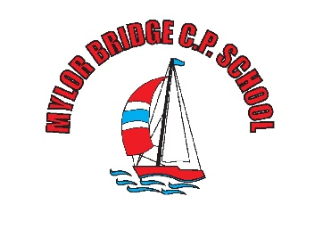
COVID19: Procedures and Mitigation Sept 21- Oct 21
Mylor Bridge Primary School

Due to Cornwall being moved into a COVID19 category, the headteacher and Chair of Governors have made the decision that the following mitigation is to be evoked - to be reviewed at the end of September 2021.
- Masks to be worn by staff in communal areas.
- Staff room is operational, but staff are requested to stay at least 2m away from one another whenever possible.
- One way systems is still in place.
- Assemblies to take place within KS1/ Y3&4/ Y5&6 groups – times TBC
- Y6 to remain with KS2 during morning play.
- KS1 to have left the hall before KS2 arrive in the hall – this may necessitate KS1 arriving slightly earlier and slower eaters finishing lunch on the benches.
- Windows to be open in classrooms.
- Hand washing/ sanitising to continue on entry and exit from classrooms. (Outside sinks can be used.)
- Individual pencil cases to be used in Classes 2-6
- Lunchtime cleaning to continue in classrooms and around the school.
- Reduced numbers of pupils in the toilet blocks.
- Staff to continue to complete 2x LFD tests Wednesday and Sunday night – report a positive result to Vicky and government.
Review date 30/9/21

