Key vocabulary
Continent | A continuous expanse of land, sometimes called a land mass.
Equator | An imaginary line drawn around the middle of the earth an equal distance from the North Pole and the  South Pole.
Mountain | A large landform that stretches above the surrounding land in a limited area, usually in the form of a  peak.
Volcano | A volcano is a vent, or opening, in Earth’s surface through which molten rock, gases and ash erupt.
Climate | The weather conditions prevailing in an area in general or over a long period.
Knowledge Organiser for Year 3 Geography Topic: Italy
Key Features and landmarks
Mountain ranges | Italy has two major mountain ranges: the Alps and Apennines. The Apennines range runs north to south down the centre of the country. The Alps stretch from Austria and Slovenia in the east all the way through  Italy, Switzerland and Germany to France in the west.
Mount Vesuvius | On August 24 79AD, after centuries of dormancy, Mount Vesuvius erupts in southern Italy, devastating the prosperous Roman cities of Pompeii and Herculaneum and killing thousands.
Colosseum | The Colosseum is an amphitheatre built during the  time of Roman Empire in Rome, Italy.
The ruins of Pompeii | A Roman town which was destroyed from the  eruption of Mount Vesuvius in 79 AD.

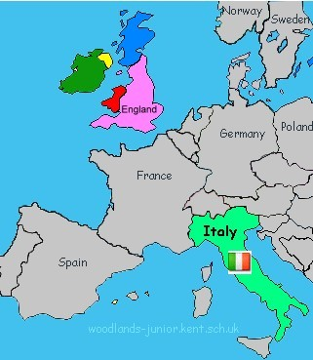
Key facts and figures of Italy
Continent | Europe | Volcanoes | Italy has three active volcanoes: Vesuvius, Stromboli and Etna
Capital | Rome | Longest river | River Po, 405 miles
Population | 59,801,004 (2016) | Largest lake | Lake Garda, 370 km²
Highest mountain | Mont Blanc, 4,810 m (the highest mountain in the Alps) | Seas | Mediterranean, Ligurian, Adriatic, and Ionian seas.
Currency | Euro

