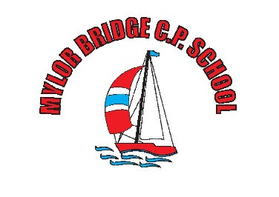

Equality Objectives – January 2022

At Mylor Bridge Primary School, we welcome our duties under the Equality Act 2010. We are committed to anti-discriminatory practice to promote equality of opportunity and valuing diversity for all children and families. The school’s general duties, with regards to equality are:

Eliminating discrimination.

Fostering good relationships.

Advancing equality of opportunity.

We will not discriminate against, harass or victimise any pupil, prospective pupil, or other member of the school community because of their:

- Sex
- Age
- Race.
- Disability.
- Religion or belief.
- Sexual orientation.
- Gender reassignment.
- Pregnancy or maternity.
- Marital/civil partnership status

Mylor Bridge Primary aims to promote pupils’ spiritual, moral, social, and cultural development, with special emphasis on promoting equality, diversity and eradicating prejudicial incidents for pupils and staff. Our school is committed to not only eliminating discrimination, but also increasing understanding and appreciation for diversity. We believe that a greater level of success from pupils and staff can be achieved by realising the uniqueness of individuals. Creating a prejudice-free environment where individuals feel confident and at ease is a commitment of the school.

This environment will be achieved by:
- Being respectful.
- Always treating all members of the school community fairly.
- Developing an understanding of diversity and the benefits it can have.
- Adopting an inclusive attitude.
- Planning for and adopting an inclusive curriculum that is accessible to all.
- Encouraging compassion and open-mindedness.

We are committed to having a balanced and fair curriculum. We believe that our pupils should be exposed to ideas and concepts that may challenge their understanding to help ensure that pupils learn to become more accepting and inclusive of others. Challenging and controversial concepts will be delivered in a way that prevents discrimination, and instead promotes inclusive attitudes. Mylor Bridge Primary School does not tolerate any form of prejudice-related incident. Whether direct or indirect, we treat discrimination against all members of our school with the utmost severity. When an incident is reported, our school is devoted to ensuring appropriate action is taken and a resolution is put into place which is both fair and firm.

