Subject - Light
Week 1 | Week 2 | Week 3 | Week 4 | Week 5 | Week 6
WALT: Understand what light is and where it comes from  Enquiry Question – How does light behave with transparent, translucent and opaque objects?  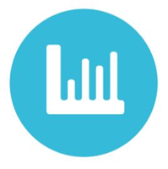 | WALT: Understand what reflection is and how we can use it  Enquiry Question – How is reflection used when designing car mirrors? | WALT: Understand what refraction is and how we can use it | WALT: Know how we can see light | WALT: Know where different colours come from  Enquiry Question – How is a rainbow created? | WALT: Know some of the uses we have for light in our lives
Key Vocabulary
Reflection, refraction, shadows, light source
Milestone Indicator
• Understand that light appears to travel in straight lines.
• Use the idea that light travels in straight lines to explain that objects are seen because they give out or reflect light into the eyes.
• Use the idea that light travels in straight lines to explain why shadows have the same shape as the objects that cast them, and to predict the size of shadows when the position of the light source changes.
• Explain that we see things because light travels from light sources to our eyes or from light sources to objects and then to our eyes.

