Context of the School

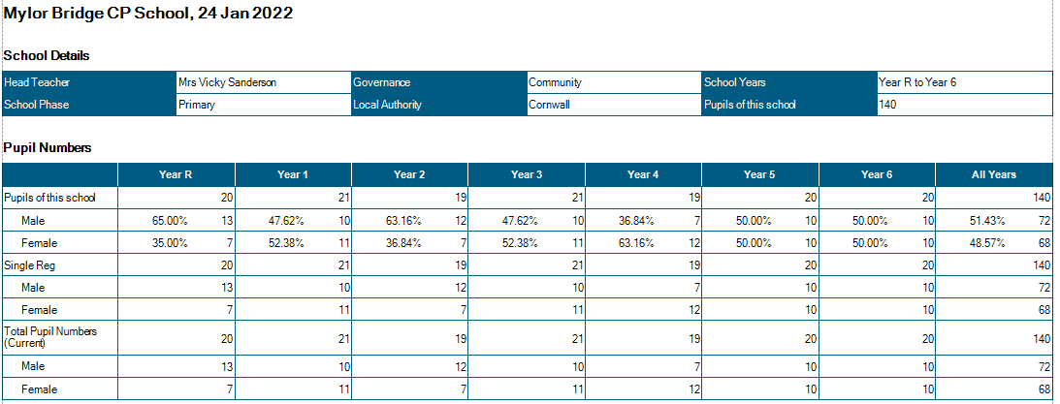

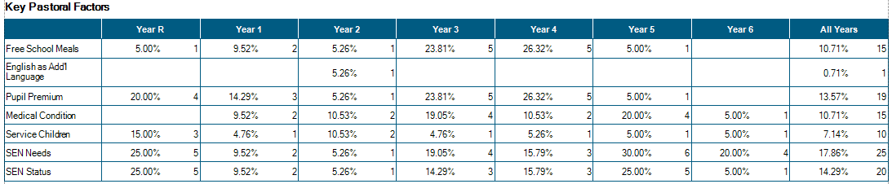

Attendance

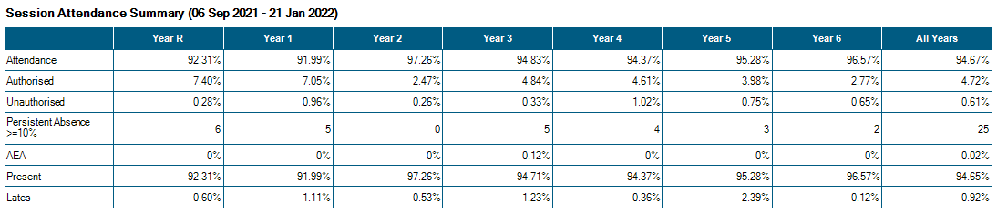
The effects of continuous COVID19 PCR testing is taking a toll on the attendance in school – lots of this non-attendance is due to children being slightly unwell, taking a PCR test and then awaiting the results.

From September, classes run in the following manner:

Class Structure from September 2021
Class 1:  EYFS -20 Year 1 - 10 | Mrs Mogridge (Mon – Wed)  Mrs French (Thurs-Fri)  Mrs Evans TA 09:00 – 15:15  Mrs R Wilkes 1:1 TA 09:00 – 15:15  Miss Short TA 09:00 – 12.00  Mrs E Lloyd 1:1 TA 09:00 – 15:15
Class 2:  Year 1 – 9 Year 2 – 21 | Mr Shainberg  Mrs Armstrong TA 09.00 – 15.15
Class 3 Year 3 - 19 | Mrs Thomas (Mon-Wed)  Mr Sanderson (Thurs-Fri)  Mr Collier 1:1 TA 09.00 – 15:15
Class 4 Year 4 - 21 | Mrs Wood (Mon-Wed)  Mrs Medlin (Thurs – Fri)  Mrs Stevens Mon - Fri 09.00 – 12.15
Class 5 Year 5 – 19 | Mr Martin  Mr Wilcox 1:1TA M-F 09.00 – 15.15  Mrs Pearson 1:1 TA Mon-Fri 09:00 – 12:15
Class 6 Year 6 - 18 | Mr Collinge  Mrs Garland (Tues – Thurs 9.00 - 12.15)
PPA Cover  Subject leadership cover | Mr Mutsaers – PE Classes 2/4/5/6  Mrs Hamilton Classes 2/4/6  Mr Wilcox Class 5  Mr Mutsaers
Intervention | Mrs Hamilton Monday 14:00 – 16:00 Tuesday – Friday 13:00 – 16:00  (Funded through national catch-up funding)
Intervention | Miss Short Tues – Fri 13.00 – 14.30 Phonics
Intervention | Mrs Pearson Mon- Fri 13:00 – 15:00 NELI/ Number Stacks (Funded through national catch-up funding)
Intervention | Mr Wilcox 08:15 – 09:00 Mon- Fri (funded through national tutoring programme)

Significant Changes/Challenges Since the last Head Teacher’s Report

- A tricky second half term, with significant staff absence caused increased levels of anxiety and stress for all staff (18/21 staff members needing to take a period of time off school due to illness) this has improved this term, with staff absence reduced (though no week has seen 100% attendance of staff)
- VERY positive Phonics Screening Check results for Year 2 pupils 95% (19/20) pupils attaining the pass mark of 32/40
- Class1 and Class 2 Christmas play took place virtually and were recorded for parents – lots of positive feedback received
- Class 5 and 7 Christmas play took place virtually – recorded for parents, again lots of positive feedback was received.
- Monitoring programme continues – with subject leaders of: Maths, English, Phonics, Science, EYFS
- VS Safeguarding update
- New SENCo employed for after February half term.
- Request from parents to offer after school wrap around care.
- Forest School Funding culminates Summer Term 2022

Quality of Education.

- Learning walk last week showed positive learning culture in school. Vast majority of pupils actively engaged in learning.
- Pupils spoke about learning with enthusiasm – they were able to talk about previous learning and how this has helped them to further understand learning in lessons now. (Action: This is not always consistent, more explicit recapping still needed)
- Writing moderation shows that improvement and progress has been made since September, notably in handwriting, presentation and spelling (though there is still some way to go in all of these areas. Action: Continued focus on handwriting, presentation and resilience for writing) Resilience for writing is also improving in all year groups.
- HT completed a Maths and English book look (Autumn 2) marking in place and in line with policy.
Feedback given is in the vast majority, actioned. Purple polishing evident.
- Slower than previously planned progress in being made in Maths – with every class still working through Autumn objectives – due to the need to plug gaps are revisit learning from previous years. (Action: monitor carefully by Maths subject leader and HT to ensure that Ready to Progress indicators are prioritised.)
- Curriculum development remains a large focus for school – this year’s monitoring timetable has been planned to ensure that all subject leaders have the opportunity to observe their subject being taught, alongside the triangulation of pupil conferencing/ book looks/ planning monitoring/ resource auditing
- Close monitoring and assessment shows that the previously lower attaining and SEND pupils are the groups who have most suffered academically during the lockdown. High quality, well-planned interventions have been put into place quickly to ensure that these pupils’ needs are being addressed and gaps are being filled; SEND pupils are slower in filling gaps than non-SEND. (see appendix for intervention tracker)
- Resilience in pupils who attend these interventions, is in the main extremely high – with some pupils attending 3x weekly afterschool intervention. (Action: HT to write to parents of non-attendees)
- In KS1 intervention is focussed on same-day catch-up alongside a focus on daily reading with the teacher/ TA.
- Subject leader for English monitors lowest 20% readers half termly – progress in reading is apparent for all bar 1 child – external assessment referral in place for this pupil.
- The plan for child who need to isolate at home due to COVID19 remains in place – accessed through class emails.

Behaviour and Attitudes

- Learning walk January 2022 showed that the vast majority of pupils were actively engaged in their learning and proud of the work they were completing.
- When asked, pupils were able to share work which they were proud of and talked with growing confidence about the knowledge and skills which they are developing – some were able to remember prior learning and state how this in building built upon within the current topic studied. E.g.: Y3 pupils were able to use fronted adverbials of time in recounts because they had learned them in narrative writing. However, learning is not always as ‘sticky’ as we aspire, with some children not being able to recall facts taught in earlier topics within the same academic year. Some pupils were aware of lower attendance affecting their understanding of a topic area – knowing that they needed to catch up with lost learning.
- Observations this half term show happy children with an enjoyment of learning. These children report that they feel safe in school and have good manners.
- Throughout assemblies, the topic of British Values has been explored – children have been able to find aspects of school and home life which exemplify British Values in practise – these have then been directly related back to school life, for example when voting in class for ideas which they think fulfil a brief more accurately, or when voting for traits within a book character.
- Feedback from pupils about returning to school has been positive.
- Children who present with trickier behaviour, are supported through Trauma Informed Schools provision and/or Draw and Talk.
- High expectations of behaviour, manners and attitudes are modelled by all staff, and staff have high morale and a great sense of team work.
- Attendance (considering the current pandemic) is still above national expectations – pre COVID. Those children who have attendance of less than 90% are closely monitored by the HT and attendance officer, where these concerns continue, parents are contacted and support is put into place. 2x letter for late attendance have been sent this half term, improvements in attendance have been seen in these pupils.

We currently have:
- 1 x child with a Special Guardianship Order
- 3x children with active court orders.
- 1x child with court allocated mentor
- 3x children currently working with social care – with allocated social workers.
- 1x Team Around the Child (TAC) plan in place
- 1x teacher of the deaf involved in planning and adapting provision in school
- 1 x teacher for the visually impaired working with 2x pupils
- 1x referral to First Light – domestic violence support, allocation awaiting.
- 1 x ASD referral made
- 2 children working with CAMHS
- 3x pupils working with FSW

- There have been 3 incidents of Team Teach since the last HT’s report. These incidents have currently abated.
- There have been 3x parental concerns raised regarding unkind behaviour in school – all dealt with by HT and CTs.

Personal Development and Cultural Capital

- Staff have mapped all aspects of the taught curriculum to ensure that coverage for teaching about the 9 protected characteristics is in place and both implicitly (book displays, clip art used etc.) and explicitly (PSHE lessons, assemblies, class discussions, character profiles etc.) taught.
- We have been accepted to be 1 of 5 primary schools taking part in the Hall for Cornwall School Partnership Programme – a 2 year programme of dance/ drama/creative studies focussing on local Cornish Myth and Legend.
- Pupils in YR/1/2/5/6/ took part in 2x Christmas plays – recorded for parents
- We continue to run split lunchtimes in order to given our younger children a less crowded space in which to eat and play. The hall is now used for all lunchtime eating on a rolling programme of year groups and timings. This has taken some tweaking as the children have returned to this routine.
- An Ecologist visited to speak with Y6 about local environmental issues
- KS2 visited All Saints Church to celebrate Christingle
- Y3 visited Penlee House Museum to learn about the Stone Age in Cornwall
- Y1 visited All Saints church as part of their learning in RE (Religious Education)
- Whole School trip to Cinderella – Pantomime Hall for Cornwall.
- Open the Book Assemblies for KS2 recommenced.
- Children represented school at the Mylor Lights switch on.
- Y6 took part in Bikeability
- Y3 welcomed a Roman Legionary into class o learn about Roman Britain
- Timeline fitted to ‘long corridor’.
- Councillor Edwards visited the Student Council to talk about democracy and her role within local government
- Student council have planned a KS2 litter pick to improve local environment
- All classes plan a fundraising opportunity in order to gain match funding from Lloyds Bank to buy class texts.
- Basketball league for Y5 and 6.
- Y5 sports leader training completed
- Y6 / YR mentoring can begin this term (post 27.1.22)
- Whole school assemblies continue on Zoom until after February half term – focus for this half term: British Values
- Extra-curricular provision for Spring term:

.

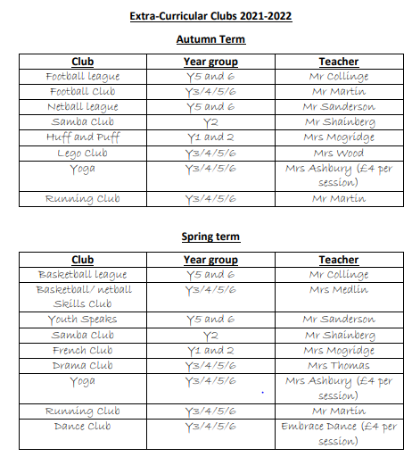

In order for staff to continue to remain up-to-date and be empowered to move our school forwards, a comprehensive, SDP-based CPD programme has been put into place.

CPD since Christmas:
VS - Safeguarding training
MC – Metacognition and Learning Skills – EEF
MC – Middle Leadership Programme
MC and AM – Maths Hub training
JP/RW – NELI (Nuffield Early Literacy Support) training
Whole Staff training – Dyslexia awareness
KS1 TAs – Phonics delivery
Planned for before half term- EYFS training for all staff and guided lesson observations in EYFS to highlight adaptations to meet the needs of the new EYFS curriculum.
Whole Staff – pre OFSTED briefing
All Governors – OFSTED briefing

Effectiveness of Leadership and Management

All teachers are subject leaders of at least one subject area. In these leadership roles, they are becoming more confident and more able to take control and lead their subjects across the school. OSFTED briefing allowed for subject leaders to audit areas that they are less confident with. Subject leadership time affords subject leaders the capacity to triangulate lesson observations, pupil conferencing and book looks with OFSTED Research reviews (Maths, History, Geog, RE, Science)
Subject leaders are developing depth to subject through investigating and introducing ‘golden threads’ which run across ages and phases throughout the curriculum areas (Action: golden threads for RE, Science and Geog to be in place by Sept 2022)
CPD and subject leadership time has been carefully matched to the priorities of the school development plan, and all subject leaders have the opportunity to observe, monitor and discuss their subject being taught across the school, Inc. meeting with lead governors to discuss development plan and areas of celebration.
Monitoring by the SIP showed that strong leadership is in place for reading/ phonics/ maths and history.
Re-mapping of the curriculum last year ensured that subject leaders know that there is consistency and progression within their subjects – there are constant tweaks and adaptations taking place to the curriculum which need to be updated regularly on the website
The use of knowledge organisers – see example, allow for clarity for children and provide opportunities to look back to prior learning.
POP quizzes allow for assessment in foundation subjects, end of unit tests and end of term test for maths are in place to identify areas of weakness before moving on, in English Cold and hot write are used to identify targets and celebrate progress respectively.

Work/Life Balance is supported
Teaching staff are encouraged to complete PPA at home.
Parents evening consultations are started at 13:00 to reduce pressure on late night consultations.
All teaching staff run an after school activity reducing the burden on a few members of staff running more than 1 club.
Blended staff meetings (held on Zoom and in real life) to allow part time staff to join us if they are able to.
Subject leadership is given ring-fenced time to ensure quality and depth of understanding.
Support from leadership and governors for family commitments (e.g. appointments/ children’s plays etc.)
Embedded positive ethos of team work well established across all team members.

Safeguarding
Safeguarding is an integral aspect to all leadership and management decisions.
Safeguarding is a standing item on the staff training agenda (weekly) and the TA (weekly) briefings. All staff know that they are accountable for safeguarding and take this role very seriously.
MyConcern is now used to record all concerns, and conversations had with parents regarding pupils.
Safeguarding training is up to date and DSL and DDSL have up to date safeguarding training. (Action: Safeguarding training in place for governing board KCSIE part 2)

Abbreviations:
9 Protected Characteristics (age, disability, gender reassignment, marriage and civil partnership, pregnancy and maternity, race, religion or belief, sex, and sexual orientation.)
ASD – Autistic Spectrum Disorder
British Values - Democracy. The rule of law. Individual liberty. Mutual respect. Tolerance of those of different faiths and beliefs.
CAHMS – Child and Adolescent Mental Health Service
CT – Class Teacher
EYFS – Early Years Foundation Stage (First year in school aged 4-5 yrs.)
FSW – Family Support Worker (Works with the Social Work Team)
HT – Headteacher
KCSIE – Keeping children safe in education- national safeguarding document which outlines accountability for safeguarding in education.
NELI – Nuffield Early Language Intervention – support for EYFS pupils to develop early language skills
POP (Quizzes) – Proof of Progress
SENDCO – Special Needs Coordinator – trained teacher who also holds the SEND qualification and over sees provision for our pupils with SEND.
SEND – Special Educational Needs and Disabilities.
SW – Social Worker
TIS – Trauma Informed Schools (practitioner) School-based trauma support.
Team Teach – Physical Intervention (e.g. to stop a child hurting themselves or others)
TA – Teaching Assistant

