***Year 6 – Rivers Knowledge Organiser***

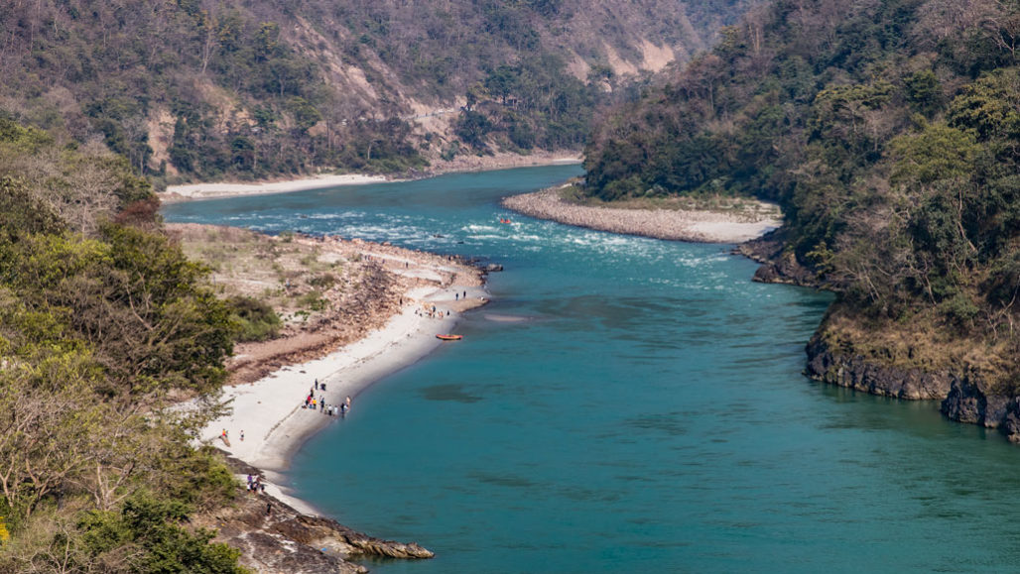

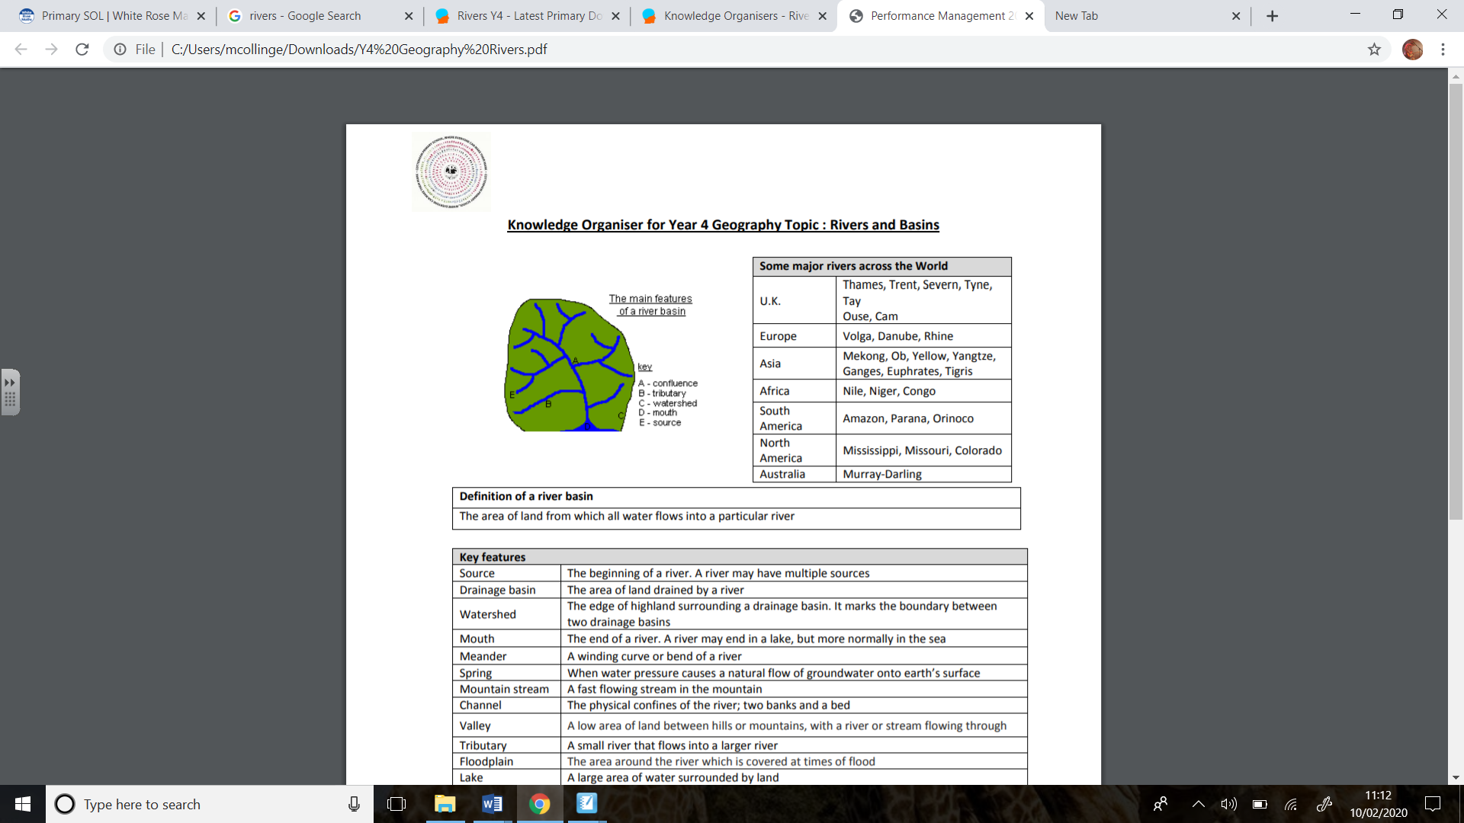

***Key Questions***

Where do rivers begin and end?

What are some of the longest rivers in the world? What are some of the longest rivers in Cornwall? How do they compare?

What are the differences between the upper, middle and lower course?

How do rivers change over time?

What is erosion and deposition?

Why are dams important and how are they used locally?

