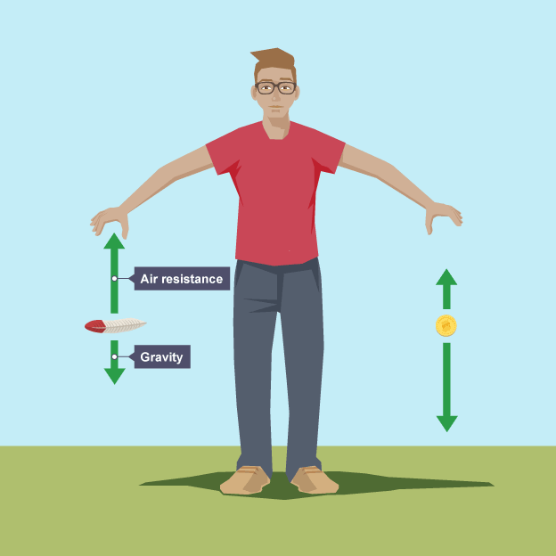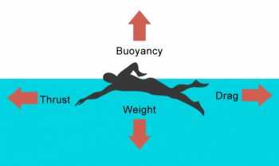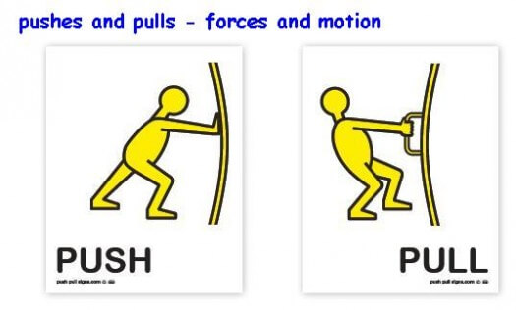

**Forces Year 5– Knowledge Organiser**

**Key Vocabulary**

**Air resistance – A force that is caused by air with the force acting in the opposite direction to the object moving through the air**

**Force – A push or pull upon an object resulting from its interaction with another object**

**Friction – The resistance that one surface or object encounters when moving over another**

**Gears – A toothed wheel that works with others to alter the relation between the speed of a driving mechanism (e.g. engine) and the speed of the driven parts (e.g. the wheels)**

**Gravity – The force that attracts a body towards the centre of the earth**

**Levers – A rigid bar resting on a pivot that is used to move a heavy load**

**Mass – The measure of matter that is in an object usually measured as weight in KG.**

**Pull force – To draw or haul towards oneself or itself, in a particular direction**

**Push force – To move something in a specific way by exerting force**

**Water resistance - A force that is caused by water with the force acting in the opposite direction to an object moving through the water**

**Variable - A variable is an object, event, idea, feeling, time period, or any other type of category you are trying to measure. There are two types of variables-independent and dependent**

**Key questions**

* What units do we measure force in?
* What is the name of the force that pulls things towards the centre of the Earth?
* What equipment do we use to measure force?
* Why do astronauts bounce around on the moon but don’t float around like in space?
* What kind of forces push against a swimmer in the water?
* How can shape help an object move more freely in the water?
* Why is it important to control variables in an experiment?
* Why is important to repeat experiments?
* What is friction?
* Why do some objects fall to the earth faster than others?
* If we want to investigate whether the size of a parachute affects the speed in which an object falls, what is the **Independent Variable**?

What would be the **Dependent Variable** in the above investigation?