Year 6 Science Knowledge Organiser – Animals including Humans
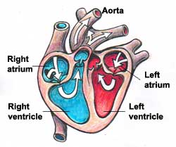
Key Questions
How does blood move around the body?
What are the key parts of the circulatory system?
What effects do lifestyle choices have on my health?
What are the roles of some of the organs in my body?
