Headteacher report to Governors – March 2019
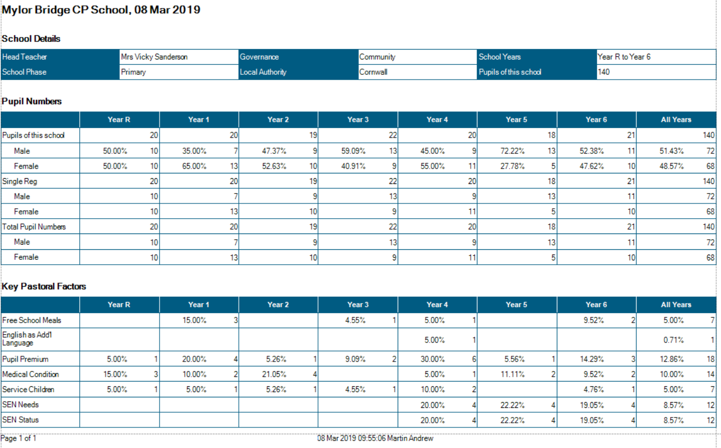
School Context

4 Boys have left since September moved out of county/country.
We have had 1 boy join since September and 3 girls ( Y. 2,3,6) We are currently at 140 pupils
Class 1 | Mrs Mogridge –  Mrs Tresidder Mon – Wed 8.45 -3.15 + LTS  Mrs Evans Tues – Fri – AM  Mrs Stephens – Thurs 8.45 -3.15 +LTS  Miss Rowe Mon – am and Fri all day
Class 2 | Mrs Edwards – Monday – Wed  Mrs French Thurs and Fri  Mrs Stephens mon and Tue + LTS  Mrs Garland Wed – Fri + LTS
Class 3 | Mrs Thomas  Mrs Armstrong Mon – Fri + LTS on Friday
Class 4 | Mrs Wilkes  Mrs Garraway Mon – Fri 8.45 – 12.15
Class 5 | Mr Mutsaers  Mrs Medlin Mon – Fri 9.00 -12.15 +LTS  Mrs Goodwin (agency) Mon Fri 12.15 – 3.15 +LTS
Class 6 | Mr Collinge  Mrs Fenton Mon – Fri 8.45 – 3.15
PPA cover | Mrs Walker (PE) and Mrs Barry (music) Tuesday all day  Mrs Heard - PE class 1 Thursday am
Interventions | Mrs Garraway covering AT and RG Mon, Tue, Thurs 12.30 – 3.15
Pastoral work | Mrs Fenton Thursday PM  Mrs Wilkes Tues 11.30-12.15 Draw and Talk
Class Structure as of Jan 2019

Significant changes and challenges since the last headteacher’s report.
- On-going concerns related to MAT resulted in a unanimous vote at FGB towards not forming.
- JH resigned as intervention TA after being off for quite a long period.
- Class 3 had to be covered for a whole half-term due to JT having an accident over the Christmas period.
- TL will not return to school up until she retires at the end of term two. JE appointed after successful interview and began in the second half of the spring term initially on supply until her contract starts in the summer term. SP did a fantastic job at covering for the first part of the term.
- HM and MG (agency staff) have been the TAs in class 5 during VS secondment. HM has a number of skills that would be extremely useful at MBS and we’d like to keep her dependent on budget.
- A focus on playground equipment and implementing sports leaders this term has reduced the number of playground incidents with y1 boys. Fundraising committee has raised money through the school book fair and raze the roof. Using this money, we have purchased two new netball posts (£460) The school caretaker has also modified one of the older posts so that it can be used in the KS1 playground.
- Using the book fair vouchers we have purchased PIE Corbett resources to link with our whole school TFW movement.
- Teacher drop-ins and mid-term appraisals have been undertaken.
- Writing Moderation has taken place within our proposed MAT – very positive outcomes and positive experience for staff. Year 6 moderation planned across Penryn Partnership.
- Parents open afternoon and mid-term reports undertaken – positive feedback from staff and parents.
- SPTO assessment package to be discontinued December 2019 – what next?
Outside provision still needs to be significantly improved for KS1 children – Garden area in the front playground and outside area cleaned and washed – Planned for 21/03/19
- An evaluation of mid-term reports and reporting back to parents needs to be planned to ensure an agreement on what is GDS and EXP at each feedback period.

Phonics intervention – impact. The impact of the phonic intervention has been positive children have moved through phases after TW rescreened in March 19
Attainment
Early years attainment
2016  88% GLD | 2017  75% GLD | 2018  65% GLD

Phonics screening
2016  84% Year one pass  Retakes Year 2 - 33% 1/3 | 2017  75% Year one pass  Retakes Year 2 – 50% 2/4 | 2018  65% - year one pass –  retakes year 2 – 75% 3/4 pass

KS1 Attainment
Year | Reading |  | Writing |  | Maths |  | SPaG
 | Sch | National | Sch | National | Sch | National | Sch | National
2016  (National Age-Related Expectation) NARE | 79% | 74% | 68% | 65% | 74% | 73%
2017 | 75% | 76% | 75% | 68% | 65% | 75% | 45%
2018 | 76.% | 75% | 71% | 68% | 72% | 75%
KS1 Teacher assessment GDS
Year | Reading |  | Writing |  | Maths
 | Sch | Nat | Sch | Nat | Sch | Nat
2016 | 42% | 24% | 0% | 13% | 16% | 18%
2017 | 25% | 25% | 20% | 16% | 5% | 21%
2018 | 29% | 26% | 14% | 16% | 14% | 22%

KS2 SAT Results
Year | Reading |  | Writing |  |  | Maths |  |  | SPAG
 | School | National | School |  | National | School |  | National | School |  | National
2016 | 71% | 66% | 79% | 74% |  | 92% | 70% |  | 75% | 72%
2017 | 81% | 71% | 76% | 76% |  | 86% | 75% |  | 86% | 77%
2018 | 77% | 75% | 86% | 78% |  | 82% | 76% |  | 86% | 78%
Greater Depth SS of 110 and above
Year | Reading |  | Writing |  | Maths |  |  | SPAG
 | School | National | School | National | School |  | National | School |  | National
2016 | 29% | 19% | 21% | 15% | 33% | 17% |  | 38% | 22%
2017 | 38% | 25% | 38% | 18% | 38% | 23% |  | 52% | 31%
2018 | 36% | 28% | 27% moderation | 20% | 31% | 24% |  | 46% | 34%

Predicted attainment KS2
Reading | Writing | Maths | SPAG
76% EXP | 80% EXP | 71% EXP  MATT 76% | 76% EXP
33% GDS | 23% GDS | 19% GDS | 23% GDS

Predicted attainment KS1
Reading | Writing | Maths
75% EXP | 70% EXP | 80% EXP
30% GDS | 20% GDS | 40% GDS

Phonics Current attainment using 2018 phonics screening materials.
Quality of teaching, learning and assessment.
- Standards of teaching and learning are at least good (from book looks and drop ins)
- Areas of improvement (as identified in the review from SIP) is boys writing including developing a whole school approach to handwriting. Handwriting schemes have been investigated but are expensive and we need to ensure that we get the right one for our school.
- Phonics – the intervention is in place and having an impact.
- Teachers are using T4W and an English policy is being written with non-negotiables agreed by staff.
- Comprehension books have been purchased and comprehension is taking place on a weekly basis.
- T4W displays showing progression of writing from EYFS to year 6 are up and have been updated. Talking tins are used to illustrate how children have improved from their Cold task to hot task.
- Whole school now teaching maths using a MASTERY approach.
- School to be involved in MATT/PARTNERSHIP INSET training progressing to being involved in DDay landing project at Trebah gardens with Mawnan, Flushing and Penryn College.
- Teachers are still using and updating SPTO despite knowing its discontinuation in December. This is used to inform planning of gaps.
- AM and MC to sign up to be part of Mastery work group as part of Cornwall and West Devon Maths Hub.
Action – to develop learning powers in School
Develop GDS in KS1 by providing deeper thinking activities particularly in maths and building on stamina for writing by consistently using a T4W approach.
Invest in handwriting policy. (NHS Handwriting development discussed at staff meeting 18/03/19

Personal development, behaviour and welfare.
We have had two court orders and one agency referral with one open case.
We have had two internal exclusions with a behavioural management referral and Dreadnoughts referral undertaken.
We have had a few injuries in school with one child being taken to A and E after banging his head and cutting his eye. We had another child in KS1 fall and bang her head resulting in another A and E visit.
A child received quite a serious splinter from the bench around the front – this was reported in to county and to the helpdesk.
Sports leaders are working in the KS1 playground and this has had a huge impact on the number of accidents or reports of inappropriate play.
Mylor Manners continues to be a focus during celebration assemblies.
The KS1 Outdoor space to be ‘refurbished’ on 21st March.

Sports and enrichment opportunities children have been involved in since January.
- Two gold medals and a silver at partnership x country. A gold and a silver at Peninsula tournament and Five children through to Cornwall School Games finals
- 16 children competed in the cross-country at Polwhele House and at Coose Tranack school over two Saturdays in March
- Two new sports clubs set up for year 1,2,3 - Monday Multi skills club with Kernow Sport and Fridays Yoga with Katie Ashbury
- Whole school trip to Eden with whole school poetry focus write after
- Reception children attended balance bike festival at PC
- Y6 bowling on a Friday
- Year six sports leaders set up - modelling effective play and games to KS1
- 5/6 basketball teams finished 4 and 6th in basketball league
- Year 5 competing in partnership hockey league
- Spring concert (April 19)
- Year 3 to Truro Museum
- Year 5 Science outreach programme
- Fundraising group organised book fair and Raze the roof
- Y4 involved in St Piran’s day celebrations and took part in the annual dance.
- 15 year 6 children involved in SongFEST.

CPD Since January 2019
ALL T4W training
AM, MC, Subject leader training at Penryn College
ALL Bar Modelling with Josh Lury at MBS – inc. Flushing, Malborough and Mawnan
KF and KM – Maths observation Ross Barnes – Teaching for Mastery
MC – SAT assessment procedures
KM – EYFS moderation
TW – ESAFETY – safeguarding update
KF – attended the KS1 Statutory assessment course.
JF, VA, RG – part of TA maths mastery group – Maths Hub work 1 X a month
SM – IMS training X 4
Leadership and management
Delay to writing the English policy due to JT injury. JT and MBS through staff meetings and consultations have now written and is implementing English policy
Maths leads have organised parents’ maths sessions to explore the way we teach maths and the expectation of each year group. Maths leads to sign up to be part of Mastery work groups
EYFS – parent phonic information sessions have been offered and delivered
Assistant headteacher has had a great opportunity and has learnt a lot very quickly in his temporary cover of VS
VS has also gained a wealth of experience in her secondment to Marlborough
Both members of staff looking forward to resuming their roles in April
Pupil conferencing around English T4W and Maths Mastery will need to take place in the summer term
Implementation and timetabled delivery of consistent handwriting approach
Investigation of a new assessment and tracking system
A school focus on Curriculum to align with new OFSTED expectations.

