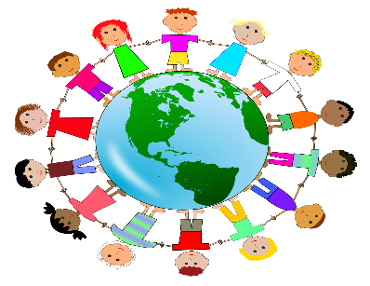

**Key Questions**

1. **What make humans special?**
2. **What do humanists believe?**
3. **How do humanists decide how to live their lives? Do they have a moral code?**
4. **How do humans look at the world and how do they find their truth?**

**What matter most to Humanists and Christians?**

**Who is a humanist?**

**Humanists** do not believe in a god. They believe it is possible to live a good and fulfilling life without following a traditional religion.

**British Humanist Association:**

* Be honest
* Use your mind
* Tell the truth
* Do to other people what you would like them to do to you.

|  |  |
| --- | --- |
|  | |
| What is a code for living? | A person often has a ‘code for living’ inside their head or heart that helps them to choose good things and say no to bad things. |
| Good & bad, right & wrong | Each individual is free to choose how they act in most situations, but the decision about what to do is based on their beliefs and the consequences of the action taken. |
| What codes for living do Christians try to follow? | The values of Christianity include love, forgiveness, peace between people and God, honesty, prayer, worship and fellowship (togetherness). Jesus showed a path for these. |
| Good Samaritan | Stories in the bible help to explain how Christians think Jesus thought people should behave |

**Key Knowledge**

|  |  |
| --- | --- |
| Atheist | Believe there is not a god or gods |
| Theist | Believe there is a god of gods (a creator who created the world) |
| Agonist | Believes that we cannot prove whether god exists. |
| Values | principles or standards of behaviour |
| Code | A set of instructions |
| Humanist | Follower of the principles of humanism. |
| Moral dilemma | Considering two or more moral duties and making a decision to only honour one. |
| Consequence | A result or effect of an action |
| Reason and logic | Thinking carefully and forming judgement |
| Faith | Believing without the need for proof |

**Key Vocabulary**