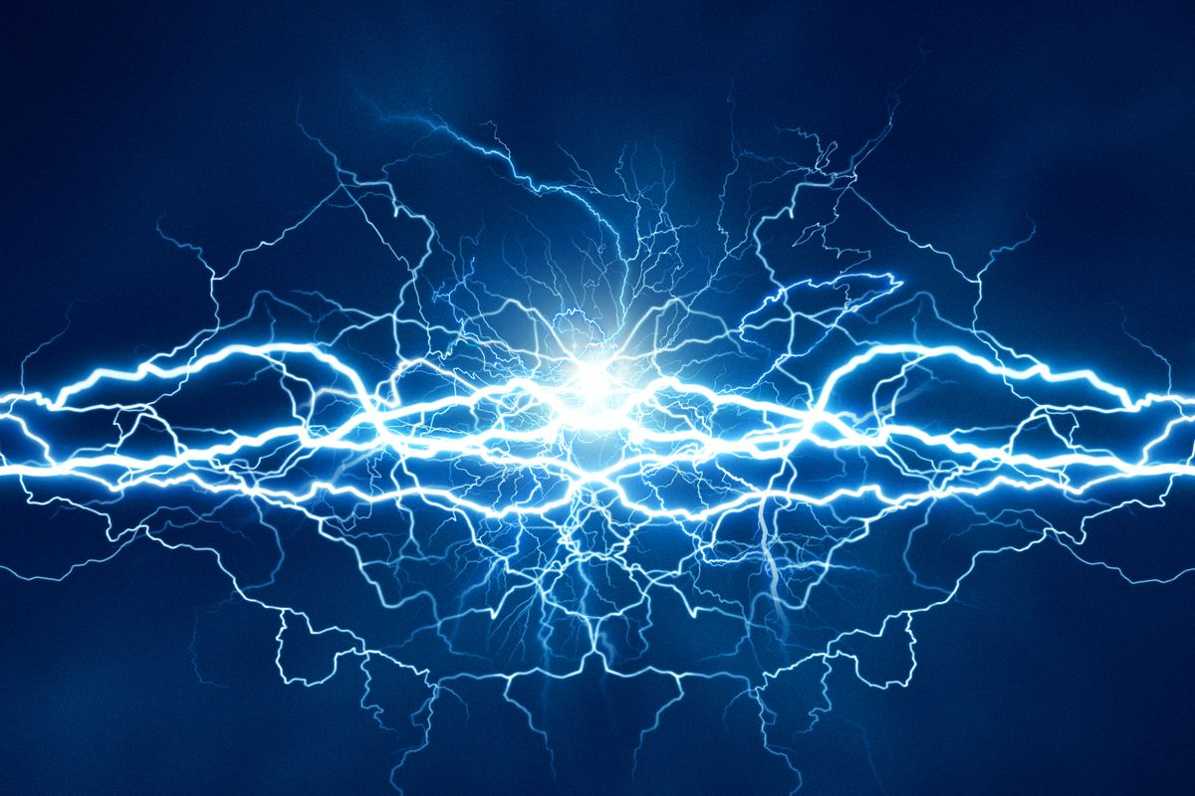

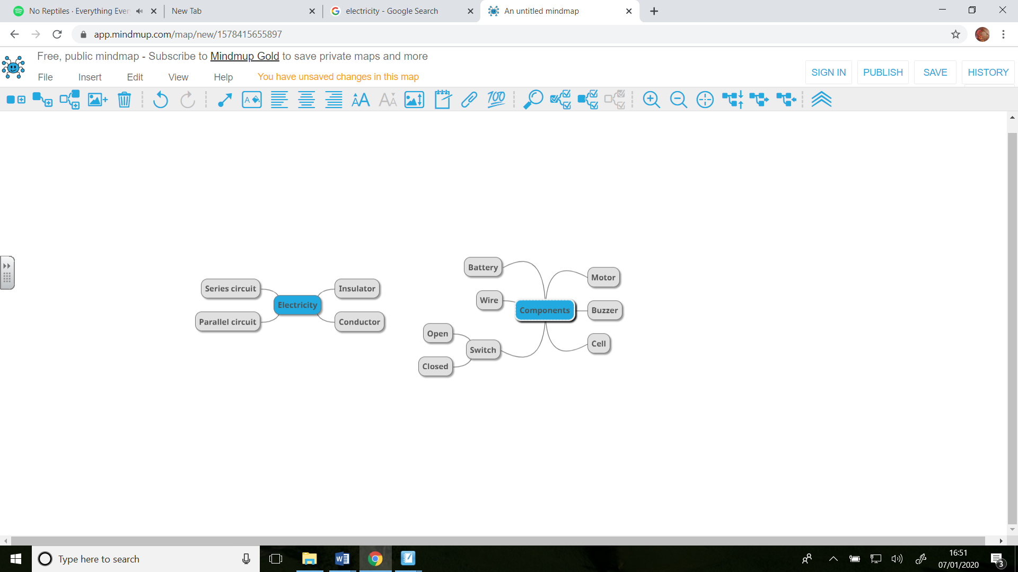***Year 6 Science Knowledge Organiser – Electricity***

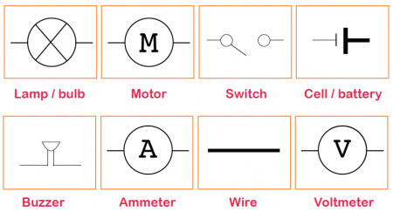

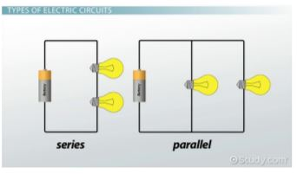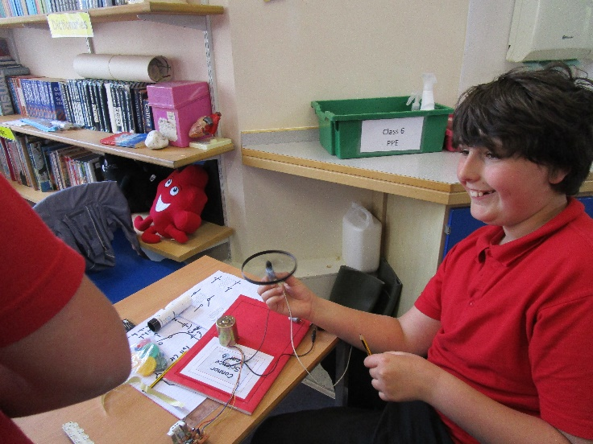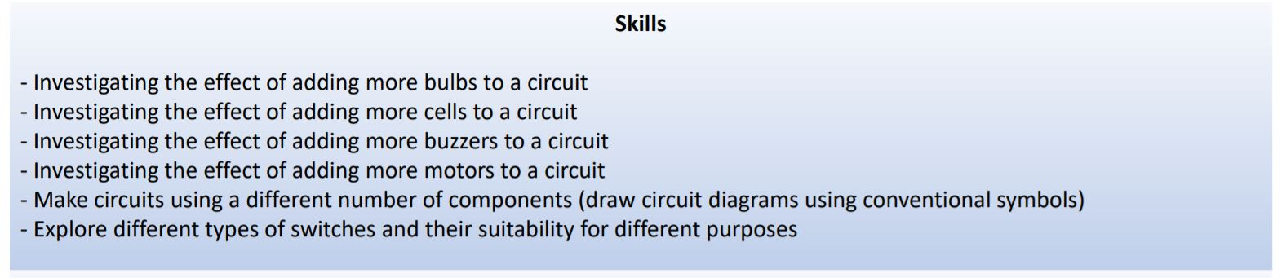****

**Circuits**

If you add more cells to a circuit, a bulb will glow brighter and a will spin faster.

If you add more bulbs to a circuit without adding more cells, the bulbs will glow less brightly.

If you have a switch in a circuit and you open it, a bulb would go off and a motor would stop.

**Circuit Diagrams**

Here are two series circuits. Both circuits have one cell (to provide power) but one circuit has two bulbs/lamps—the bulbs in this circuit will glow less brightly than the bulb in the circuit with only one bulb.